Hi Dragonfly Families,

Welcome to 2020! This month we started off the New Year with many children out sick and Sueann and I as well. The way I look at it, we got that out of the way and should have a healthy year ahead of us. Having a little snow was exciting! It is fun to be outside when the children are prepared for the cool/wet weather. Thank you for encouraging them to wear the appropriate clothes. Clothing can bring on challenges at this age as they develop their will and enjoy making choices. Sometimes it is about what is easy to put on (like boots) and other times it is about control. Whatever it is, allowing them plenty of time to dress, giving limited choices and talking about the weather outside and comfort may help. In the classroom, the children have been working on zipping their jackets, putting on gloves and shoes and are now very successful.

We have two new friends that joined our classroom this month. Both have experience in other Montessori schools and have recently moved to Camas. Sarah is 4.5 and Gabriel just turned 4 in December. It has been so wonderful welcoming them and getting to know them. We had a fun Birthday Celebration for Nolan who is now 4-years-old. He enjoyed giving the playdough to all his classmates. Speaking of giving, I want to thank you for the wonderful gifts I received before the Holiday break. I have been using my wonderful mug, getting coffee at Starbucks and smoothies at squeeze and grind, shopping at Target, and eating yummy treats! I feel so spoiled and very appreciated. Thank you and I hope you all had a wonderful holiday season!

Donna sent out a letter about observing in the classrooms last month. I encourage you to take some time out of your day to do this. The best time to see your child at work and socializing with friends is in the mornings from 9-11:00. If you are interested, just let me know a day or two ahead of time.

Lyrics to a song by Bob Marley

Don’t worry about a thing
Cause every little thing gonna be alright
Singing “Don’t worry about a thing
Cause every little thing gonna be alright!”

Rise up this mornin’
Smiled at the risin’ sun
Three little birds
Pitch by my doorstep
Singin’ sweet songs
Of melodies pure and true
Saying, “This is my message to you”

Singing “Don’t worry ‘bout a thing
‘Cause every little thing gonna be alright.”
Singing “Don’t worry (don’t worry) ‘bout a thing
‘Cause every little thing gonna be alright.”

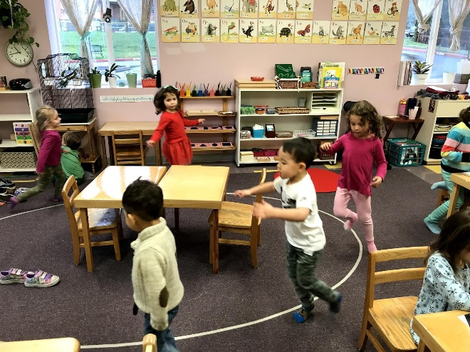
Getting some movement in on a rainy day by moving to walking on the line activity CD’s .

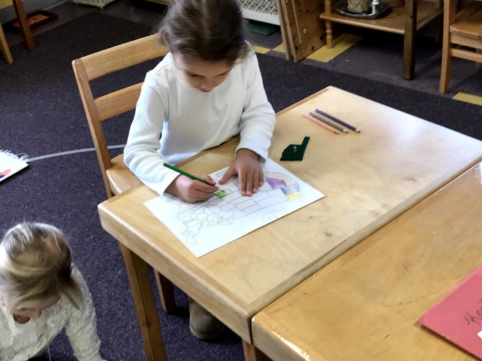
Isla is coloring in the states after learning the names.
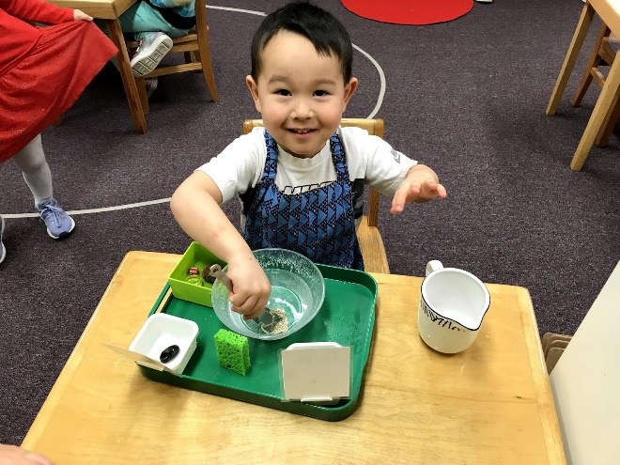
Nolan is enjoying sink and float.

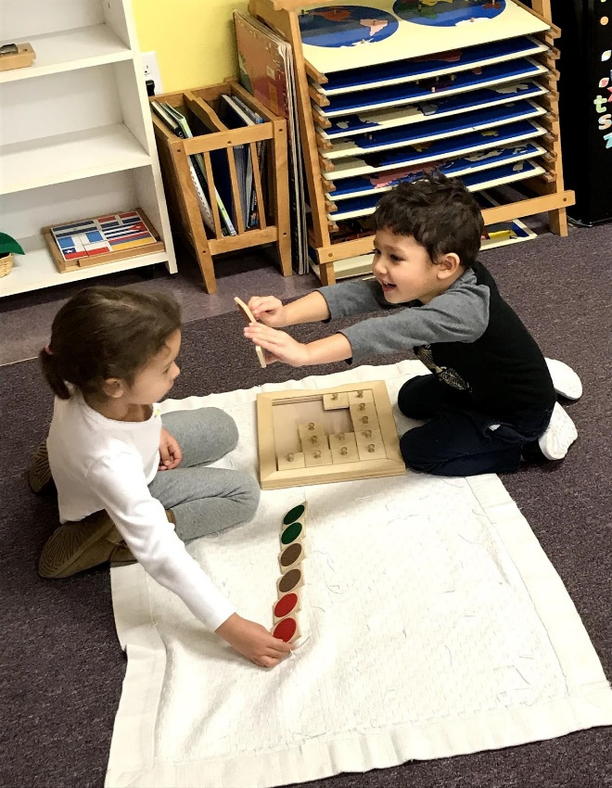
Gabe and Isla playing the color matching game.

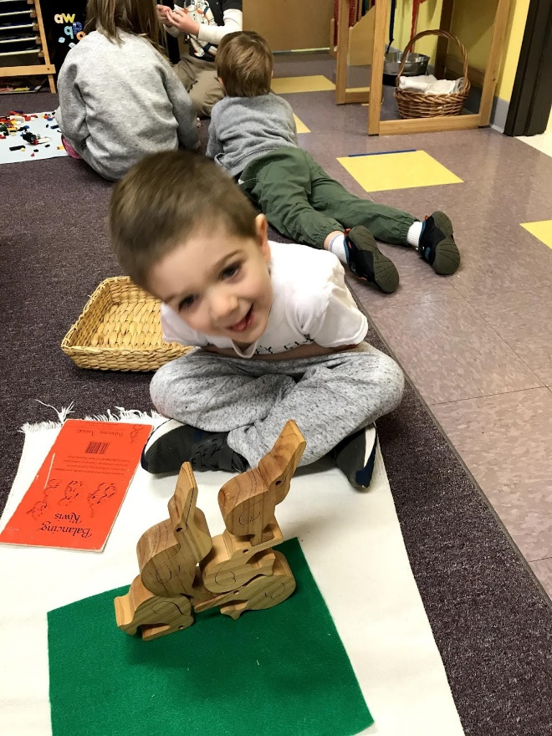
These are the stacking kiwi’s. Lincoln was thrilled to get them in this position without them falling over. It is harder than it looks.

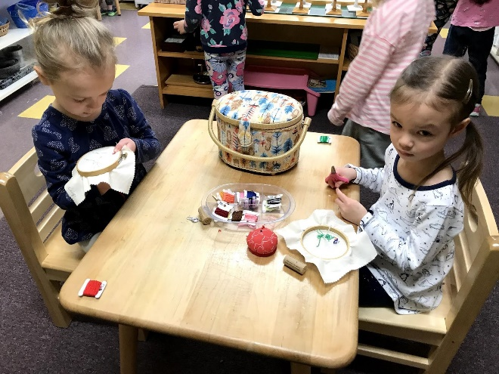Lilly and Rowe are sewing embroidered squares to make a small pillow. We later used the sewing machine to sew the back on.

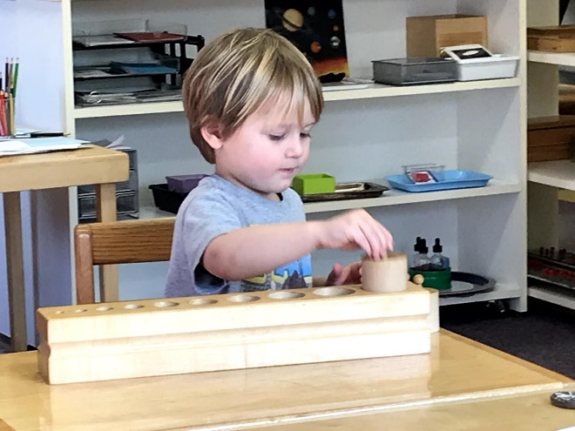
Merrick is working with the cylinder blocks learning dimension and strengthening his pencil grip.

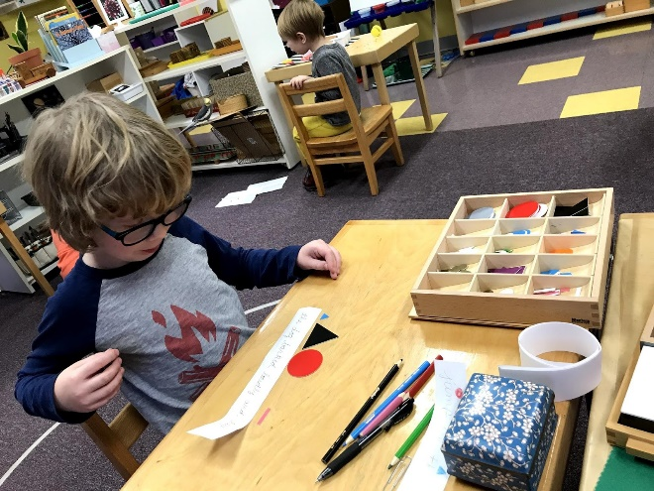
Isaac is using the grammar symbols on a sentence. We talk about what different words do and they each have a function and a symbol. For example: A verb is a word for something you can do and is represented by a red circle.

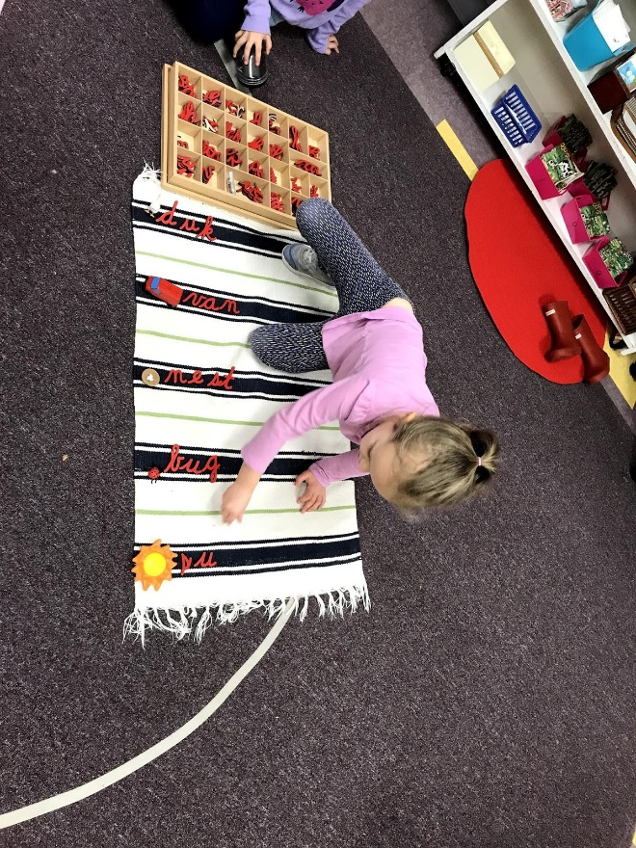
Lilly is building words with The Small Moveable cursive alphabet.

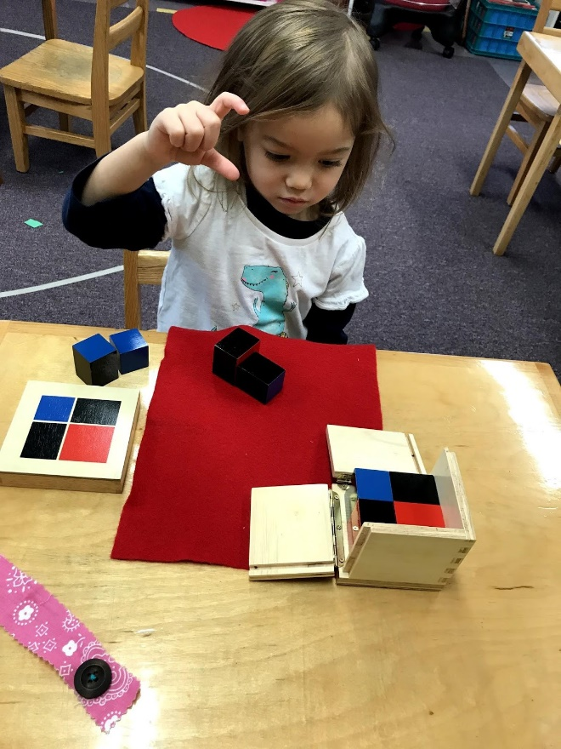
Thea is building the Binomial Cube.

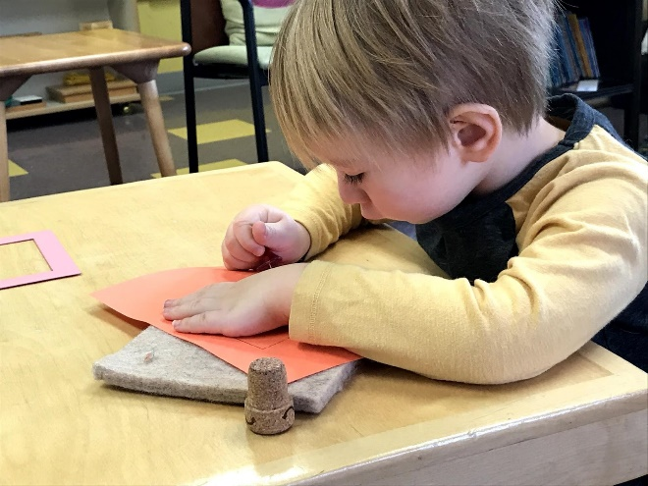
Rory is pin pricking a shape. A great work to strengthen fine motor.

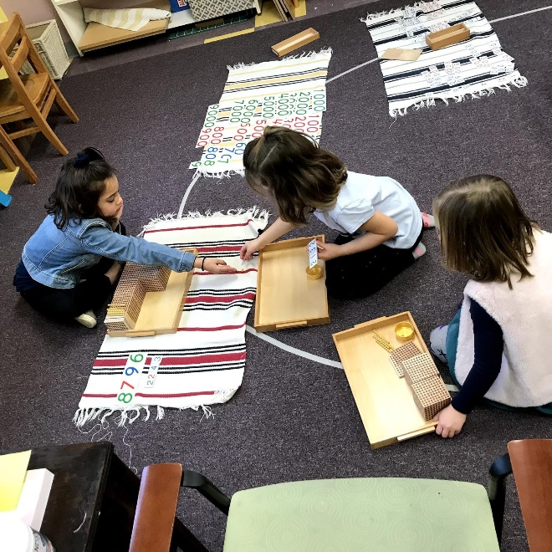
Ida, a former CMS student, came to visit and led an addition game with the Golden Beads. Kori and Penny are experiencing Math into the thousands.

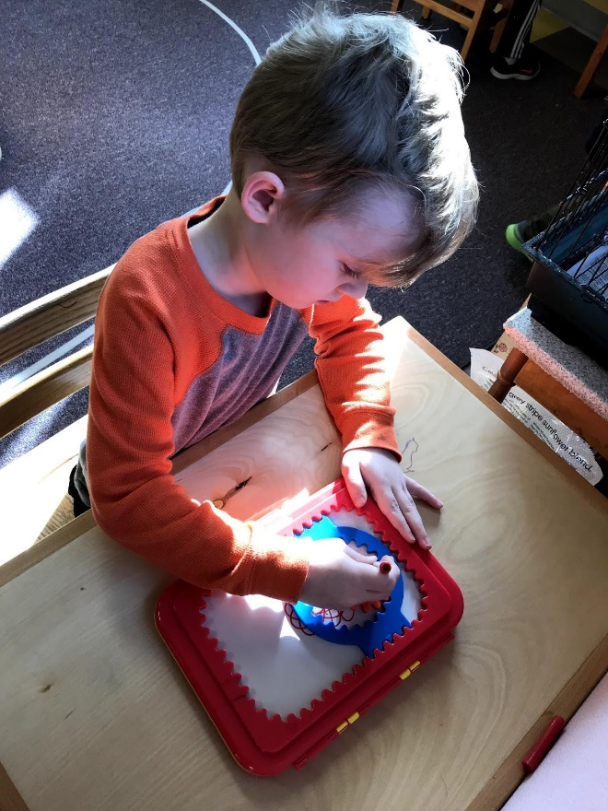
Connor loves working the Stenograph we got as a gift for the classroom.
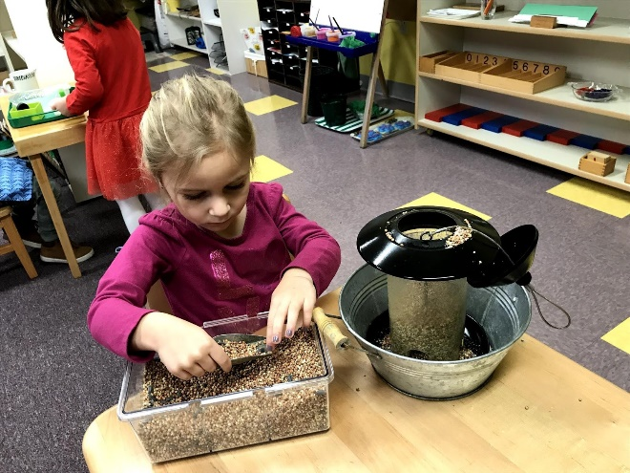
Senna is filling the bird feeder for the hungry January birds. The backyard birds eat through a full feeder in two days.

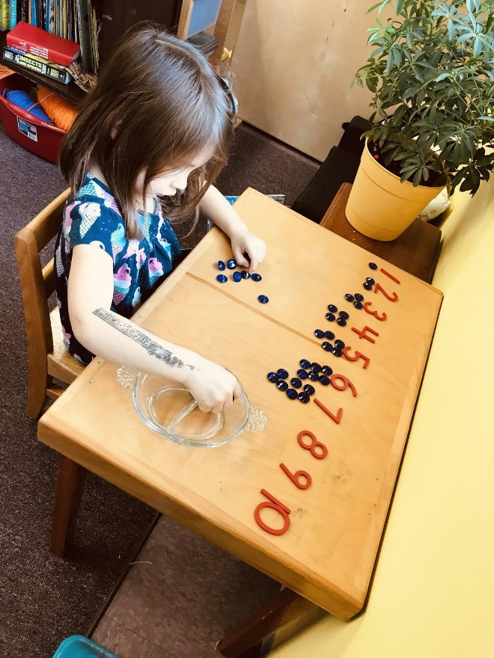
Sarah is counting to 10 with the cards and counters.

