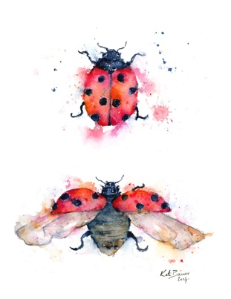
Ladybug Letter
Happy 2020! And Happy Chinese New Year! To the children’s delight a little bit of snow arrived with the new year, along with colder weather, so we are dressing in our warmer clothes. We’ve encouraged the children to zip up, and wear their hats, mittens and boots (in the rain and playground mud). I am happy to say everyone can now put on their own coats and zip them up.
Speaking of such things . . . please be sure to check their cubby bins and replenish any of the extra clothes in cubbies that have come home, as soon as possible. If the clothes from the nap room also need replenishing, label the bag ‘for NAP room’. Also please check that many clothes have been out grown, and many are summer shorts and shirts. Thank you.
I send a very heartfelt thank you for all the lovely, and quite generous gifts given to me from the children and families at Christmas! I plan to spend the gift certificates ahead of our AMI conference in Seattle Feb. 14th -17th. Hooray! Your hand made gifts and notes of appreciation made me feel quite special.
Thank you also for the gifts given to our classroom. They have been put to good use and are always appreciated by the children.
January Scholastic Book Club order has been submitted and will be arriving any day. It is great when you find a book or two of interest because we all benefit with credit toward a classroom order. We received a set of classroom nature early readers last month and a wonderful dictionary. If you are able to come in to the classroom to observe, you may see that there is much excitement when another child has learned to read. They love to share their emerging skills with one another. Your support in helping your child learn the letters sounds (the consonants and short vowel sounds to begin with) makes the precious task of guiding your children feel like team work. There are some children now counting by ones, fives and tens to one hundred thanks to your engaging them in the fun at home!
Classroom Observations begin in February. This is a time to see the how they all go about their day, finding work of interest, observing others, problem solving, and such. A sheet will be posted outside the classroom door to sign-up in advance for a day and time. Observations will be in the morning on Tuesdays, Wednesdays and Thursdays. Please refrain from engaging in conversations with the children. Simply say, “I am here to watch the children (you) work.” I’ll have an ‘observation chair’ set up for you. A child may offer you a cup of tea (and if you so wish, will likely be delighted if you accept). It is usually quite a busy little hive. We ask for only one observer per 20 minute time slot please, as we preserve this special prepared environment as the children’s house.
Our Polar Bear support has topped $50, qualifying us for ‘adoption’ papers and a little soft polar bear through the World Wildlife Fund. I look forward to creating other fundraising ideas with the children. It has definitely raised their consciousness of the interconnectedness of life on earth. Have you noticed what fun it is to talk about the continents with your child, of places, habitats, plants, news and the animals that live there. Montessori work in geography really expands at the elementary level. I love the geography work. A world globe and an early atlas is a great gift for a child.
Our afternoon (extended day) class is growing with two more children about to turn five! That makes for greater dynamics among them. They are approaching what Dr. Montessori observed as another markedly distinct milestone in their development. She named it the ‘Second Plane of Development’. I find it such fun to recognize and understand. We will talk a bit about this at the next Parent Education Night, this Thurs. 5:30-6:30. There will be child care and pizza for the children. RSVP
The second CMS family Child-led Open House will be at the end of February, Wed. the 26th. Please sign up for a time to attend: 4:00- 5:30 and 5:30-7:00. Once again this is on the end of the month early release day.
Worth noting: the public Open House held on Sat. Jan 25th was a huge success. Our waiting list is growing!
Our class is preparing to begin tooth brushing this month. A few children have begun to lose their front teeth and there is talk amongst them of the ‘tooth fairy’. I am so lucky to witness their ponderings and joy!
Once again we have enjoyed a performance as a benefit of Run for the Arts. Eth no tec told stories from Asia with great personal animation. Your children participate as a very polite audience.
Here is a song they love to sing and might share with you if you start with the first few words:
Way up in the sky,
The momma bird flies.
Way down the nest,
the little birds rest.

With a wing on the left
and a wing on the right,
the little birds sleep
all through the night.

Shhhhhh . . . they’re sleeping. (whisper
and pause)

The bright sun comes up.
The dew’s on the trail.
Good morning, good morning
The little birds wail!

I have a classroom wish list to which I am adding:
- Old travel magazines
- Old National Geographic magazines
- A person that sews, for the edge of a small blanket and hemming cloths
- Dried rose petals (in summer)
Our VALENTINE Celebration is in the morning on Thursday, February 13th as there is no school on the 14th. I will send home a list of student names that your child can hand copy, or cut and paste onto the Valentines they give. This is a sweet opportunity for practice in writing their name. Creating your own together can be great fun, but I suggest you do it over several days so it is not an overwhelming task. Please keep in mind that we shy away from giving candy. If you choose to give a Valentine to someone, please give one to every child in the class.
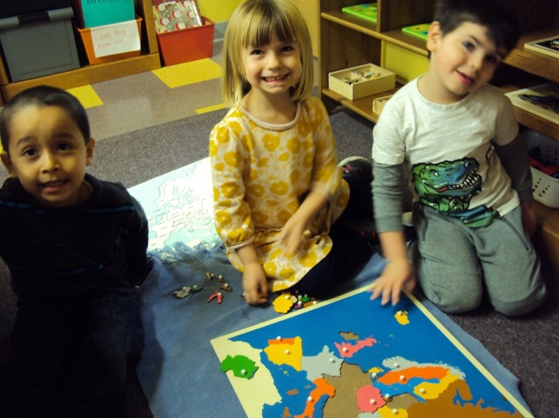
Richy, June and Reid are enjoying working together on the puzzle map of Europe. There is a lot of interest in our beautiful maps of late.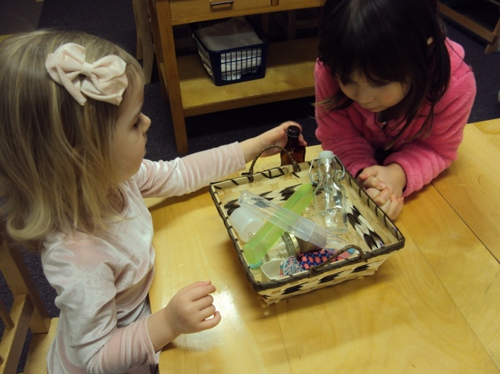
A few new containers in ‘opening and closing’ is just enough to spark a renew interest. 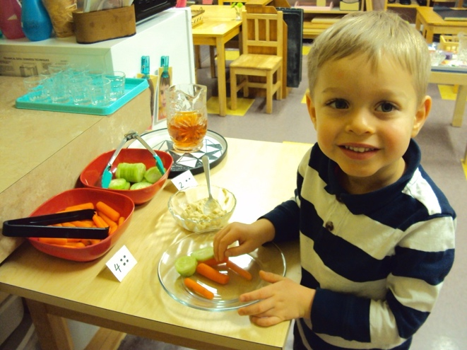
The children prepare their own snack each day, as Nick is doing here
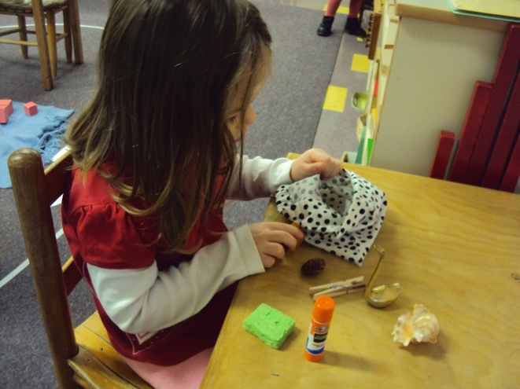
Lydia is discovering the contents of the ‘Mystery Bag’ by just feeling the objects.
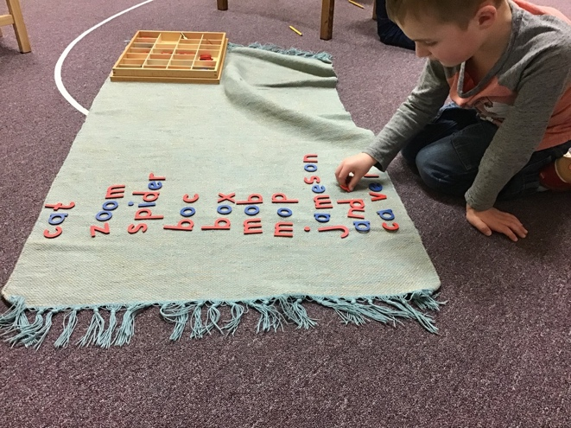
Carver has been building words letter by letter as he analyzes the sounds he hears

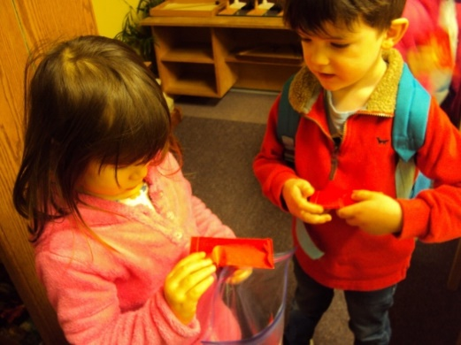
Abby and Ethan have been sharing their family holiday traditions with us, teaching us how to celebrate the Chinese New Year.
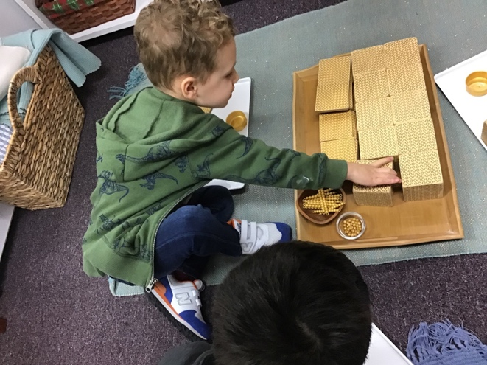
Landon and his friends have been working with the golden bead materials, making large quantities with thousands, hundreds, tens and units. We will soon do the same with the number cards as well!
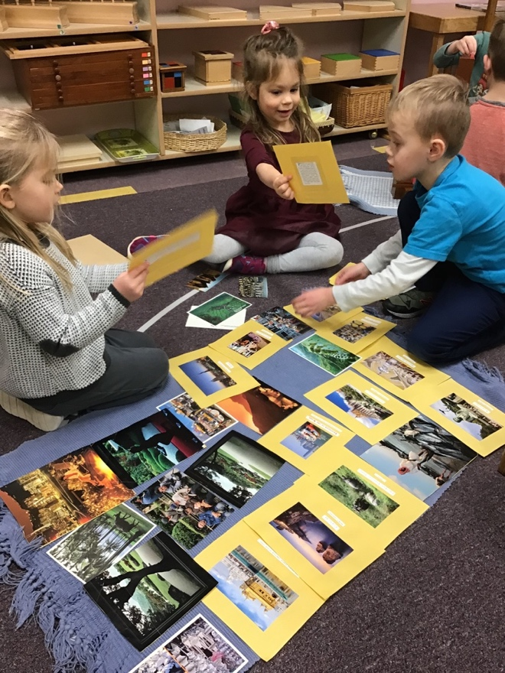
With great enthusiasm, Ivy, Nadine and Jameson explore pictures of how the people on another continent live.
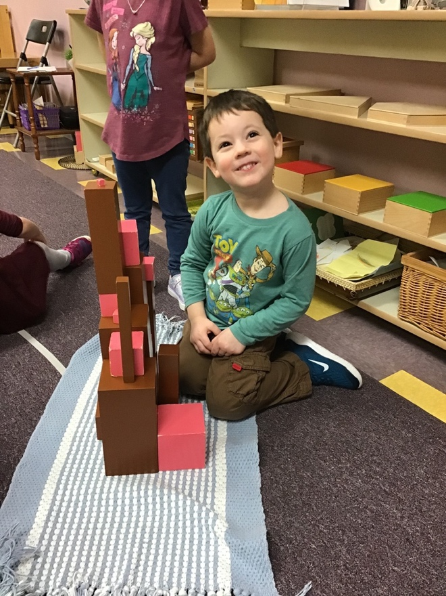
This smile shows the pride and joy of happily doing great work!

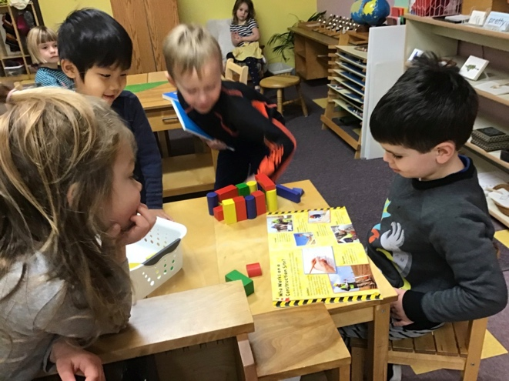
Inspired by a great book about construction here was moment thinking about how it is done.

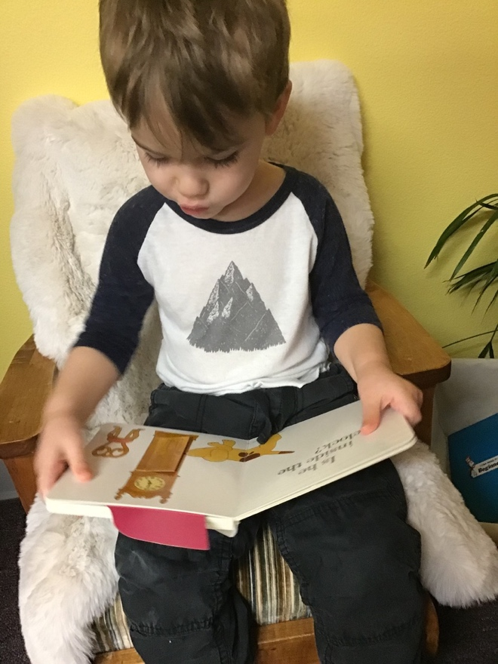Quinn is engrossed in the tales of Spot, the puppy, and his mom.
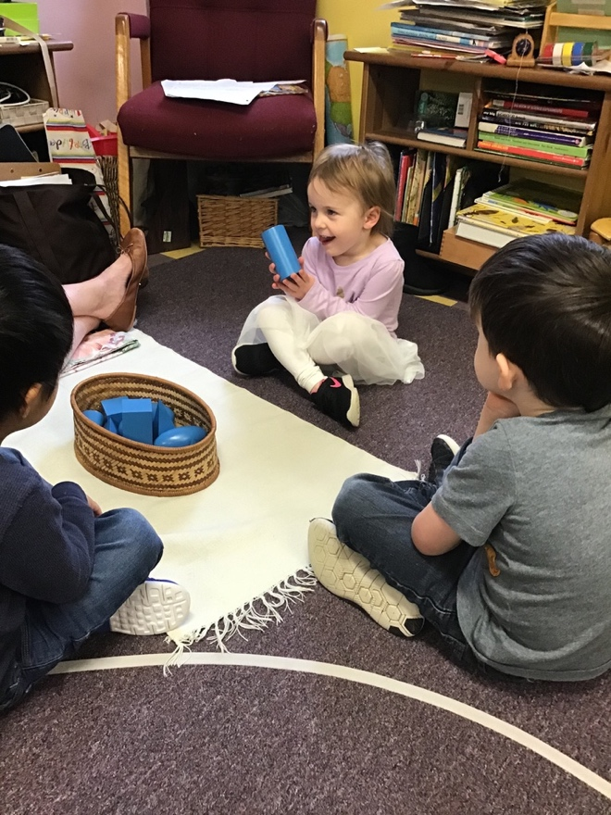Learning the names of the geometric shapes, Payton experiences how the cylinder feels.
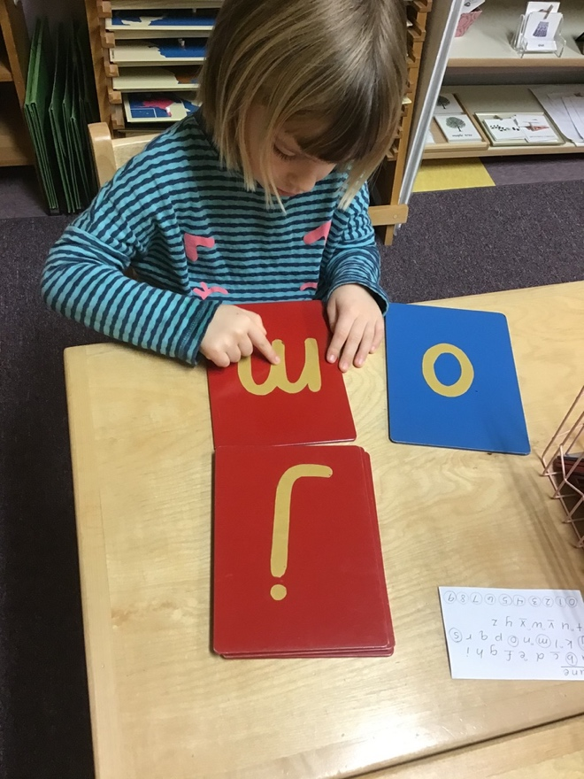
June really wants to know all the letter sounds! I think she has her eye on making words with the moveable alphabet.
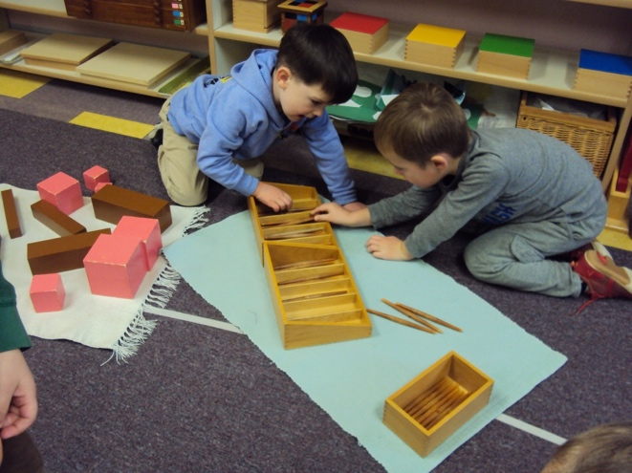
This friendship between Carver and Archer often brings them together laughing, sharing ideas, working or sharing apple cutting.

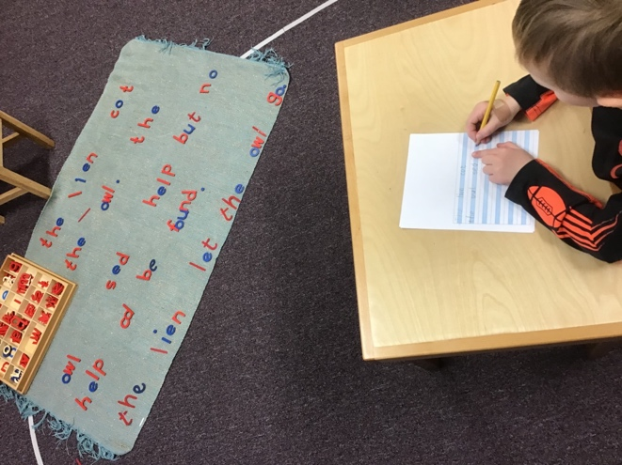
That lovely moveable alphabet makes creative writing quite easy and fun.
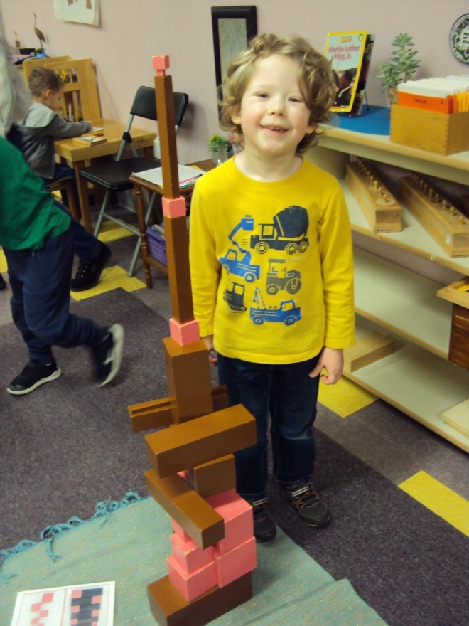
The brown stair and pink tower are a source of endless possibilities, as Grayson has created. Check out the top of this tower.
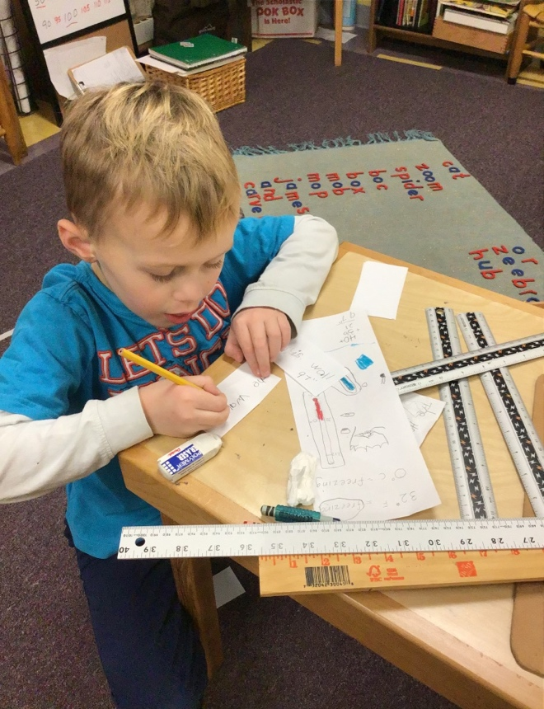
Jameson (and Carver) have been measuring the room and various things within it using both inches and centimeters. The classroom wall is 97 inches high, in case you were wondering.
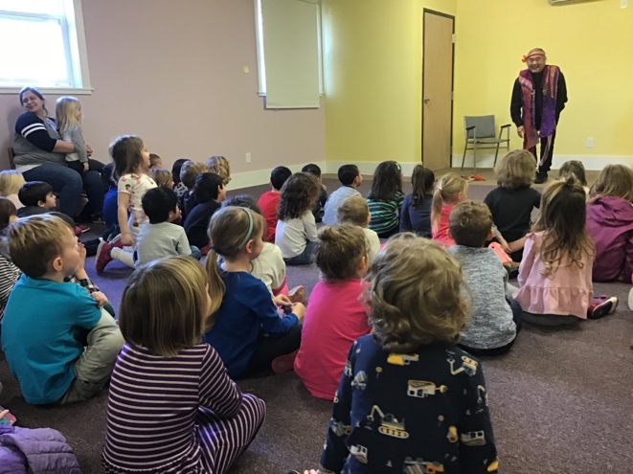
Spellbound by such an animated story presented by Eth no tech. The stories and musical instruments were from Asia.

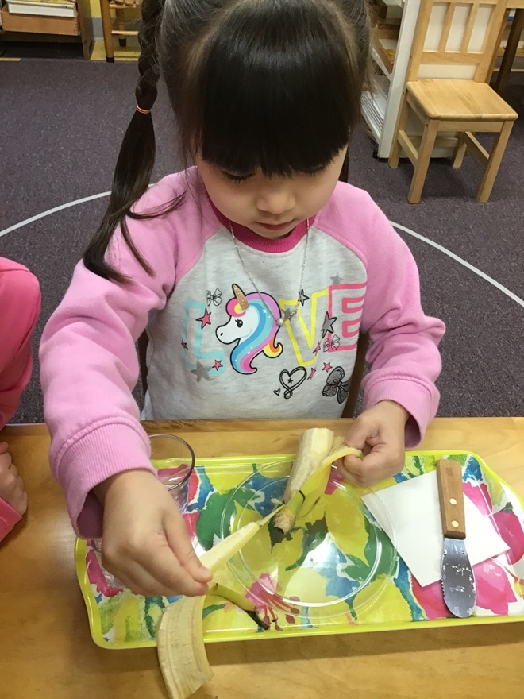
Ellie prepares to cut a banana to share with her classmates, the joy we all find in being a host.
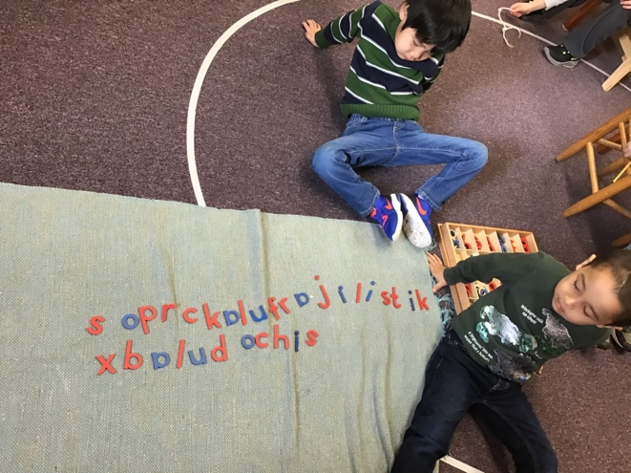
Can you read (or sing) this creation Richy and Ethan made together?
Ta ta until next time!
Happy Valentine Day, with love to you wonderful parent of great children! Cindy

