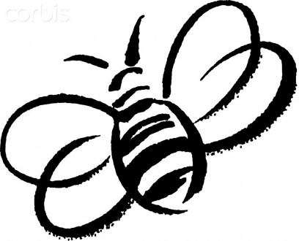
January Buzz from the Bumblebees

Welcome to the New Year! We started January off with everyone excited to come back to school. The children all missed their friends and we enjoyed hearing all the stories of their winter break. We started having the children wash their snack dishes. They love it! Together we noticed how many paper plates and cups we were using and just throwing away, we all agreed it was very wasteful. You can help us out by remembering to pack your child’s lunch in a microwave-safe container if it needs to be reheated. We are going to assume that if it is not in a separate container, it does not need to be heated up. Also, your children have learned how to wash and rinse plates quite well, have them try it at home!
Group and Sharing time have been going well. The kids love taking a turn to talk to the class about something special to them. Helpful ideas for sharing are a favorite book, pictures of pets, friends or family, a special rock or other object they found outside. Please help us by not bringing in toys for sharing, thank you!
We celebrated some birthdays this month: Richard turned 4, Sky turned 4 and Levi is turning 3 at the end of the month, happy birthday! We have been talking about the Arctic and the animals that live there. Ms. Danae came and visited our class, the children were so excited to see her and give her lots of hugs! She has decided to stay home with her new baby for the rest of this school year. Luckily, Ms. Sara has been a wonderful addition to our classroom this year and
she is happy to stay with us!
We will be having a Valentines party on Thursday, February 13th. I will send out a list of the children’s names this coming week. Conferences will be coming up in mid-March as well so be on the lookout soon for signups..
~Jessica and Sara

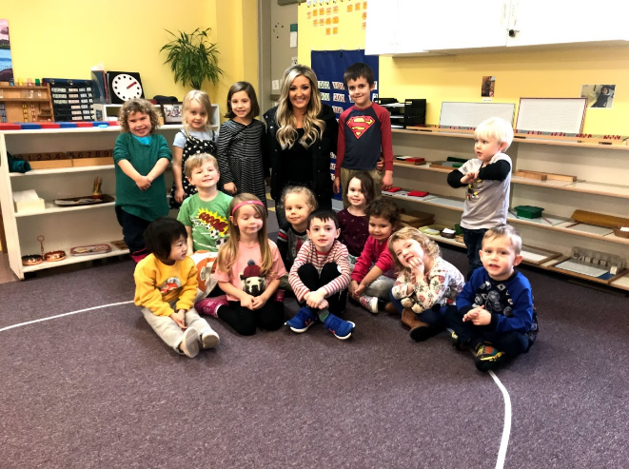
Ms. Danae surprised the children with a quick visit! We show the class pictures of Brielle and even FaceTime Ms. Danae and Brielle every now and then. The class really enjoys that!

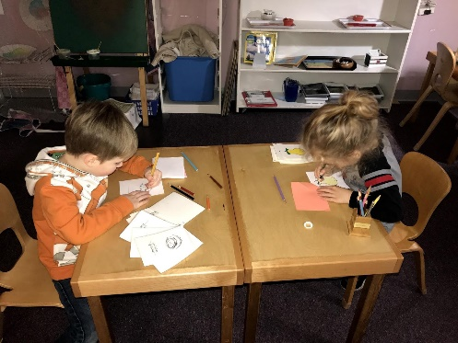
Bennett and Kahlil working on parts of books.

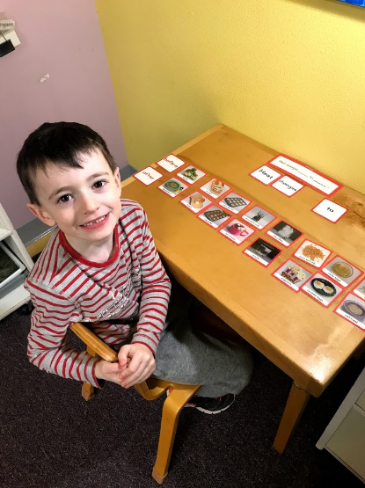
Euan working with science cards.

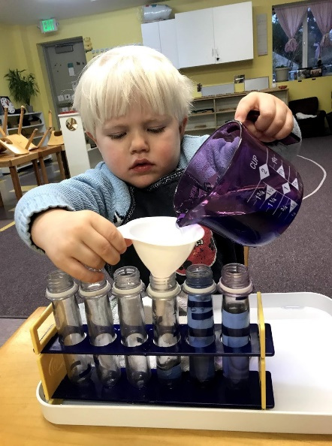
Levi working with a pouring work.

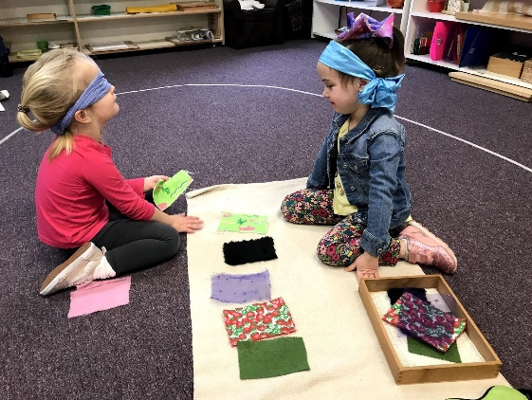
Emma and Leia using the fabric boxes.

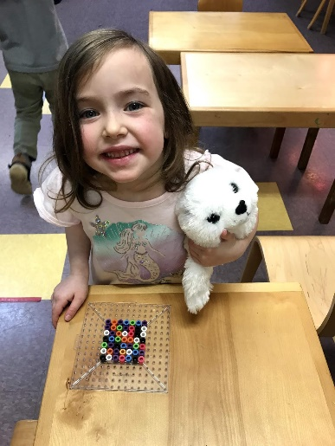
Leia and the fusion beads, working on her pincer grip.

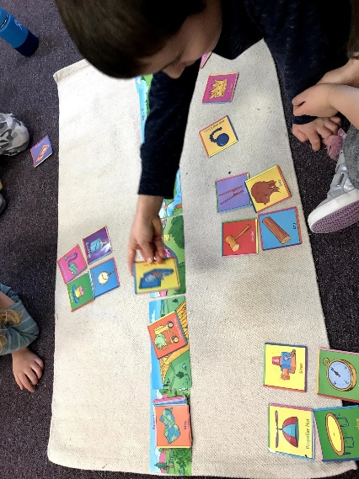
Owen really enjoyed the “Obstacles” game we played with the kindergarteners.

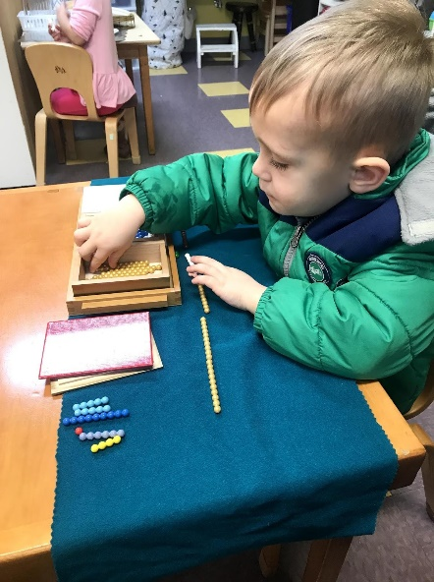
Richard is learning how to make 10’s with the snake game.

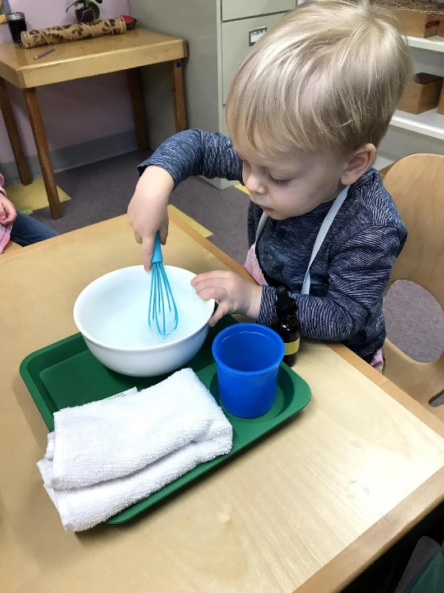
Jake and the bubble whisking lesson.

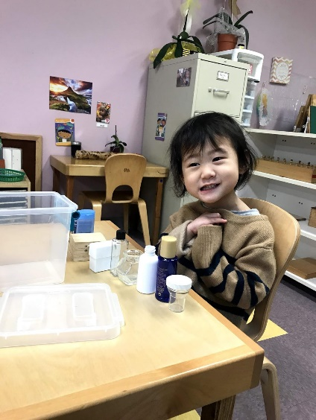
Ashley is quite proud of her with the opening/closing work. She finally got all of the lids back on by herself!

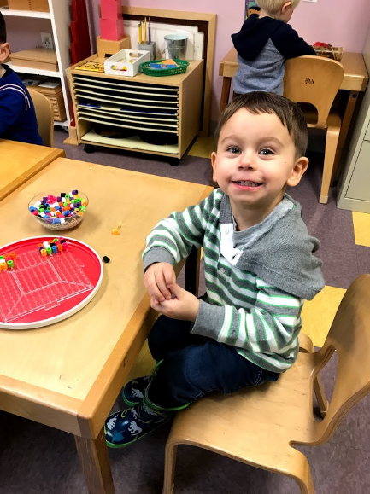
Nehemiah’s favorite work right now is the fusion beads. He makes many different patterns and designs with it!

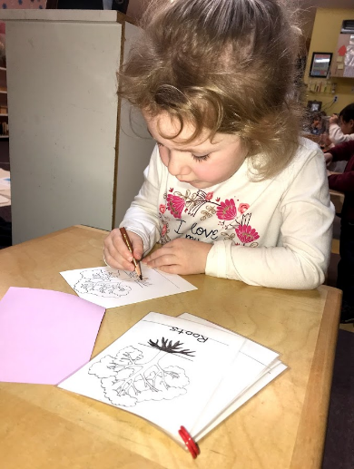
Abbie enjoyed her new lesson on parts of books.

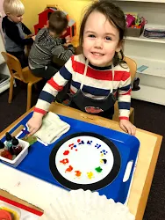
Phoebe loves the color wheel lesson and using an eyedropper!

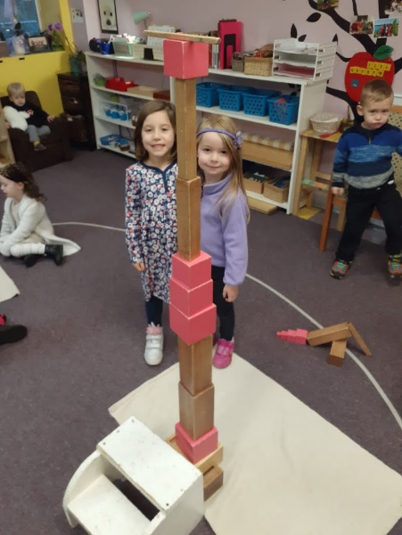
Mackenzie and Eleanor made a new design with the pink tower and brown stairs.

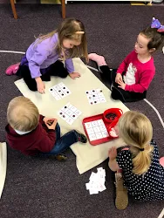
Eleanor, Leia, Emma and Jake are using the sound bingo game together.

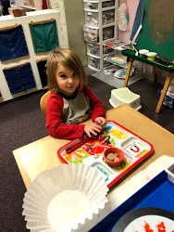
Findlay is exploring with the
magnetic and non-magnetic work.

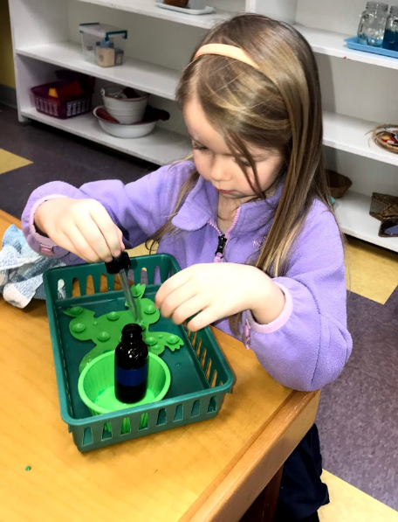
Eleanor is refining her pincer grip with the eyedropper work.

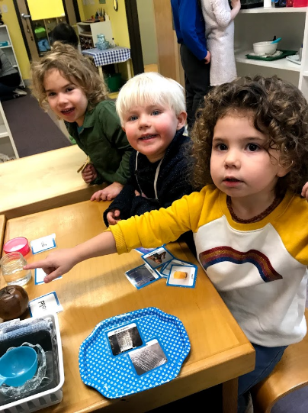
Sahalie, Levi and Sky are learning about the Three States of Matter with our science lesson. They are learning about solid, liquid and gas.

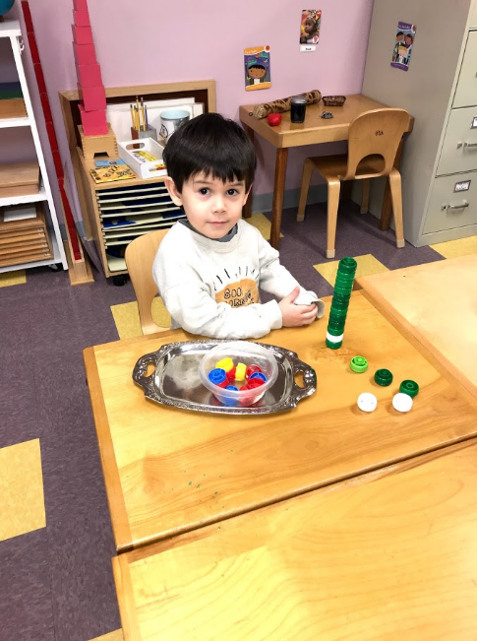
Here is James building a tower. We noticed that the children always play with their applesauce and yogurt package lids. Ms. Sara started saving them, she washed them, then put them on the shelf for the children to use. They love this work! We really pride ourselves on following the children and their interests and sometimes the things most adults see as garbage, we see as a great tool for building up those fine motor skills and hand muscles! The children enjoy stacking the lids and making towers and they enjoy seeing who can make the tallest before it falls over. They also learn that some lids do not fit or stack well even though they look the same.

