Happy New Year,

We’ve had a fun month of January. Your children are all doing great!

We have one birthday this Month. Riley will be turning 5 years old on January 30th.

We will have a parent information night on February 6th. Hope you can attend.
We will have our open house for all current families on Feb. 26. I hope to see you all there.

Here are photos of our classroom in action. Enjoy!

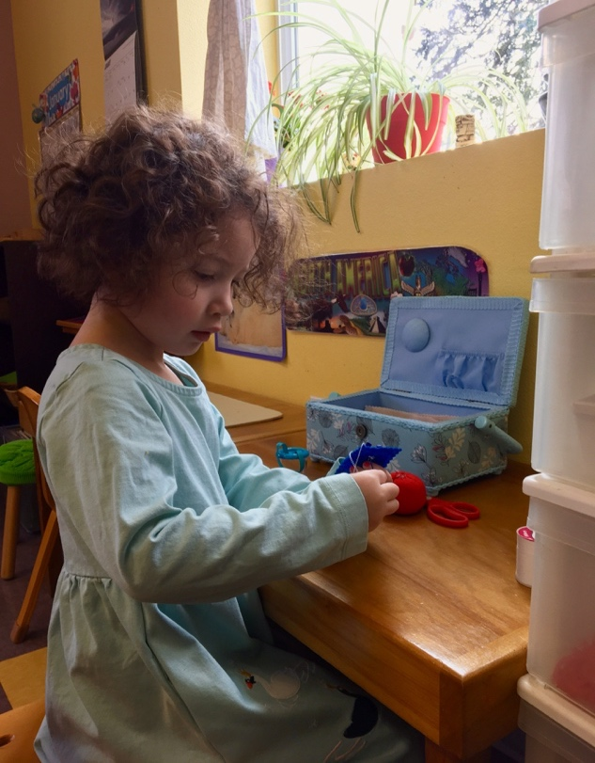
River sewing a button.

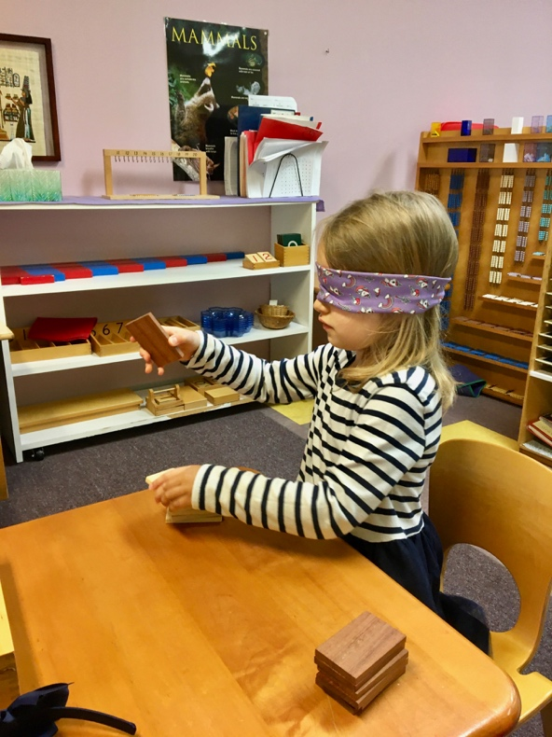
Cate sorting the “Baric Tablets” (sorting by weight).
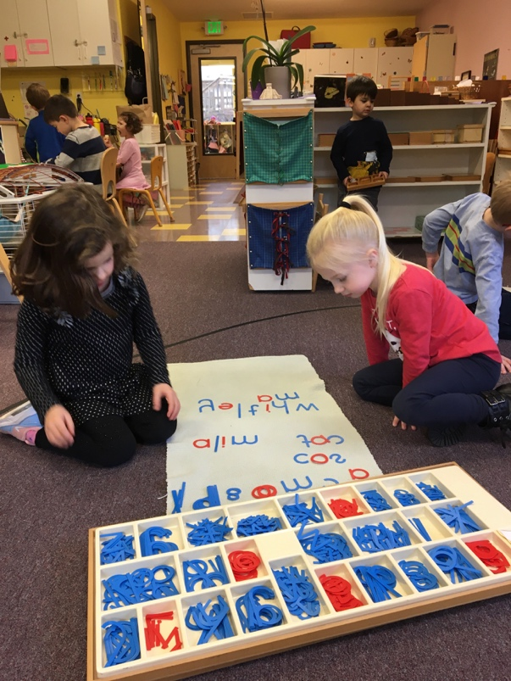
Whitley and Mila are building phonetic words using the moveable alphabet.
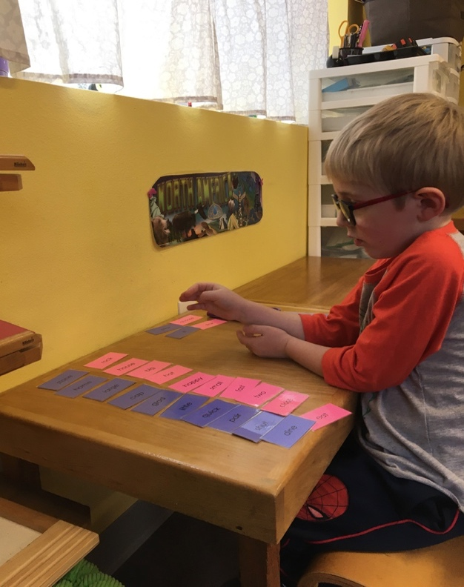
Anders matching words that mean the same thing. (Synonyms)
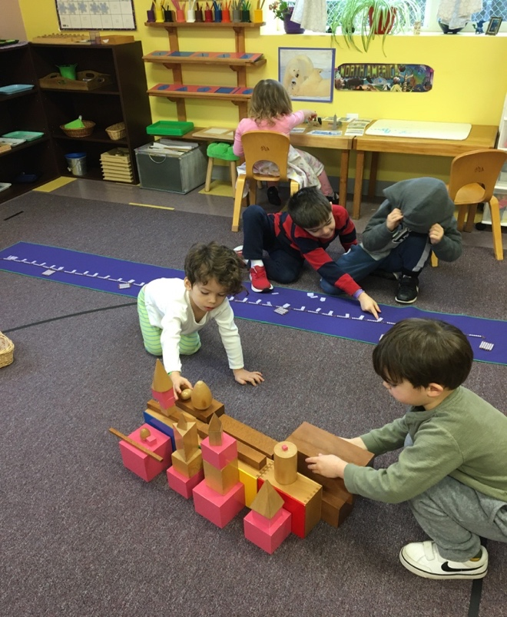
Adie and Blake building using the tower, stairs and geometric solids.
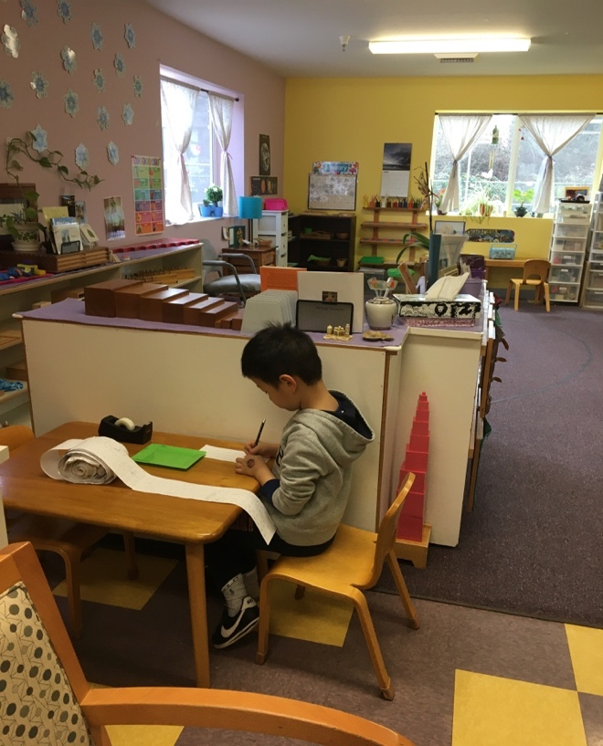
Raymond working on his number roll (He’s on the 4000’s!).
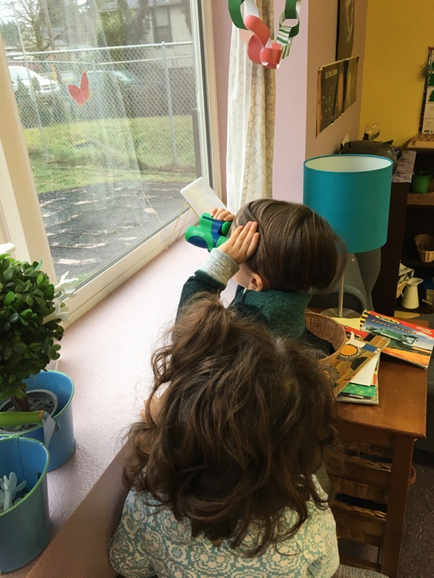
Riley using our binoculars to give us his weather forecast.

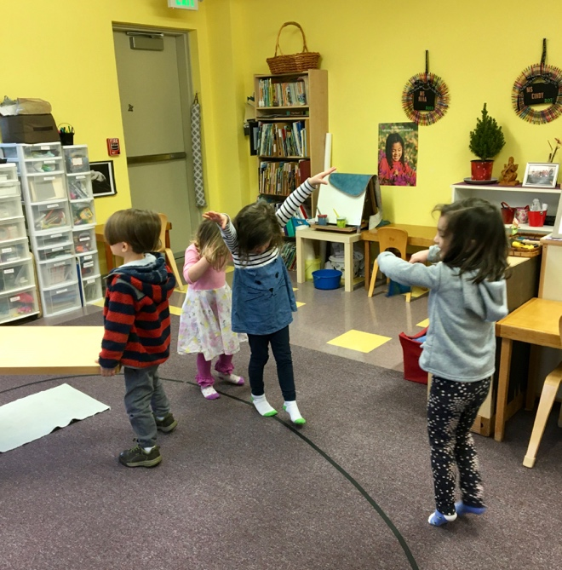
Lillian, Whitley, and Madelyn walking on the line to music.

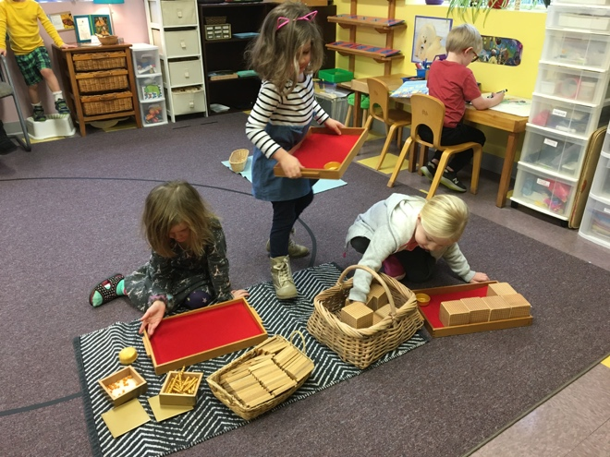
Jeweliann, Whitley, and Mila are playing “bring me”. I will ask each one to bring me a quantity such as, 4 thousands, or 5 ten bars, 6 units or 3 hundreds. This work is prepping for operations with the golden beads work.

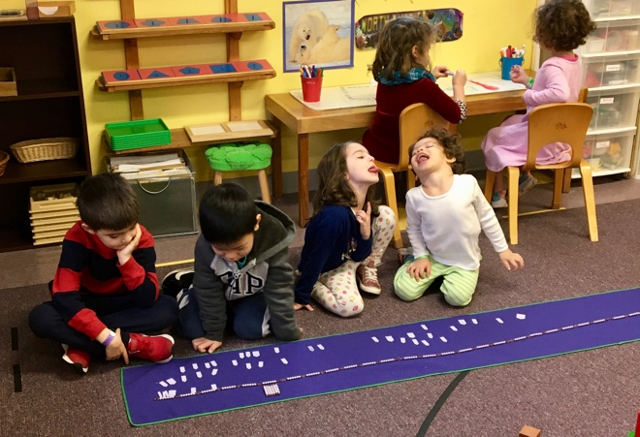
JD and Raymond counting the cube of six chain. Lillian and Adie being silly.

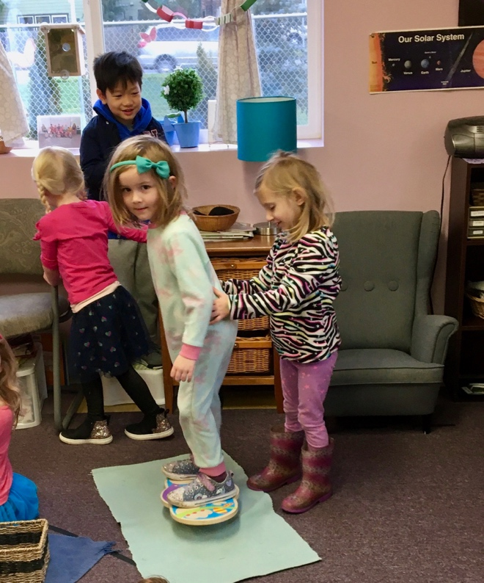
Jeweliann on our balance board
and Elise giving a little support.

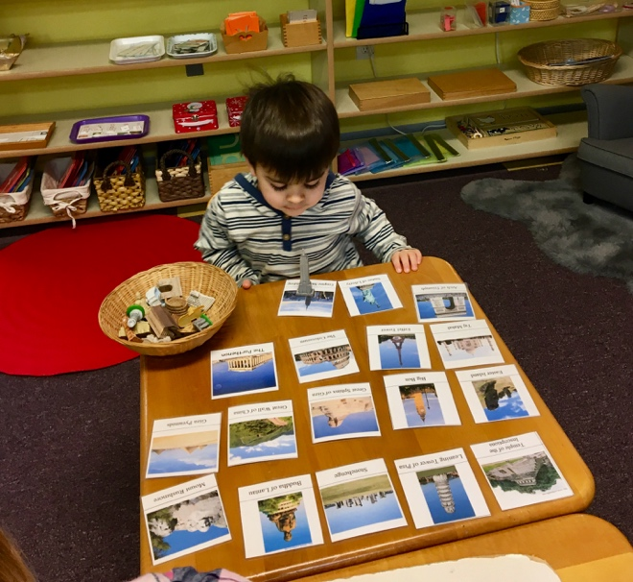
Aksel matching famous landmarks and buildings to their photo.

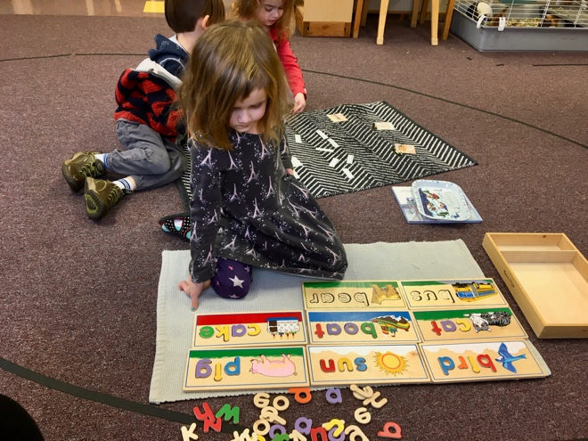
Jeweliann using the word puzzles.

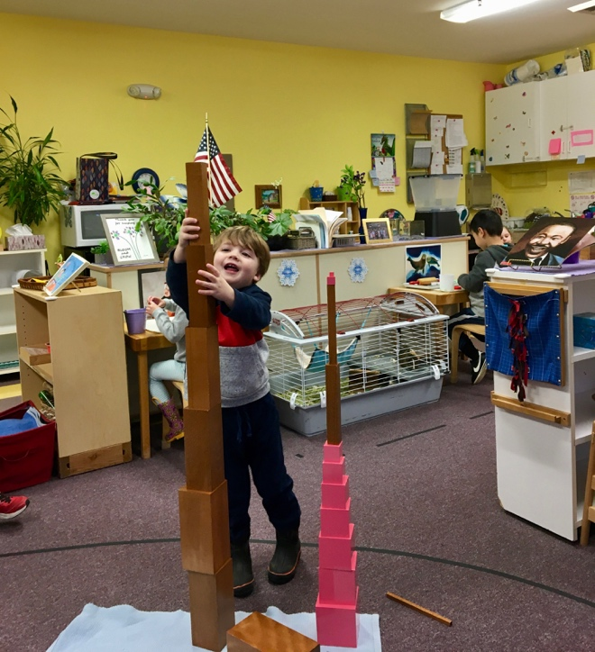
Kaden building two towers using the tower and stairs.

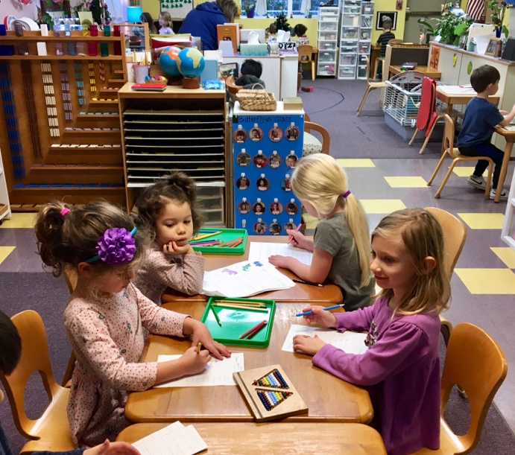
Adie and Mila are working on a letter sheet, while Whitley and Elise are working on a bead bar sheet.
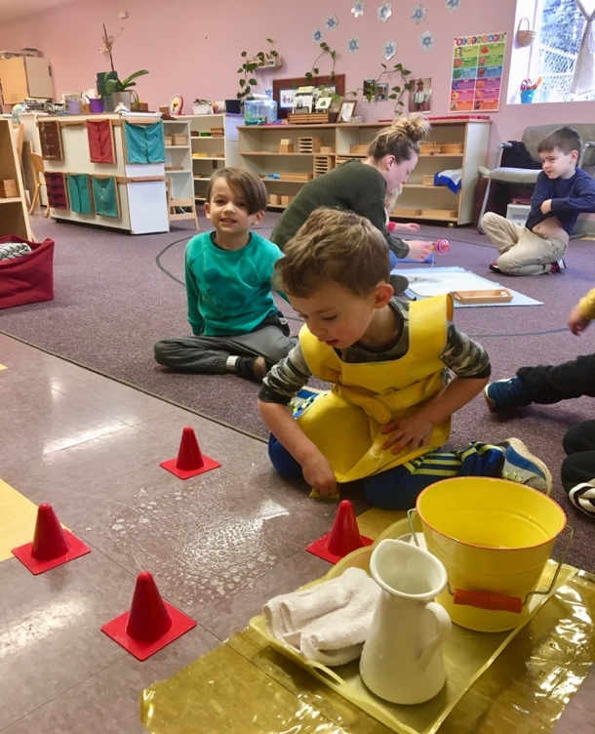
Ethan scrubbing the floor.

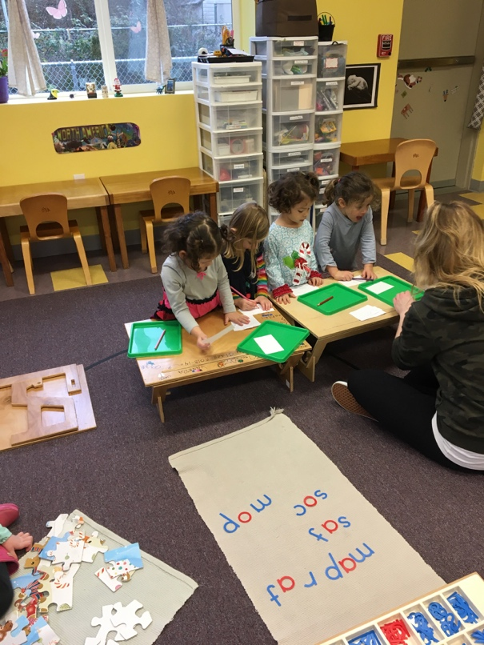
River, Elise, Adie, and Whitley writing words they built with the moveable alphabet.
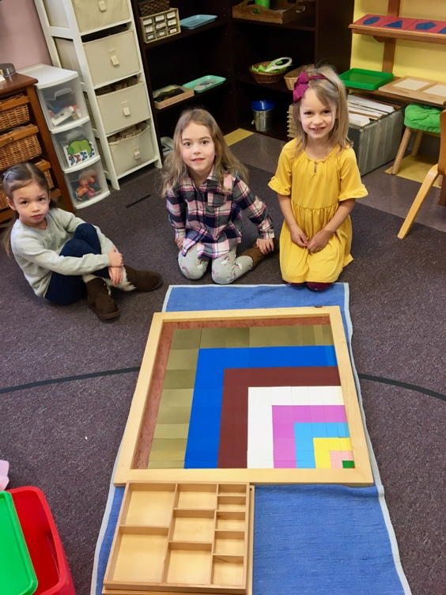
Hazel, Grace, and Cate built the Decanomial square.

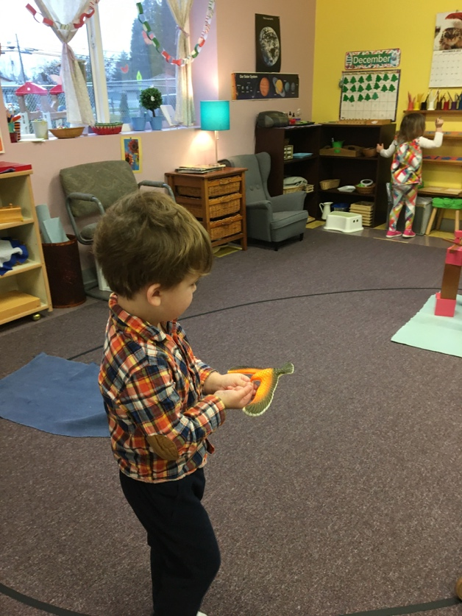
Kaden walking on the line.

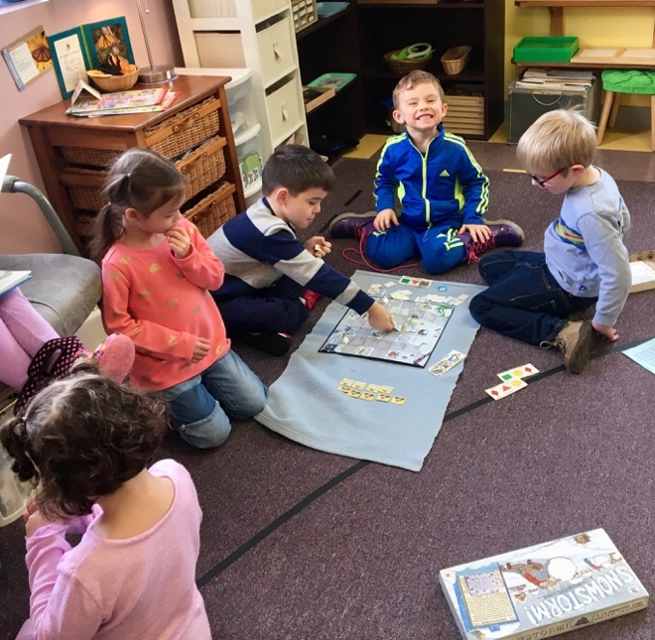
Hazel, JD, Ethan, and Anders playing “Snowstorm”, a cooperative game. The children work together to help four families complete their errands and get home.

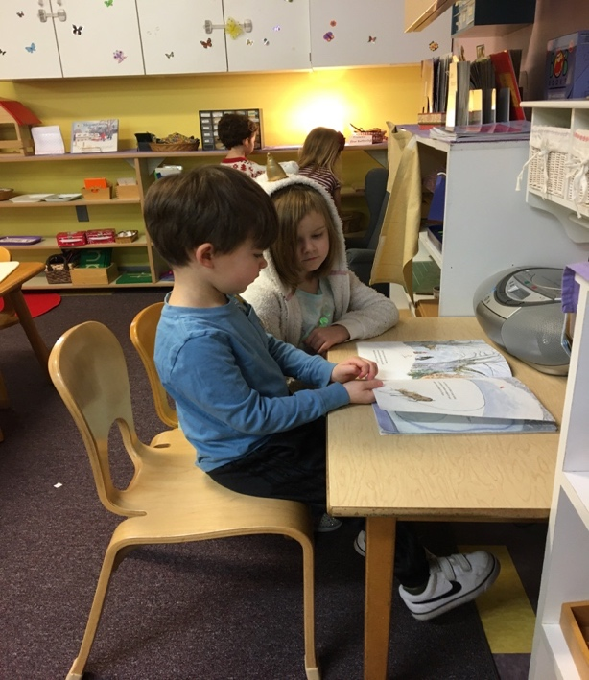
Jeweliann and Blake look and listen to an audio book.
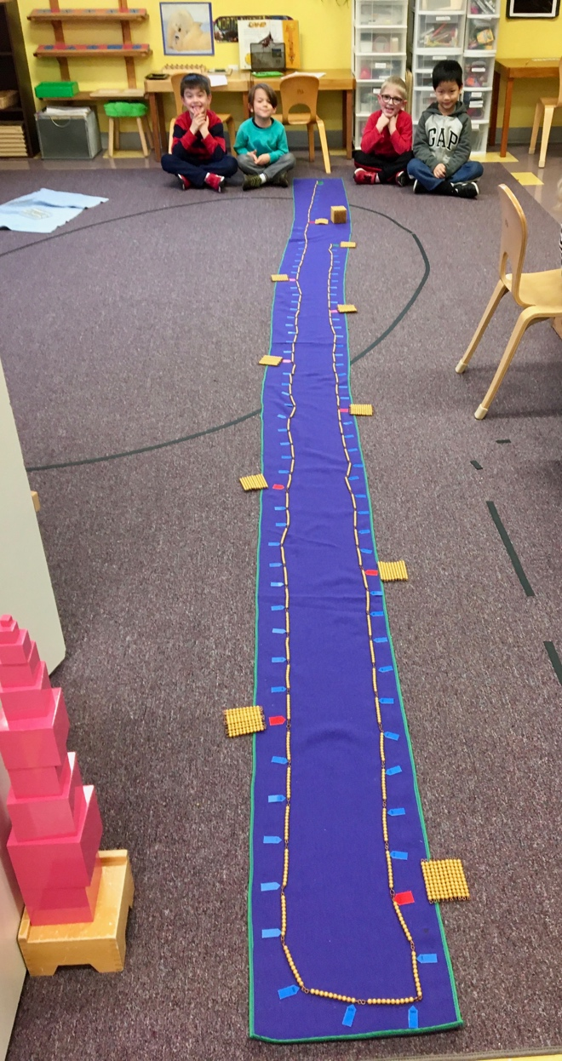

JD, Riley, Anders, and Raymond. “The Thousand Chain” (Counting by tens to 1000).

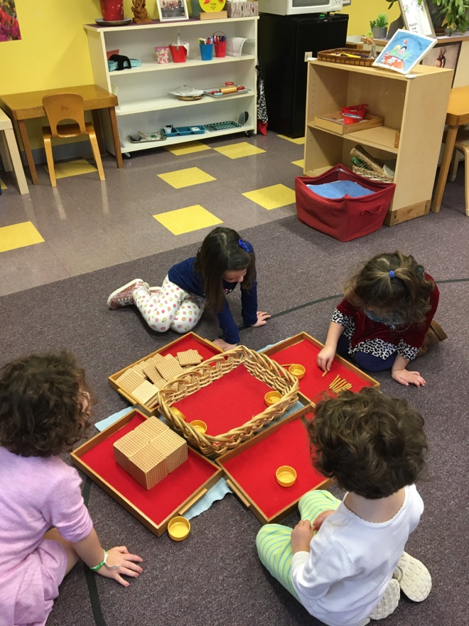
River, Lillian, Whitley, and Adie are doing the Change Game. In this game they count and make exchanges for the next category. Ex: 10 units for a ten bar, 10 ten bars for a hundred and 10 hundreds is the same as one thousand.

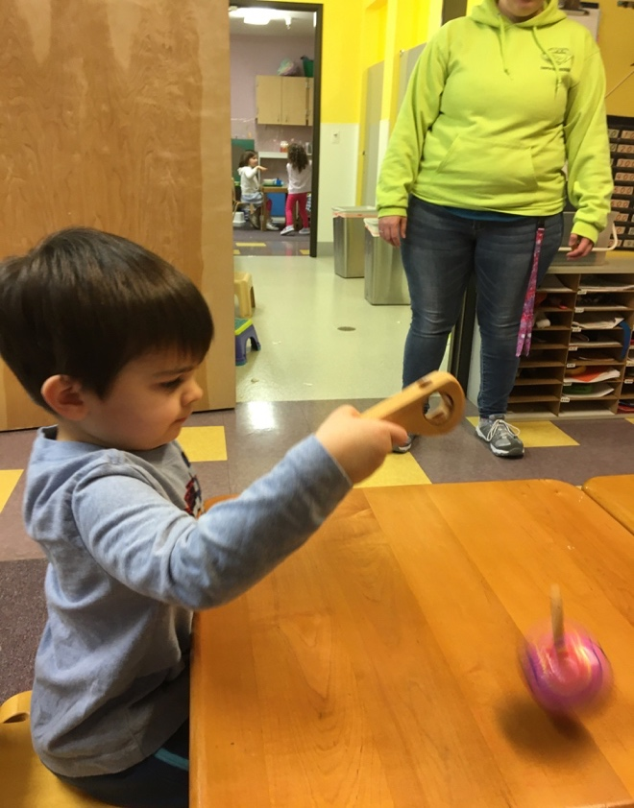
Aksel spinning the top.
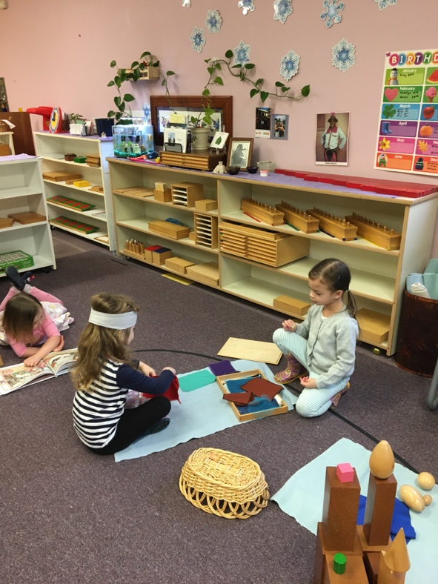
Grace and Hazel using the fabric boxes.
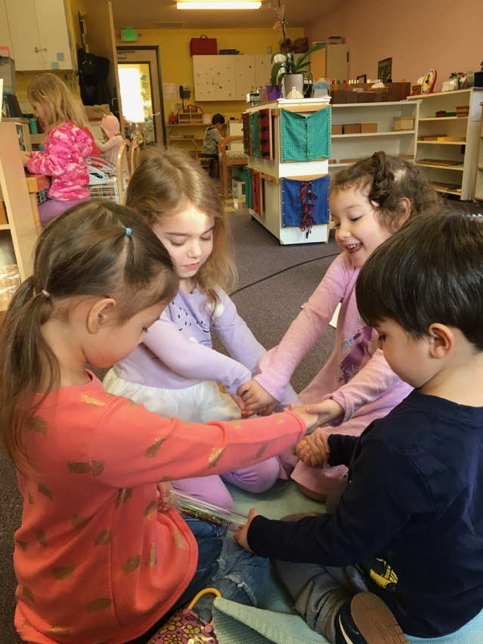
Hazel, Grace, River, and Aksel using the “Energy rod”. When they complete a circuit, it lights up and beeps!
There is constant movement and lots of growth and development going on. Every day is fun and full of discoveries and lots of great conversations. Thanks for sharing your children with us!

Ms. Nina and Ms. Cindy

