Hello CMS Families,

First of all, I want to thank you for attending the conferences. I know they are short, but I do always get some insight into how I can better support your children. On that note, we have a wonderful parent night soon on November 7th. This will be a great opportunity to get some practical tools to help support Montessori’s amazing method at home. Hope you can make it!
Also at conferences, many of you expressed wanting to know more about what your child is doing at school. So, we decided to add an open house to let your child show you some of their favorite works. This is my favorite event because, I too, get to see and learn from what choices they make. That is on Nov. 20th, early release Wednesday. Sign up for a 45 minute shift, so we don’t get too crowded in the room.
Thank you all for volunteering when possible. Our school relies on the families to
keep things running smoothly, such as: hot lunch, yard work, library books, morning drop-off and fundraisers. Please let us know if you want some hours, but have not been asked. There is always something.
Penelope, or Penny, turned 5-years-old this month and Bayr turns three. Please wish them a happy birthday if you happen to see them. Also, we welcomed a new family to CMS. We are thrilled to have Lilly join our class.
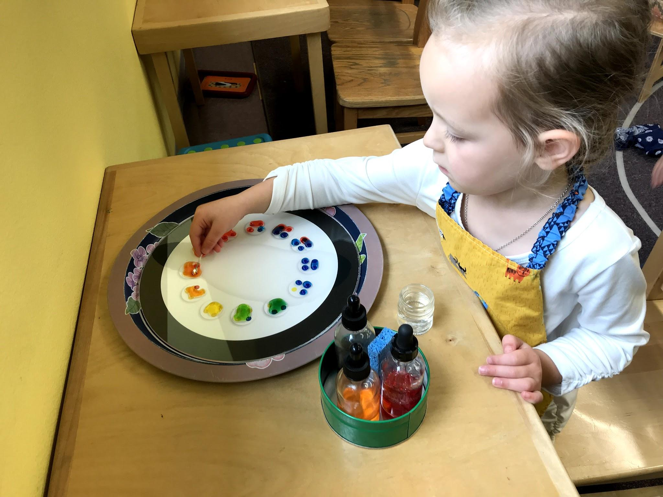
Lilly experimenting with mixing primary colors to make secondary
colors.

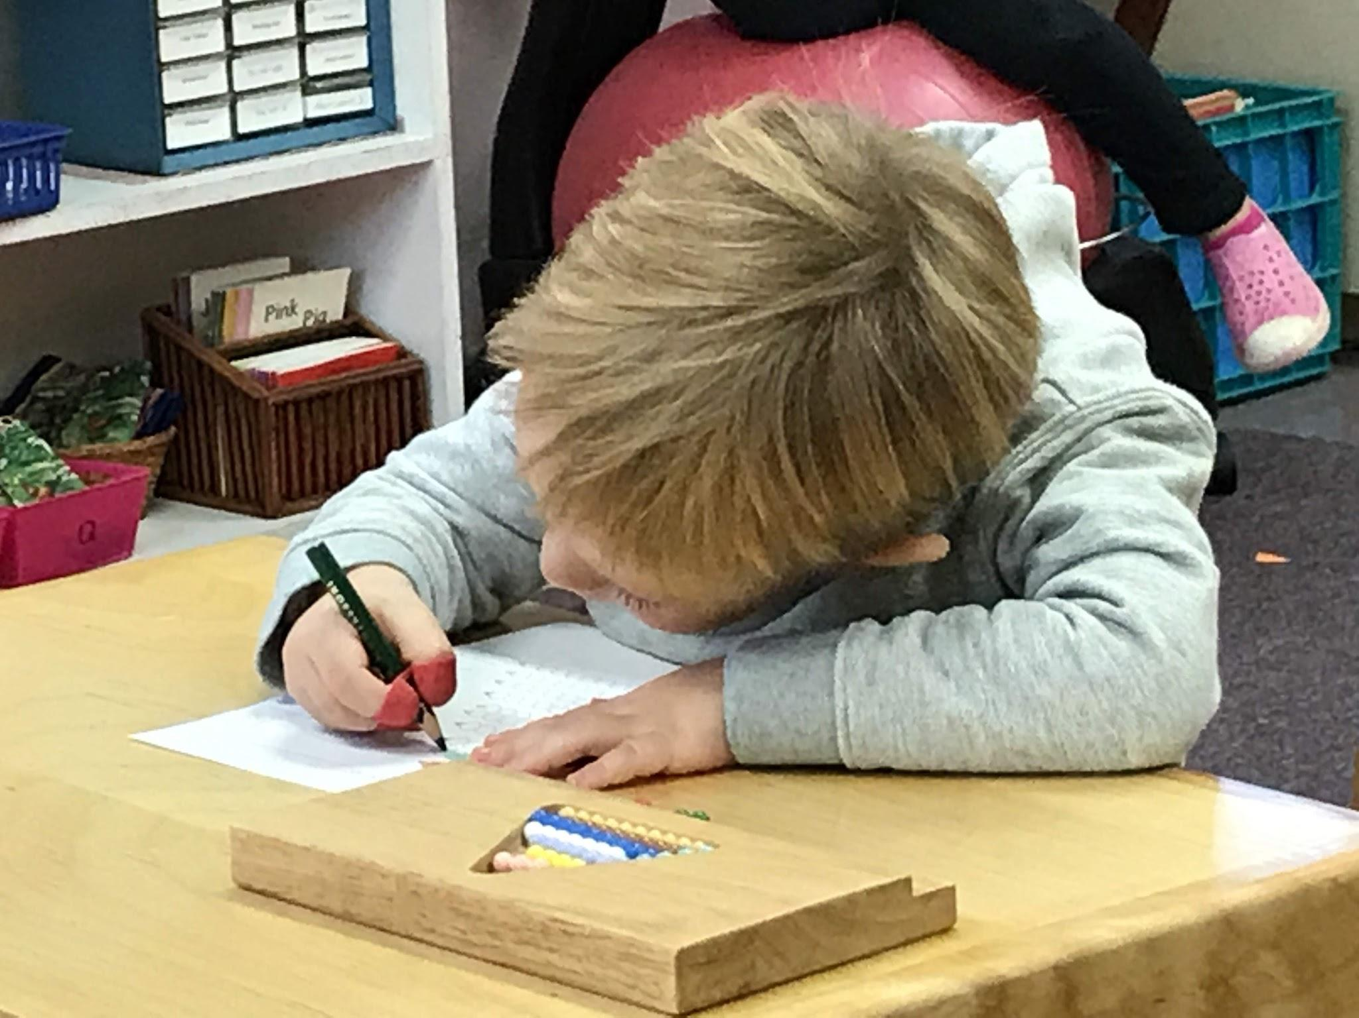
Rory working on numbers and pencil grip.

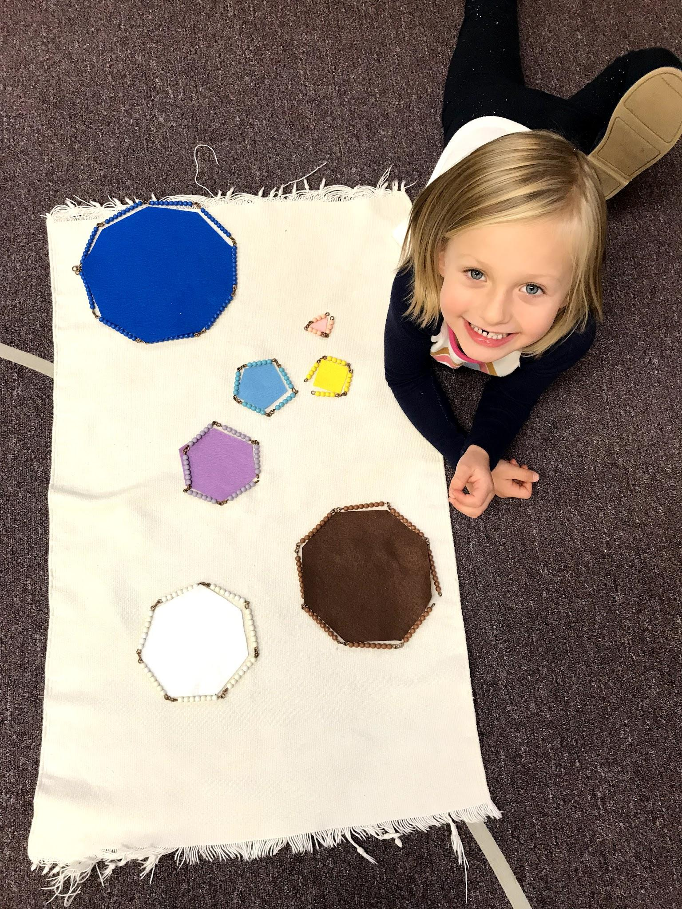
Kori discovering how the short (squaring) chains can make polygons.

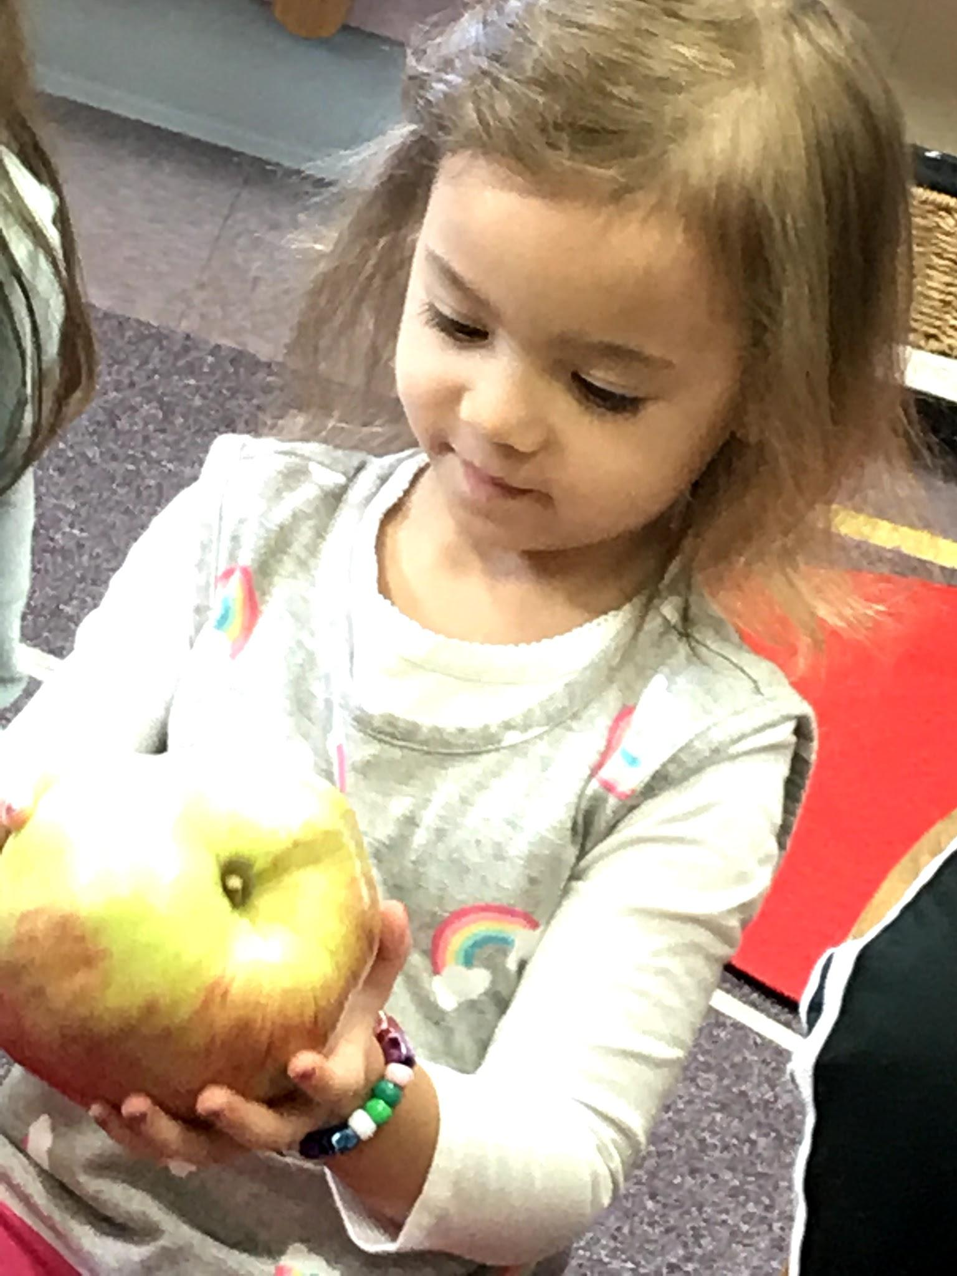
Thea taking a look at the giant apple Rory brought in for sharing.
Children can bring sharing in once a week.

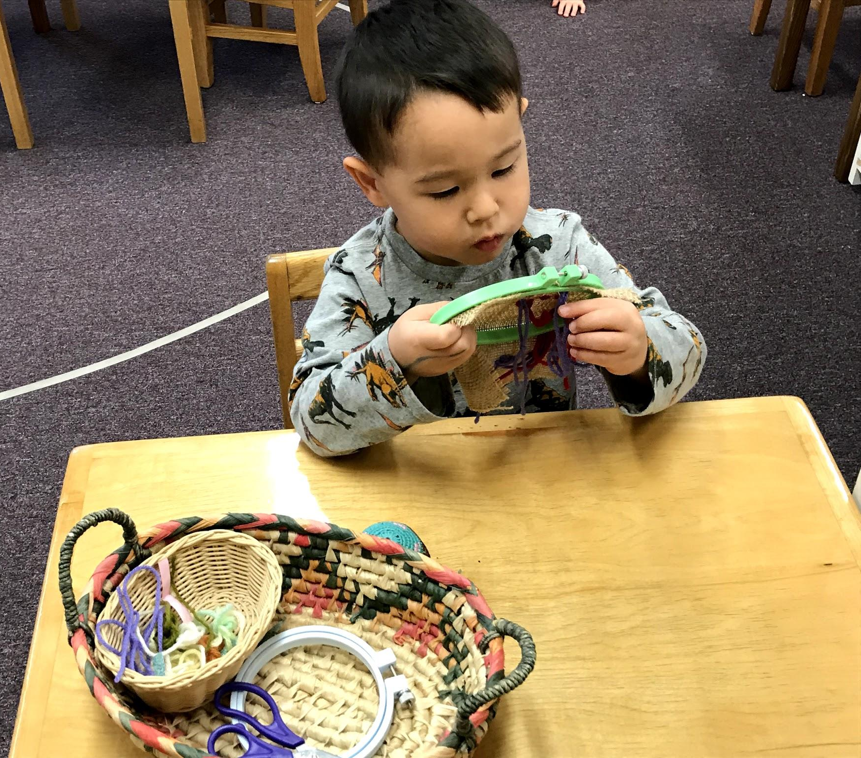
Nolan sewing on burlap. The lesson precedes embroidery sewing.

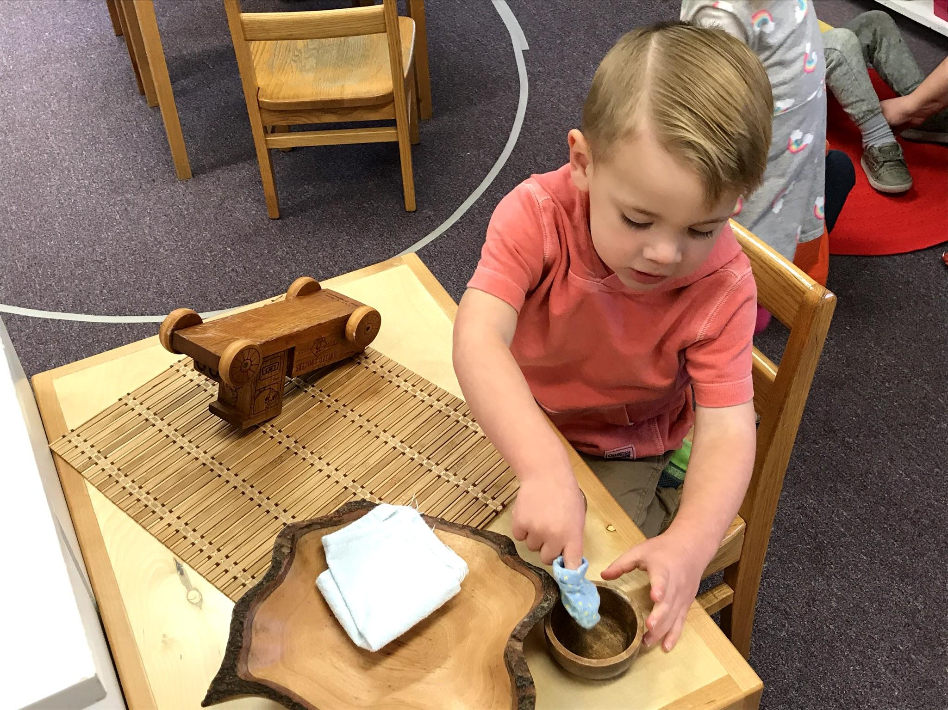
Creighton polishing the wooden truck.

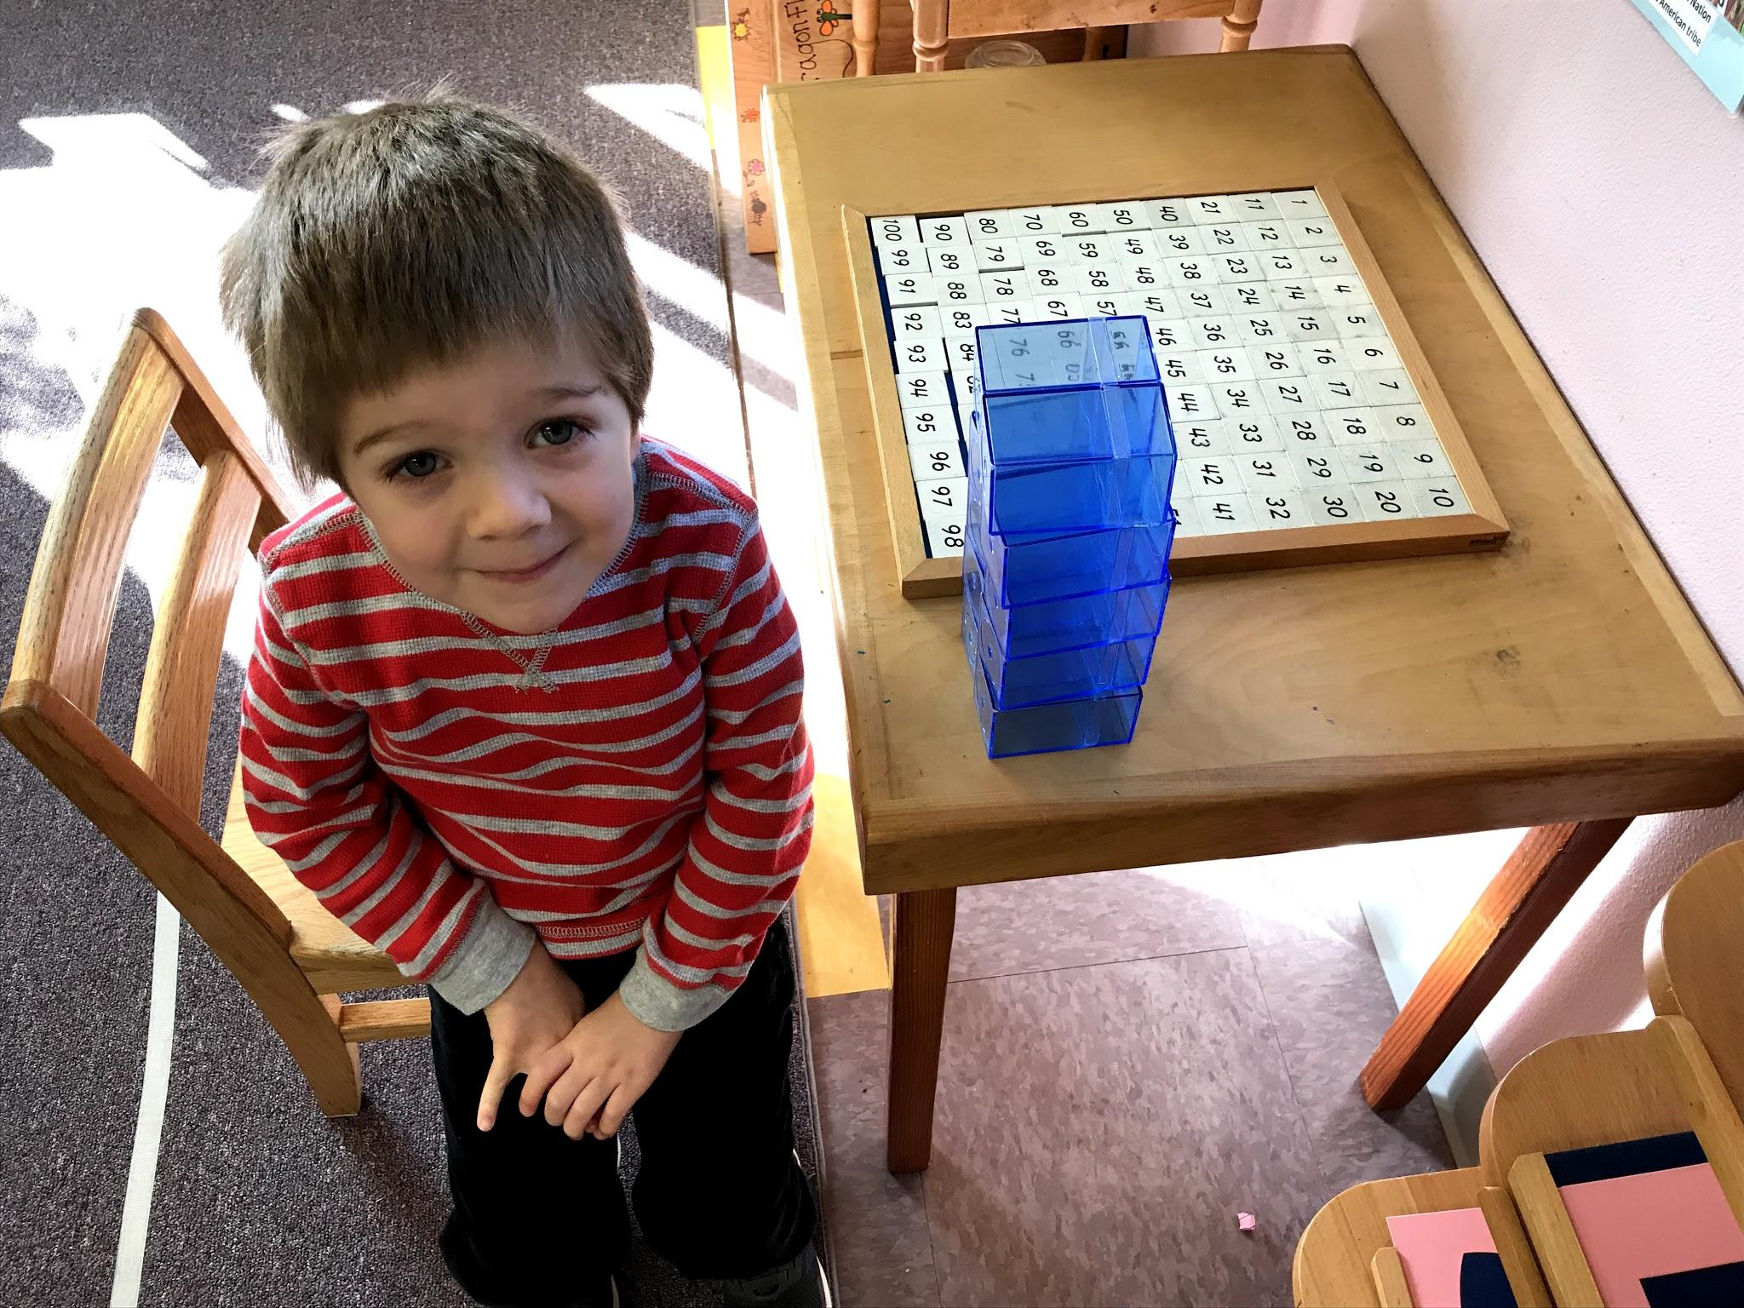
Lincoln completes the 100 board for the first time with no help. So proud of his determination.

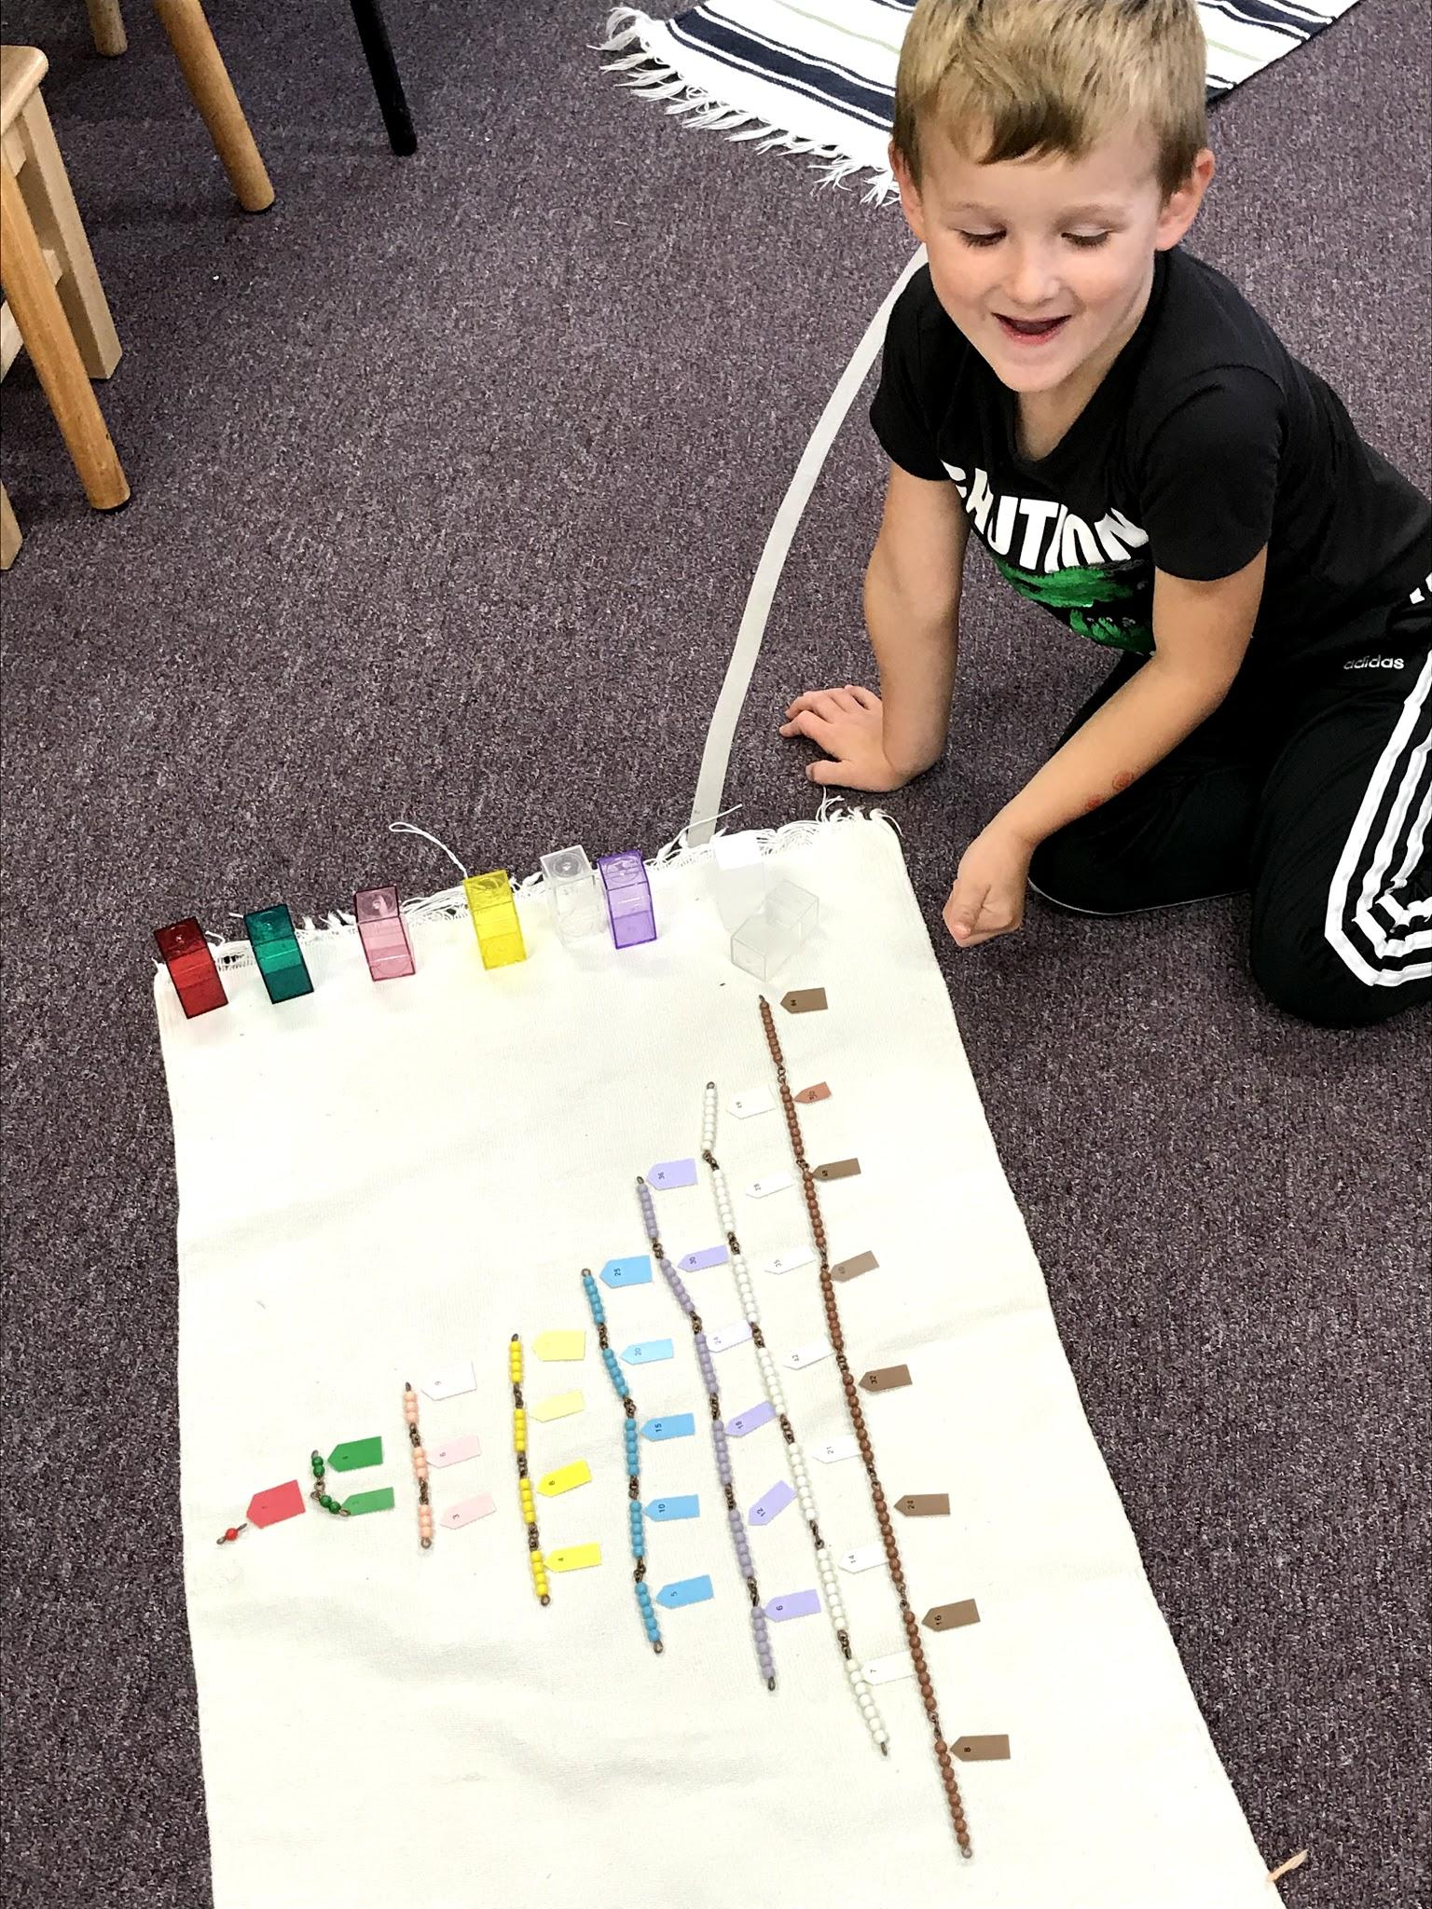
Jack counting all the short squaring chains, making a pyramid shape. The final label tells the result of each number squared.

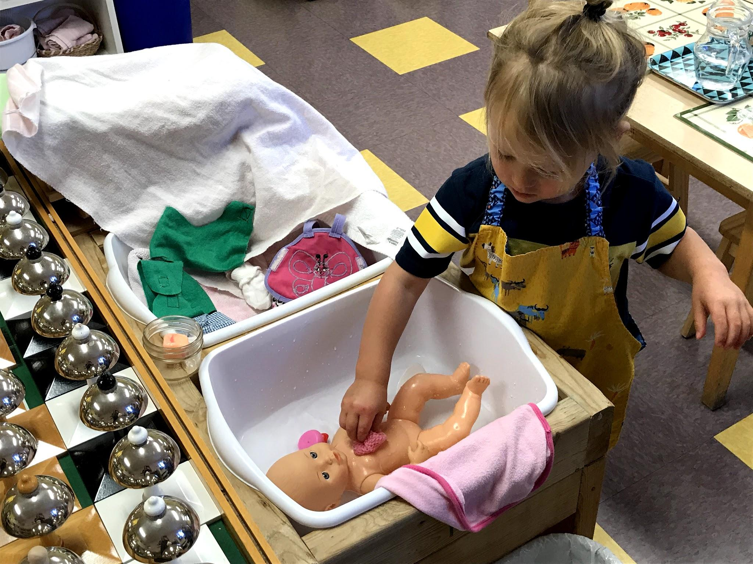
Merrick washing the baby doll. They dress and undress it as well.

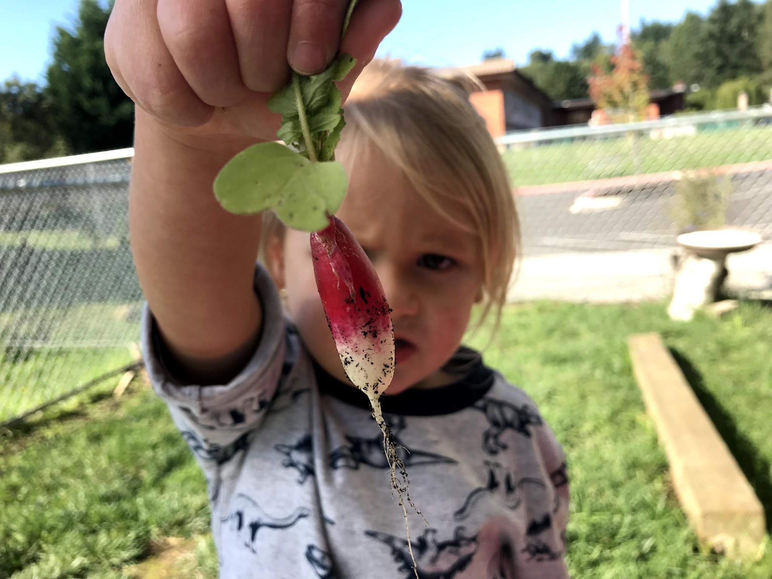Merrick checking out a radish we pulled from the garden plot out back.

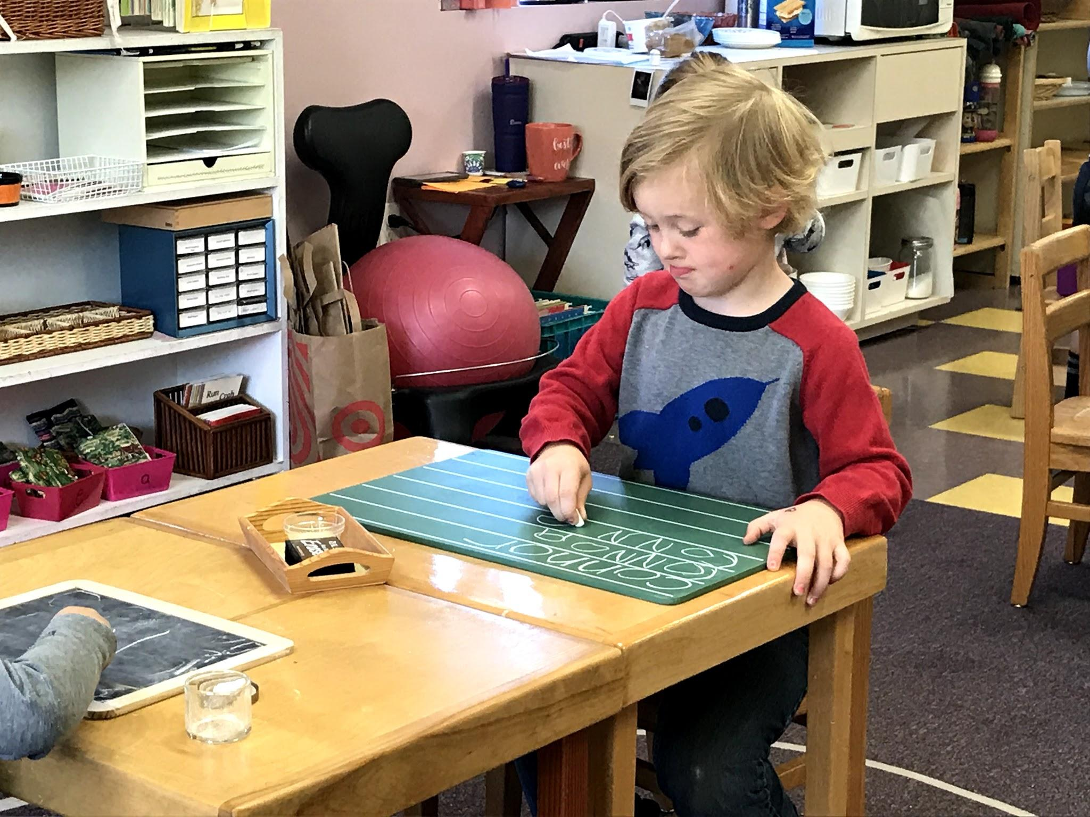
Connor practicing writing his name on the chalkboard. Using chalk helps with the correct pencil grip.

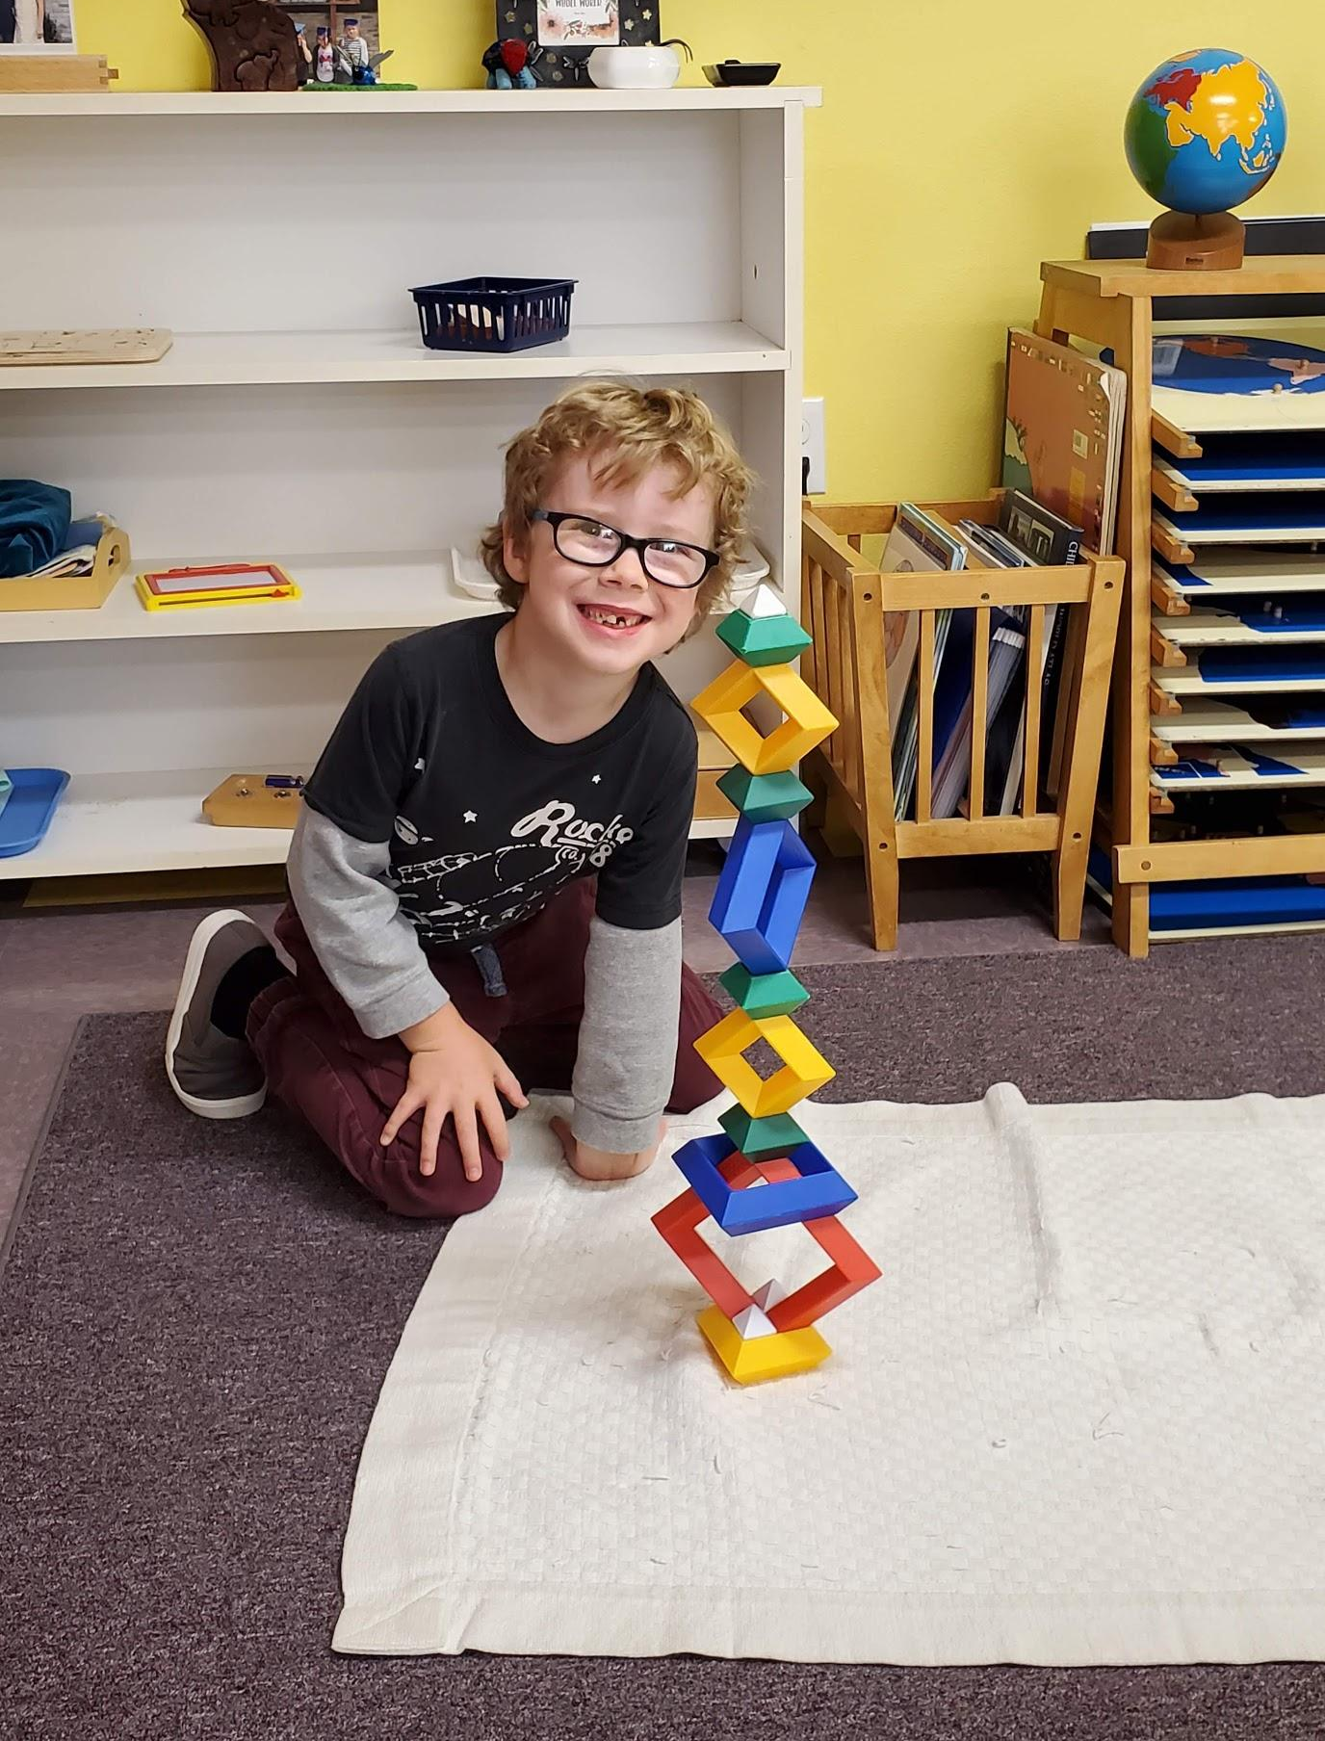
Isaac making some amazing towers with these shaped blocks. I am often amazed at what the children come up with.

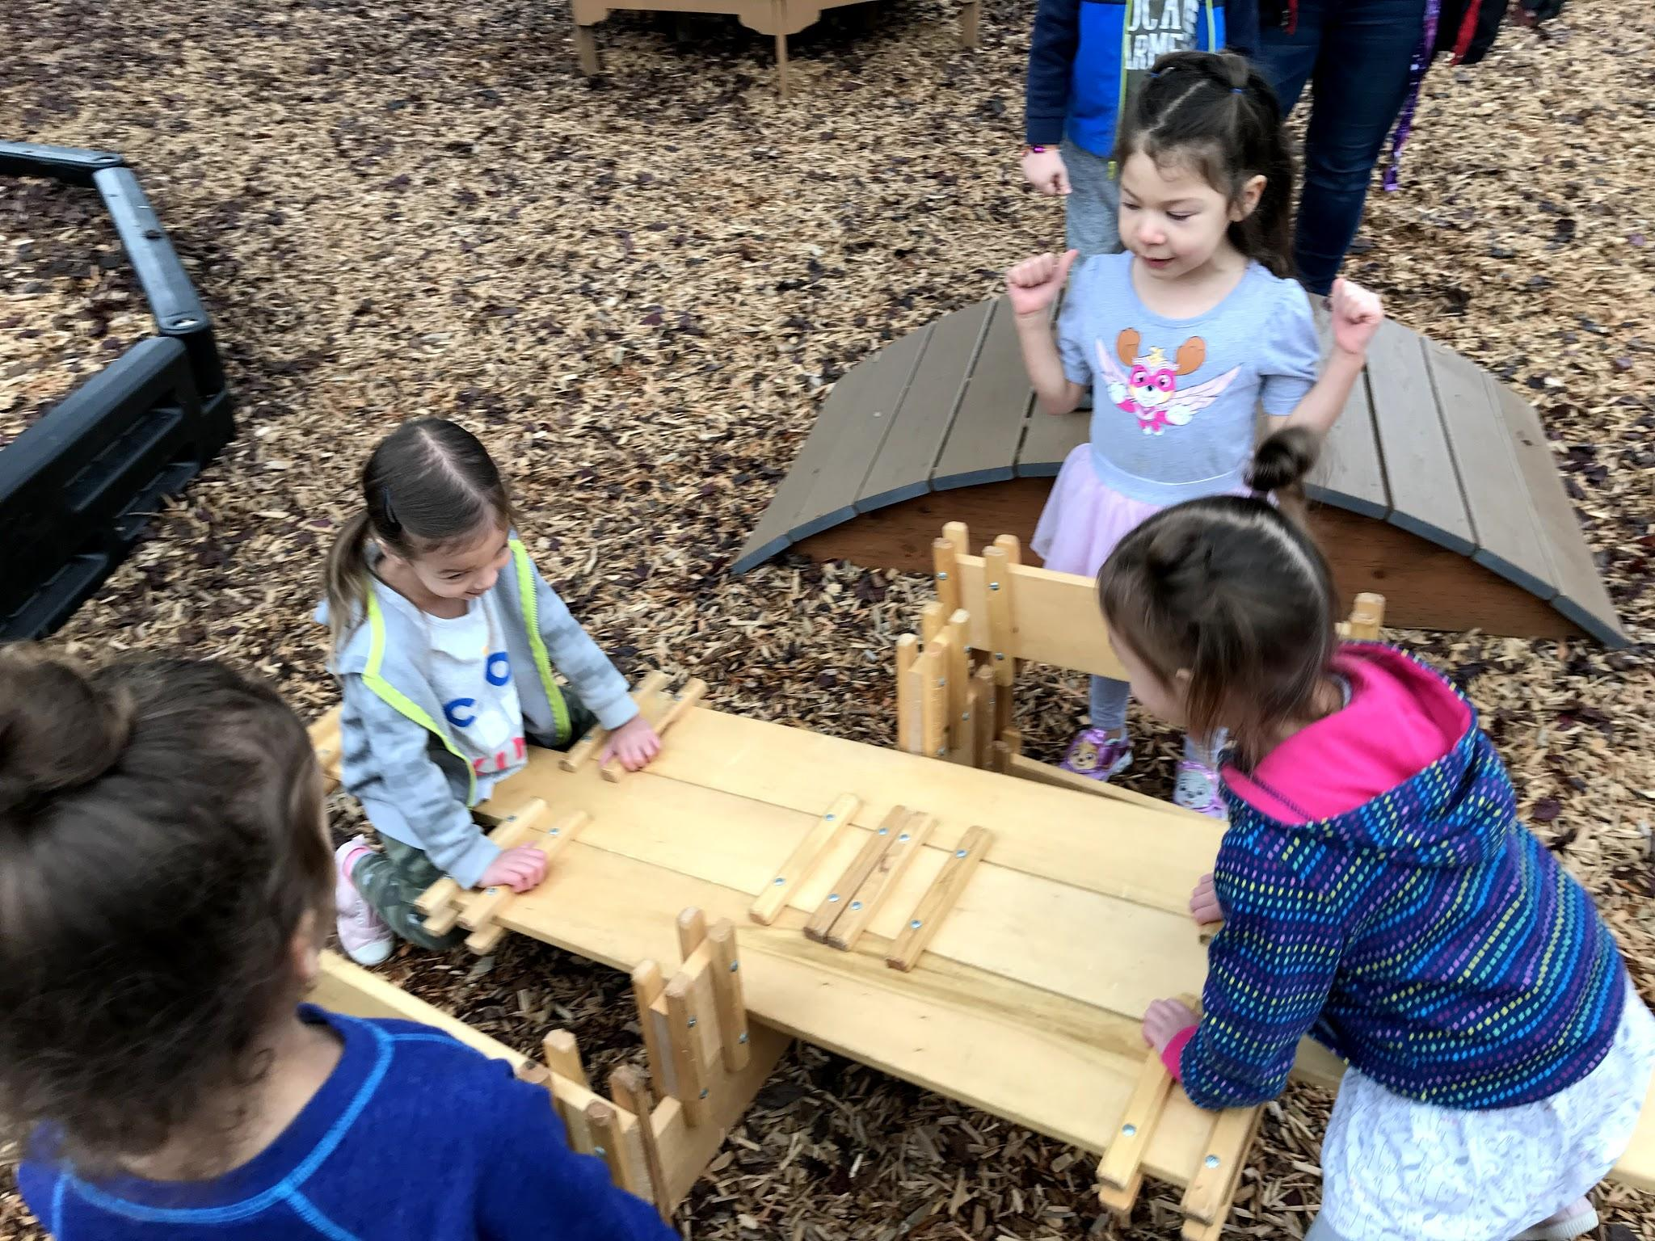
Rowe and Hazel sitting on the teeter-totter that the children built.
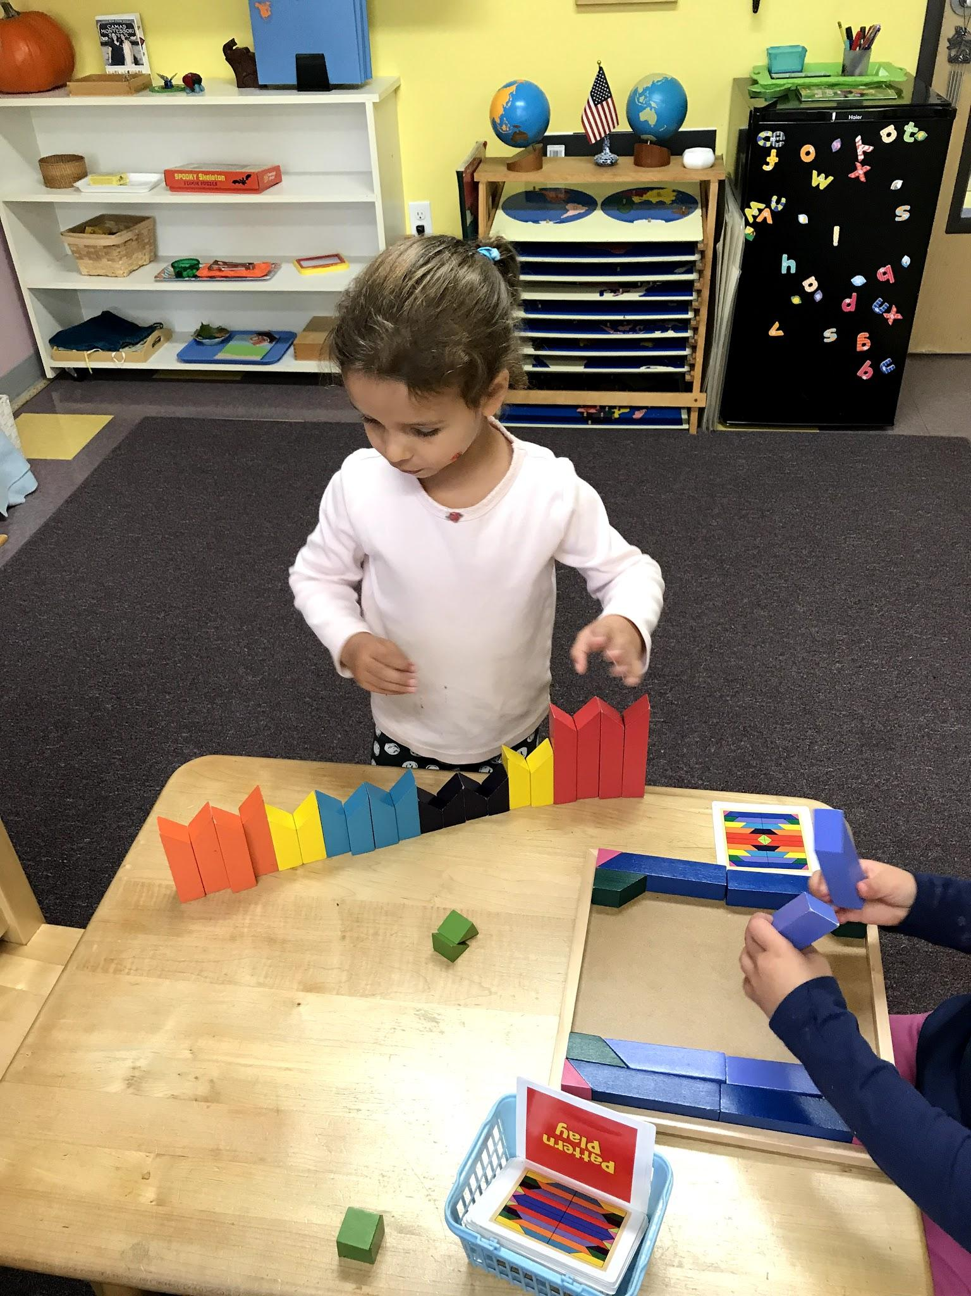
I thought this wall of blocks Isla build was inventive. I have never seen these prism blocks used in the way before.

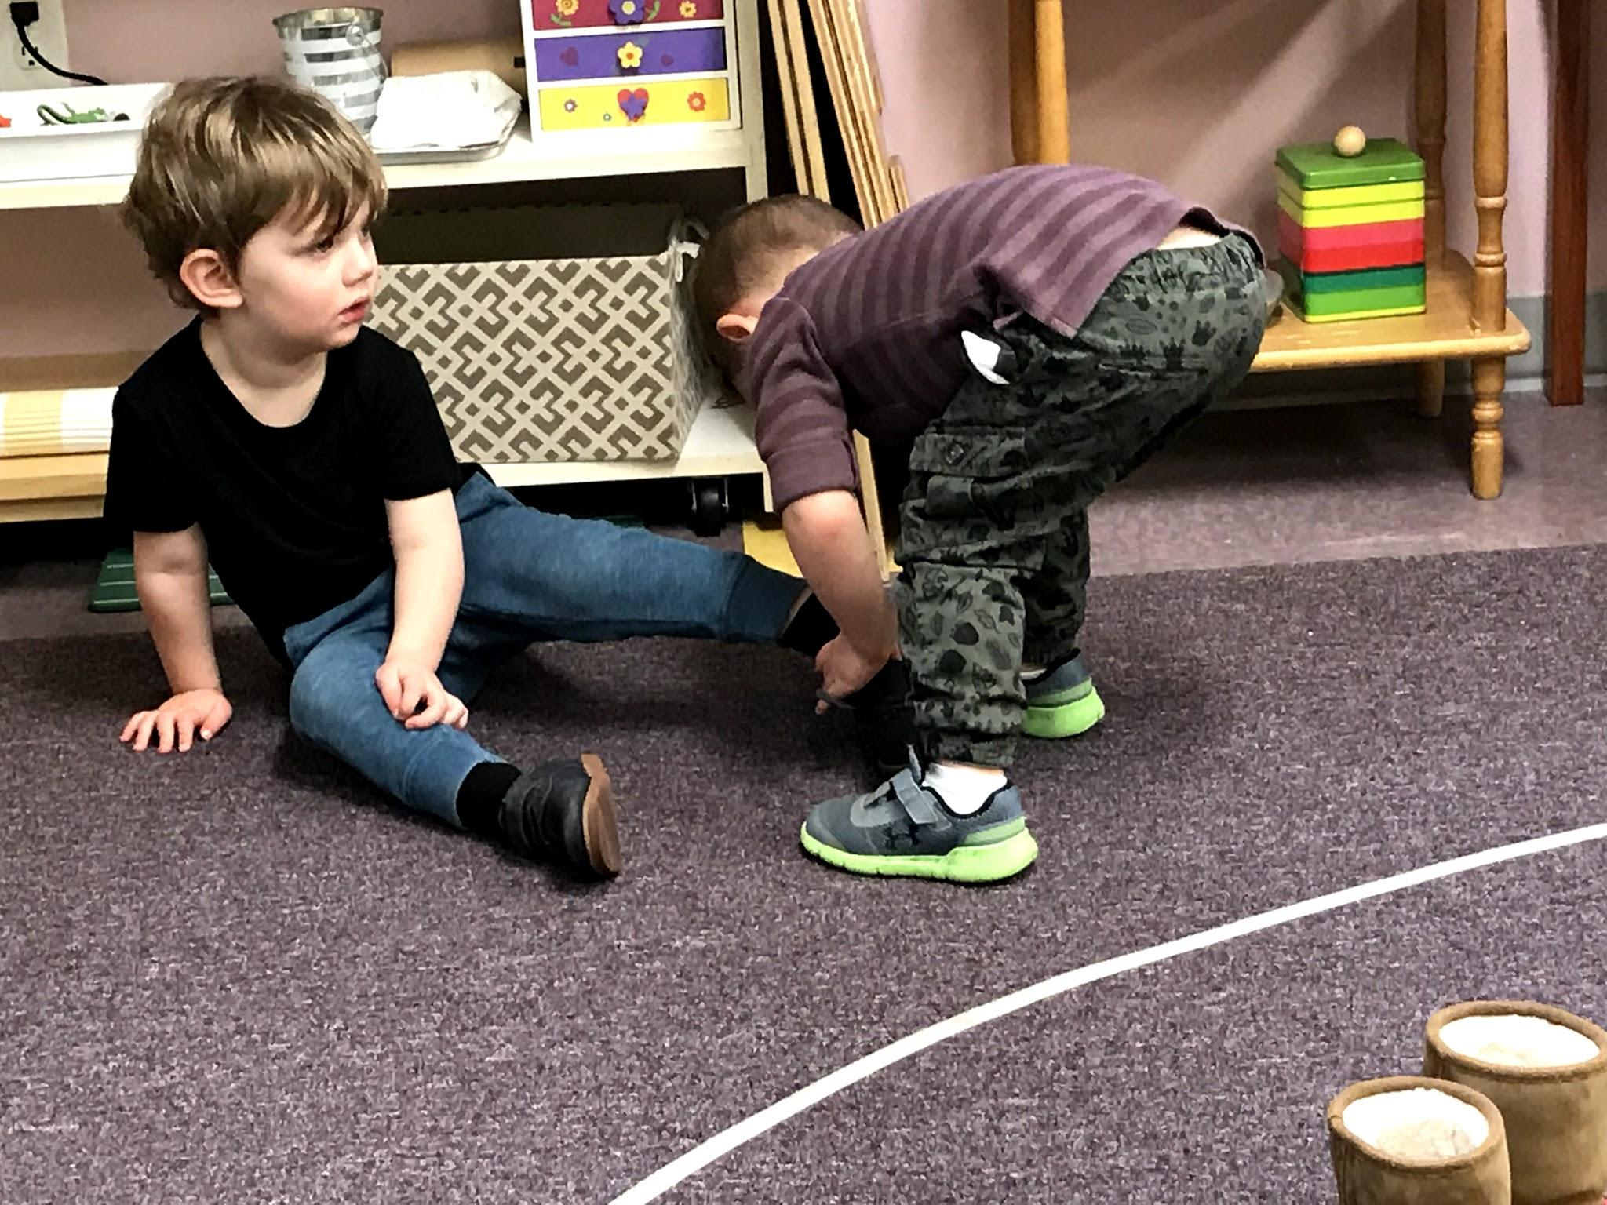
Bayr getting some help with his shoes from Creighton after walking on the line.

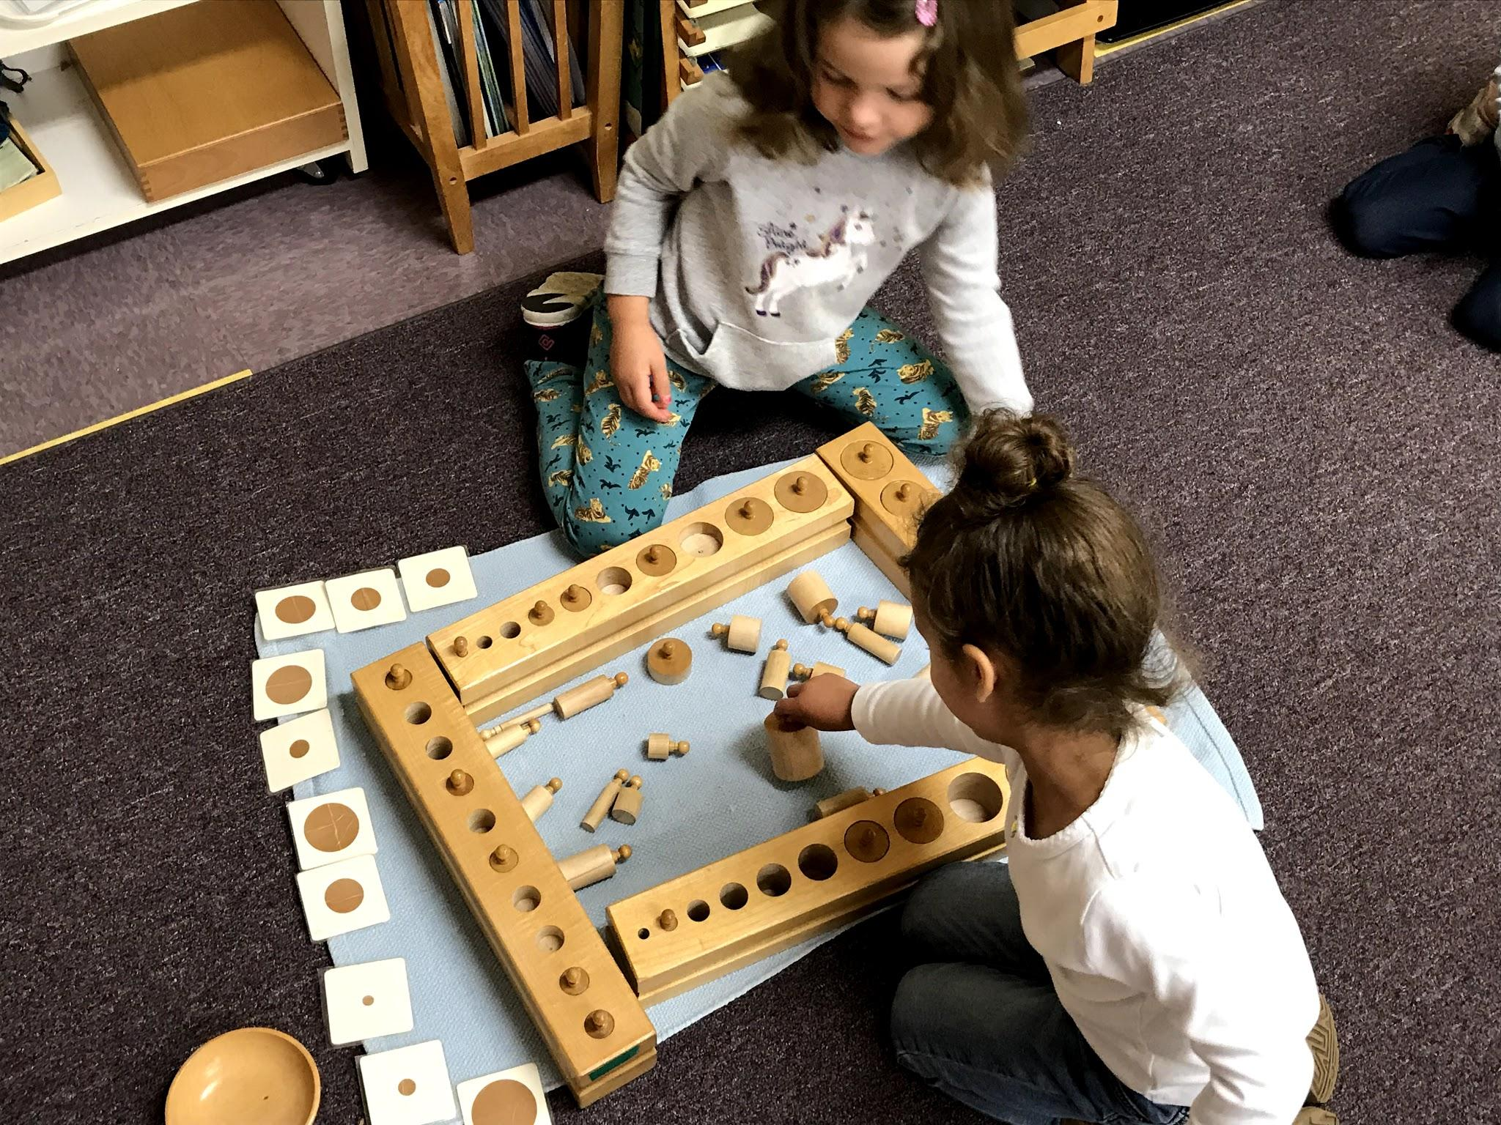
Penny and Isla experimenting with all four cylinder blocks. Each block has a variety of cylinders changing in length, height and width.

Nolan taught us this great song we have been singing.

Well...There is Mercury and Venus, Earth and Mars, Jupiter and Saturn, those are the big ones, Uranus and Neptune,
But not Pluto. Those are the planets, Yah!

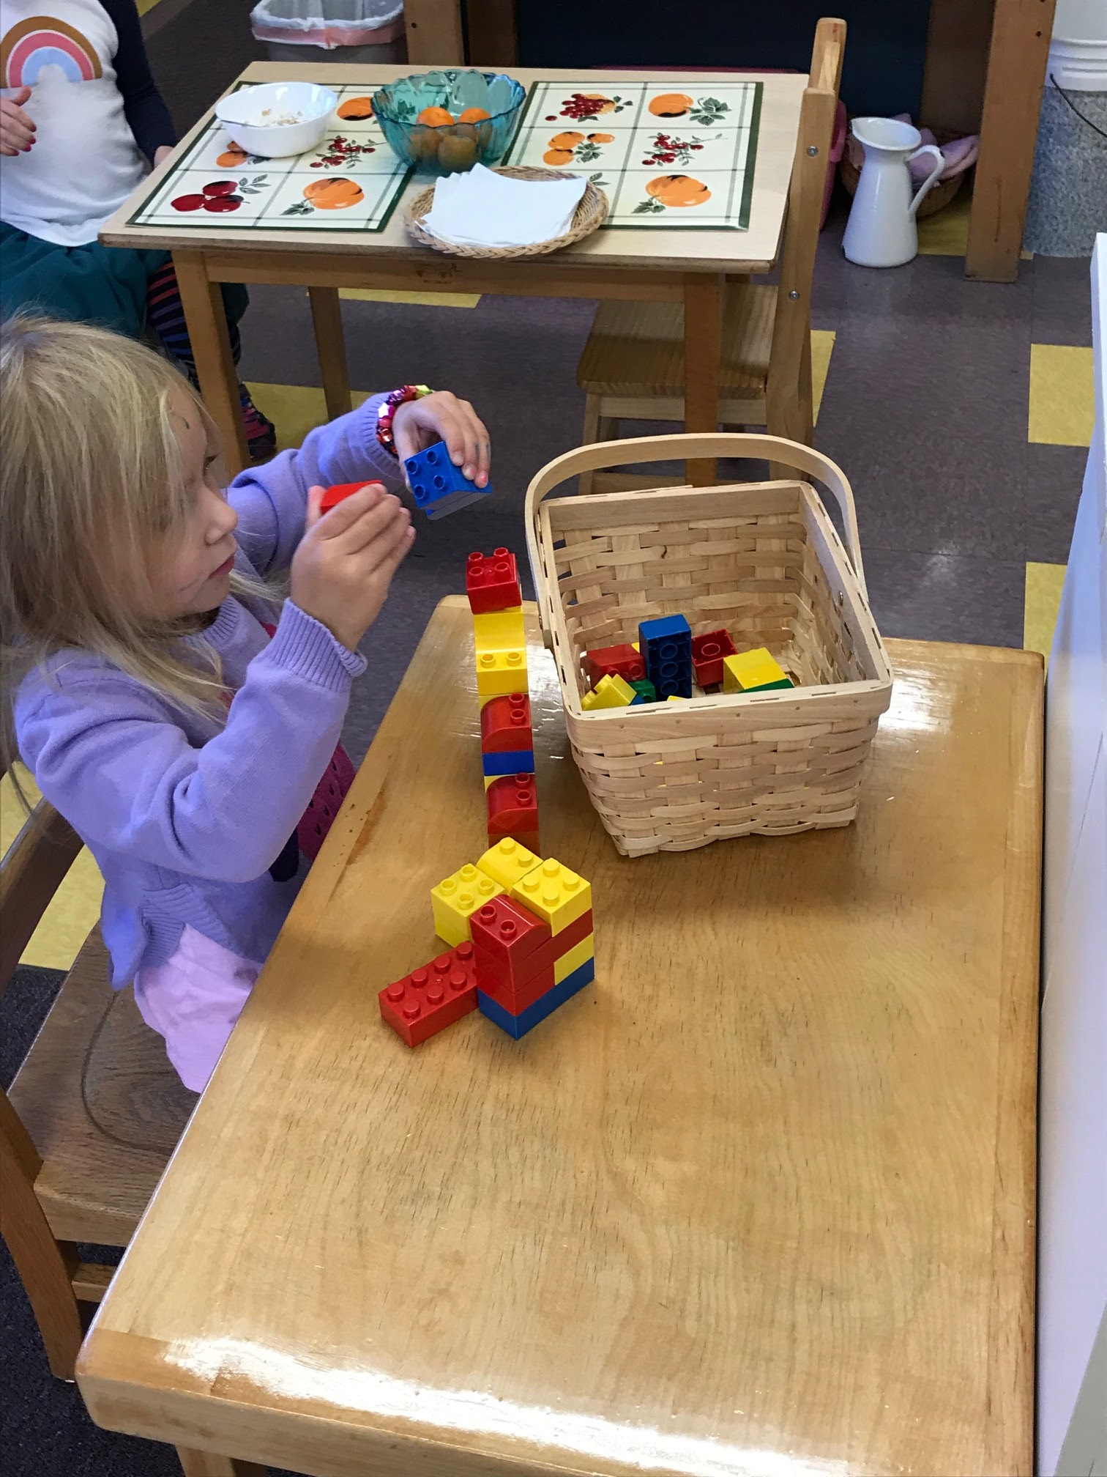
Senna built with Legos during morning recess. These are put on the shelves at the beginning of the year as a familiar piece of material especially for children new to Montessori.

