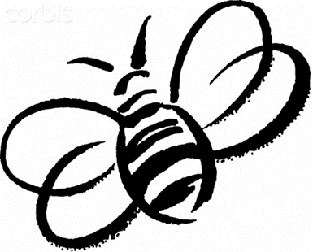October 2019 Buzz from the Bumblebees
Happy October! We have been learning about patterns and sequences this month. The children have been excited to get crafty and decorate for Halloween. We also learned about nocturnal animals such as bats and owls.
Run for the Arts was so much fun and our class did amazing. I was so proud to see them stay in line and walk together and listen to the teachers! We have been working so hard on these skills and it seems to be finally paying off. Thank you so much to those of you who have been talking and working with your children at home, it really shows!
We welcomed four new kids this month: Eleanor (4) Euan (4.5), Jake (2.5), and Sahalie (3). Our class is so warm and welcoming that all four of these children have already bonded with the class. Our room really bursts with empathy and kindness, it is so wonderful to see this in action!
~Ms. Jessica & Ms. Sara
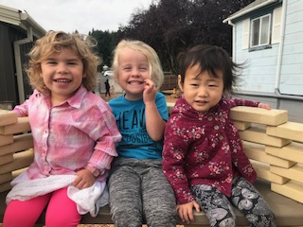
Emma, our resident caregiver, making our friend Sahalie feel welcome.

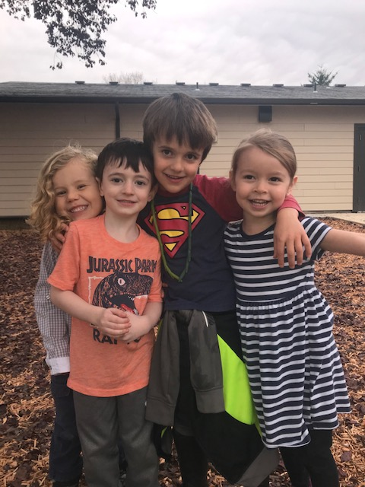
Eleanor and Euan became best friends on their first day and Owen and Kahlil helped to show them around.

*************Here is what your child has been up to*************
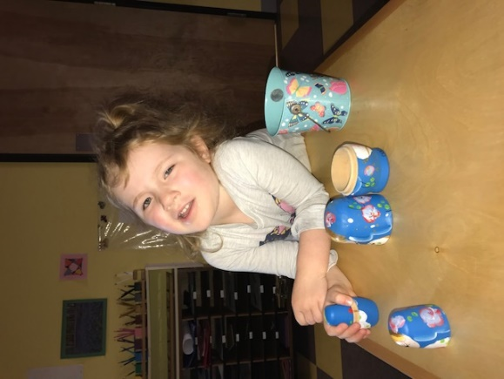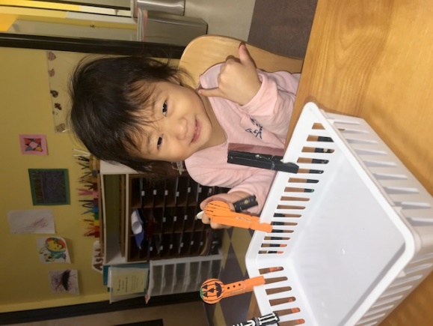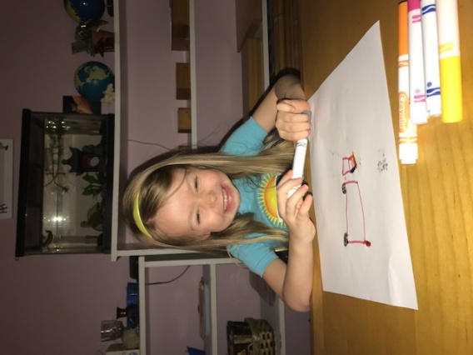
Abbie- nesting doll Ashley- clothespins Eleanor- markers, drawing
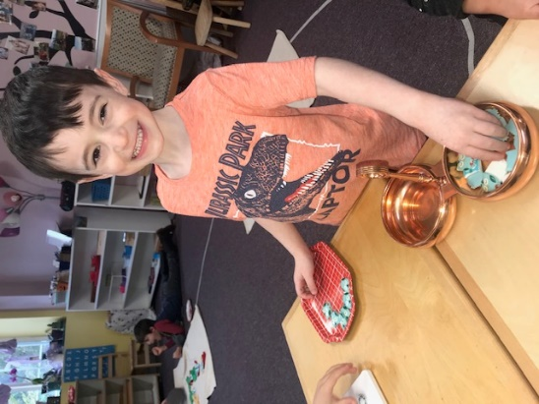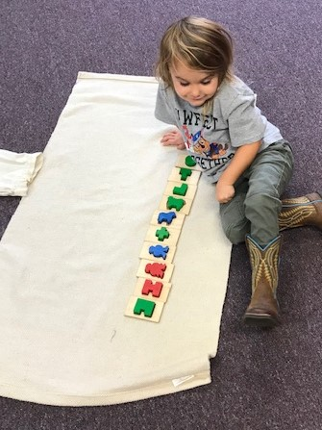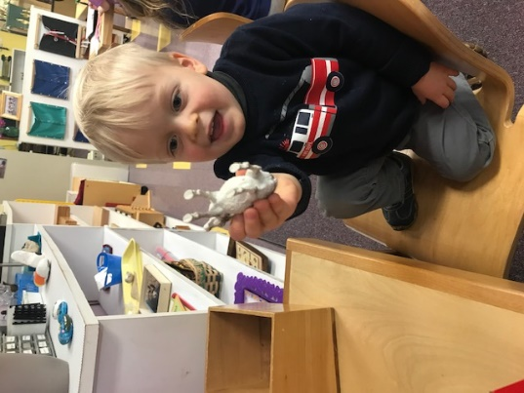
Euan- memory game Findlay- memory sensory puzzle Jake- farm animals

*Be sure to read Ms. Donna’s article for explanations of some of these lessons. If you need more information, ask me!
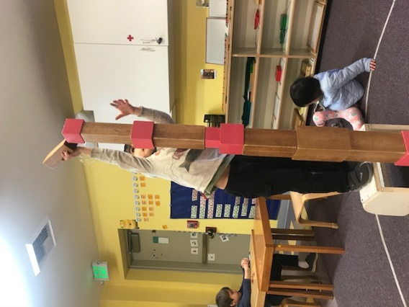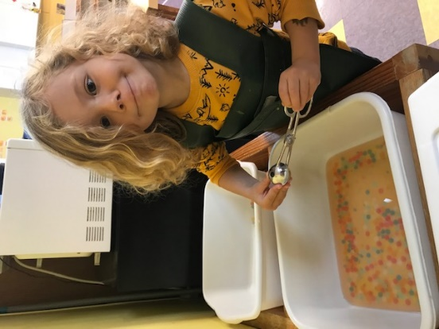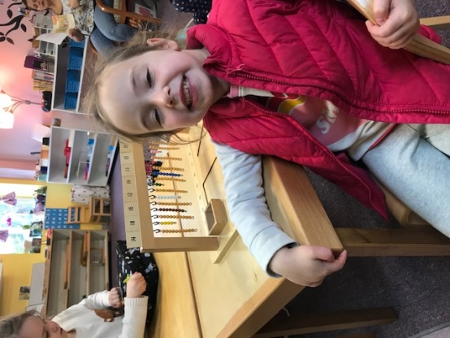
James- tower and stairs Khalil- sensory bin. Water beads Leia- teen beads
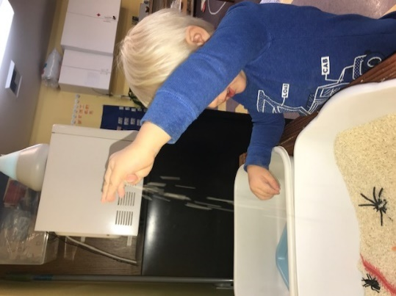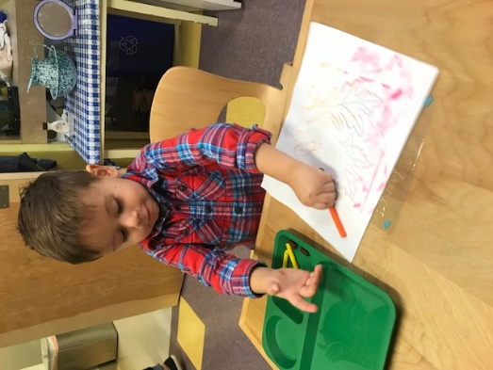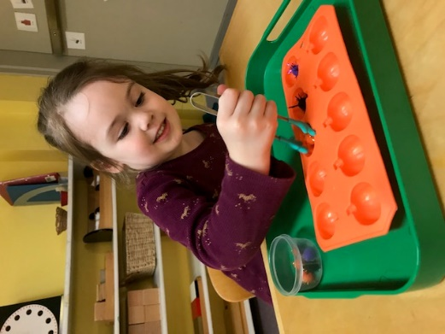
Levi- sensory bin Nehemiah- rubbings Phoebe- tongs
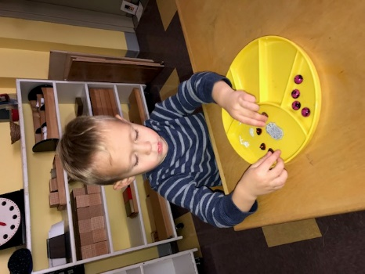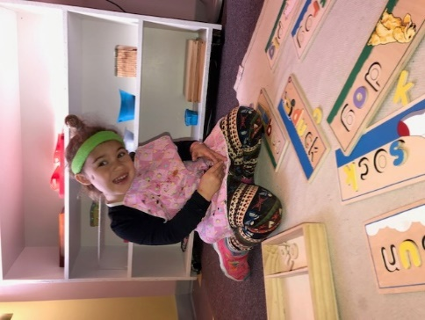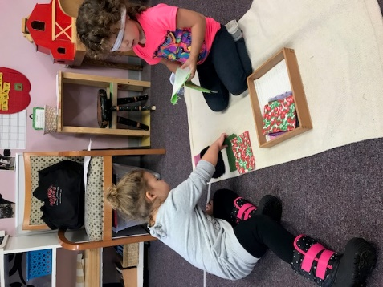
Richard- sorting Sahalie- word puzzle Sky- fabric boxes
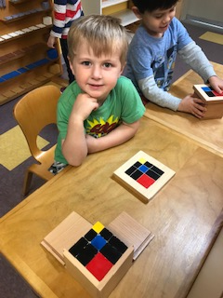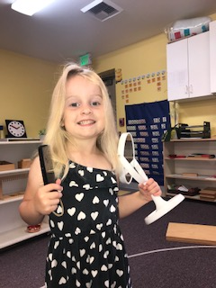
Bennett- trinomial cube and teaching a friend Emma- hair brushing
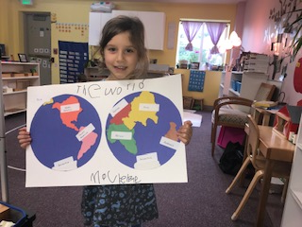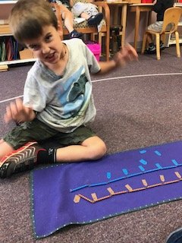
Mackenzie- world map Owen- skip counting with long bead chains

The children’s favorite song this month:
5 Little Pumpkins
Five little pumpkins sitting on a gate
The first one said, “Oh my it’s getting late”
The second one said, “There are bats in the air”
The third one said, “But we don’t care”
The fourth one said, “Let’s run and run and run”
The fifth one said, “I’m ready for some fun”
“Ooooo” went the wind and out went the light
And the five little pumpkins rolled out of sight

