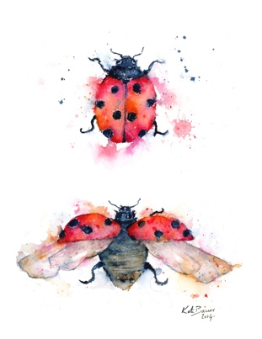
Ladybug Letter

Another lovely and sunny month has come and gone! Our days have been filled with the wonders of little true stories, old and new songs, books and poems, visiting spiders and beetles, birthday celebrations, a Halloween party, the big run and a new friend.

Thank you for attending our first conferences. I truly enjoyed meeting with all of you, sharing stories and gaining insights.

We are grateful for the many parents who help support our children in so many ways including washing laundry, helping children arrive in the morning, with parties, bringing snack, organizing fundraisers, planting spring bulbs, helping us stretch before we run and cheering us on (just to name a few!) We send a very sincere THANK YOU !

We have a little more sunshine in our classroom! We welcome Abby McClelland to the Ladybugs. We’re glad you are discovering the warmth of new friends, and the fun of so many interesting things to do. Abby turned three years old in August.

Speaking of birthdays … since school began in September, five children have celebrated their trips around the sun. Ivy, Ethan and Nadine became four, and Payton is now three years old. Happy, happy birthday!

In our gatherings, we speak of the calendar, the seasons, the months and the days of the week. Our ‘weekday song’ is an old familiar one. Your child might sing it for you . . .
Sunday, Monday, Tuesday, Wednesday, Thursday, Friday. . . Saturday.
Then, we often name all the months, and count the days we have had thus far in a month.

Seeking opportunities to count aloud is often a spontaneous activity. We sometimes count to 100 and begin at any lower number. For example, “Let’s count to 100, beginning at 37.” Or perhaps count by 10’s, or 5’s. Rote counting is such a good way to build on the number work we do in the classroom.

There are a few events that are coming up in November that I’d like to share . . .
Parent Education Night is scheduled for Thursday, Nov. 7th, 5:30-630. Just one hour long, it is sure to be packed with ideas you can do at home grounded in Montessori theory. The practical life area of the classroom is chuck full of good thinking. When we prepare the classroom environment, we think of the children’s ages and size and note their interests. You can also prepare your home environment with your young child in mind. They are capable of a surprising number of activities, especially after a modeled lesson on how to do something.

Another event we have planned is our child led Parent Open House Wednesday, November 20th . There will be a choice of times to attend: 4 - 4:45 or 4:45 - 5:30. It is a wonderfully fun opportunity for your child to share with you a little bit of ‘work’ they enjoy doing in the classroom. I have posted a sign-up sheet by the door. That day is our November Early Release day as well.

A few ideas for home . . .
With an activity in mind, analyze before-hand what you will need, and think about the steps and movements you’ll want to clearly show. Preparation is a key.

Offering children the language associated with their experiences is also something we do in the classroom. Appealing to their sense of order we give opportunities to classify the world around them, for example: objects in the room made of glass, or wood, or plastic, or naming things with wheels, or animals they would see at the zoo. You might notice your child is becoming familiar with the names of geometric shapes, as well as the names of the seven continents. Their absorbent mind quite readily retains the language given.
Perhaps you’ve heard them sing the continent song:

Tell me the continents
Tell me the continents
Tell me the continents, if you
can . . .
North America, South America, Europe, Asia, Africa.
Don’t forget Antarctica,
Don’t forget Oceania
Tell me the continents
Tell me the continents
Tell me the continents, if you can.

It’s quite lovely to have a conversation with a four year old about a family that visited Asia, or Ms. Cindy’s daughter that lives in Europe, or the pyramid in Africa, or those dinosaur eggs that were found in South America.

The solid geometric shapes we speak of include: an ovoid (eg. egg), a cylinder (eg. a can of soup or a pencil) a cube (eg. a box or block), a rectangular prism (eg. a stick of butter), a cone (they joyfully relate to this one quickly), a square based pyramid (eg. the Great Pyramid). The plane geometric figures include the square, a circle, an ellipse, an oval, a rectangle, a rhombus, a triangle, a trapezoid, a parallelogram, a pentagon, an octagon (the polygons up through a decagon.)

Our Run For the Arts raised $4000.04! This money is dedicated to performance experiences for the children throughout the school year. Thank you to everyone for taking part! These performances come to us and enrich our lives.

Earn FREE materials for our school . . . Hopefully, you have seen the Small Hands catalog at school or online www.forsmallhands.com . Montessori based, it offers wonderful items for young children to participate in activities at home and has great ideas for holiday gift giving to family and friends.
And, there is an additional way to support our classroom if you or your child would like to get a personal gift for the Ladybug room. Teachers have each created their own ‘wish list’, written them on little ‘ornament tags’ and posted them outside the classroom. There is a larger classroom resource catalog teachers can also use to order through www.montessoriservices.com .
The September order deadline has passed. The next two order deadlines are Nov. 19th (for orders to arrive before Christmas) and Dec. 30th.
Ladybug parent Audrey Maddox (Payton’s mom) is overseeing this for the whole school. Her email is: AudreyAmaddox@gmail.com .
for questions and help in placing your order. Thank you again!

Here are a few pictures of the children. Please forgive my limited tech skills and tardy newsletter as I figure out how all this comes together!

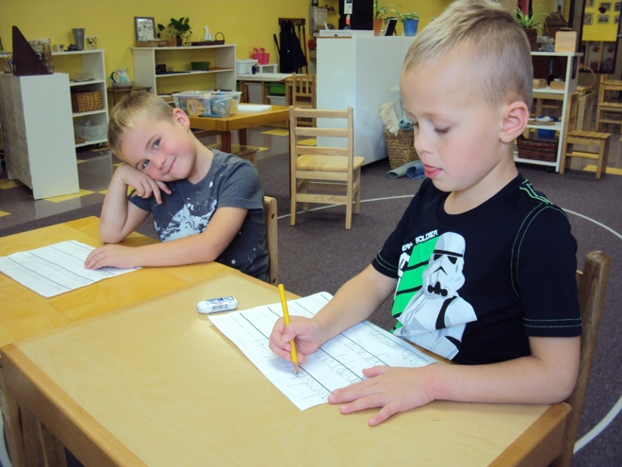
Carver and Jameson practicing their handwriting between a base and waist line.

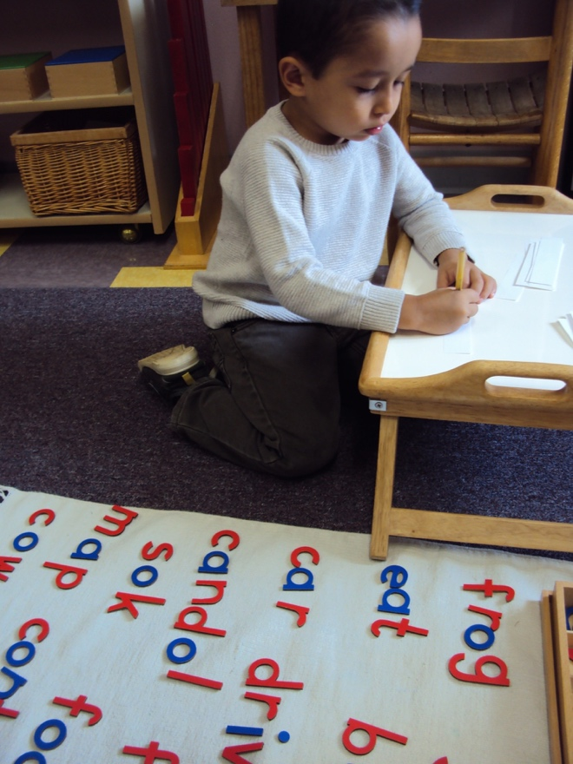
Richey enjoying his ability to write words and record them into a little book.

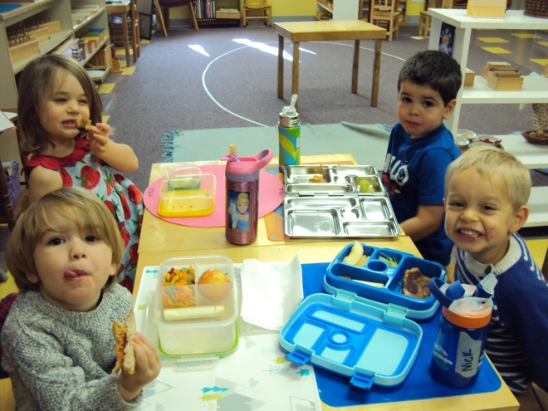
Quinn, Lydia, Reid and Nick a lunch time.
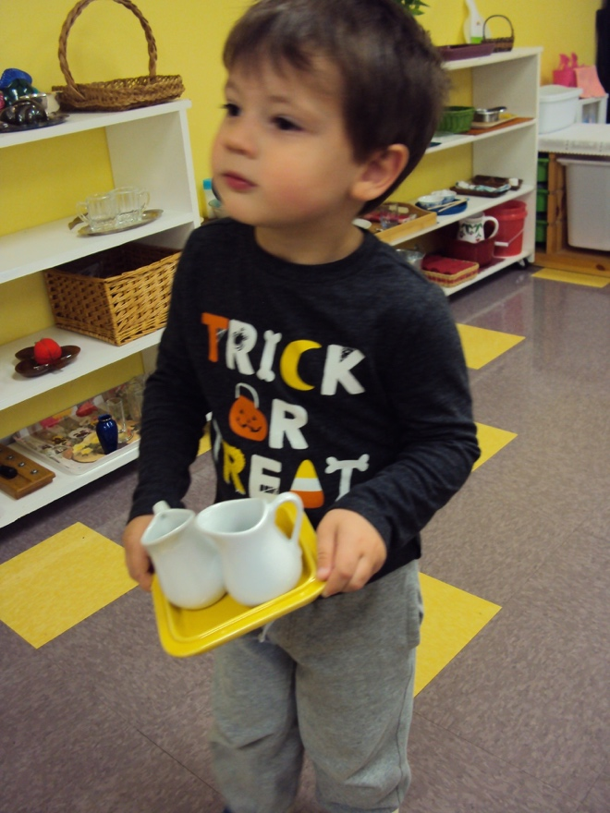
Bowen defying gravity and about to do dry pouring.
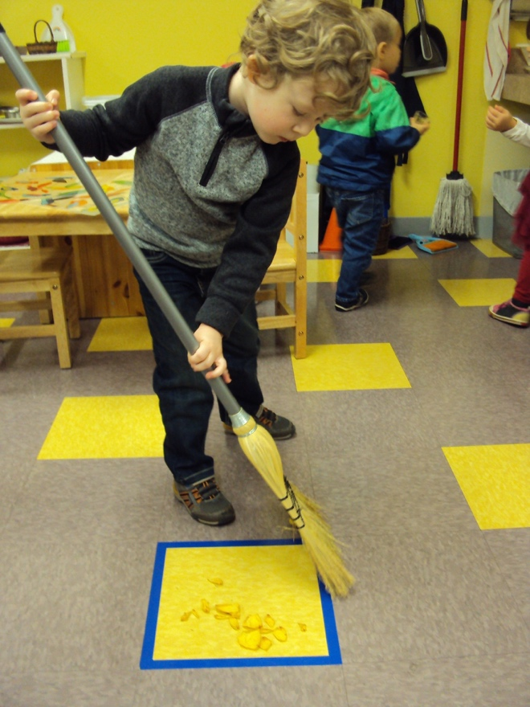
Sweeping dried rose petals is a lovely and easy way to learn to use a broom.
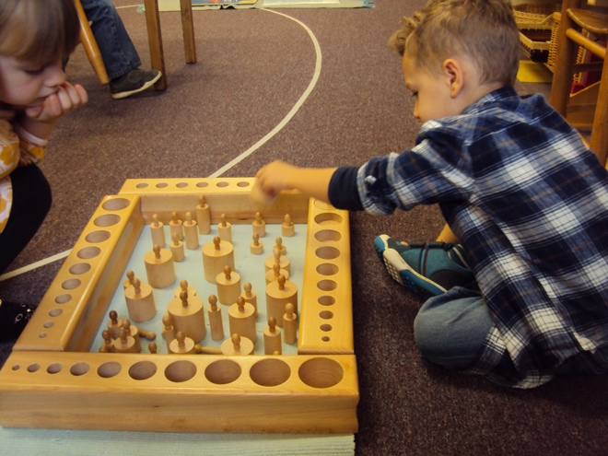
Landon taking on the challenge of four cylinder blocks, which vary in the dimensions of heights and diameter.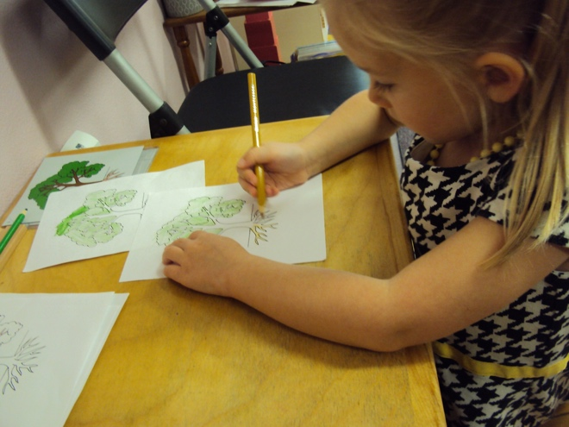
Ivy has learned the parts of a tree through making a book with the botany cards.

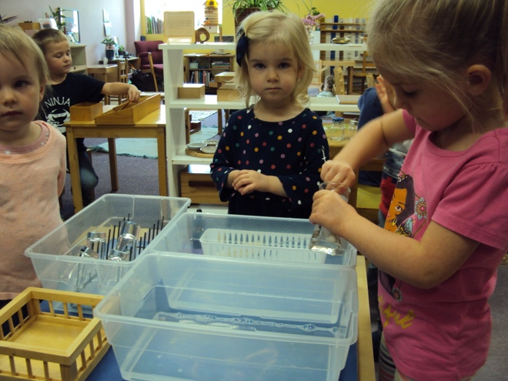
Payton and Madeline watch Ivy as she helps care for the classroom, gathering the small bouquets that have died and then washing the vases.
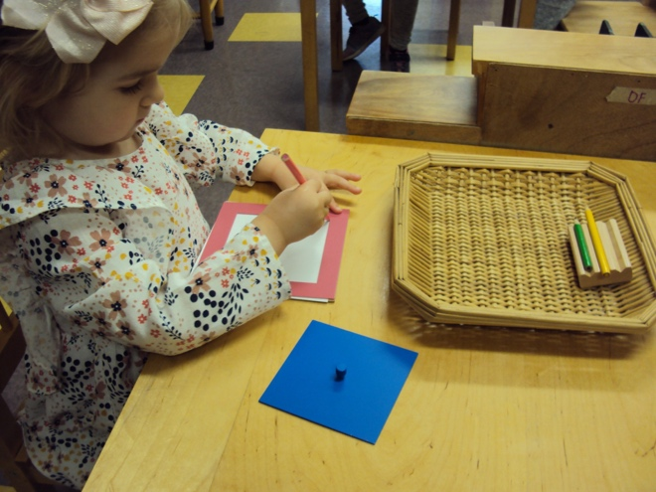
Not only helping Madeline to develop fine motor skills, the metal insets offer the possibility of creating beautiful designs using geometric shapes.
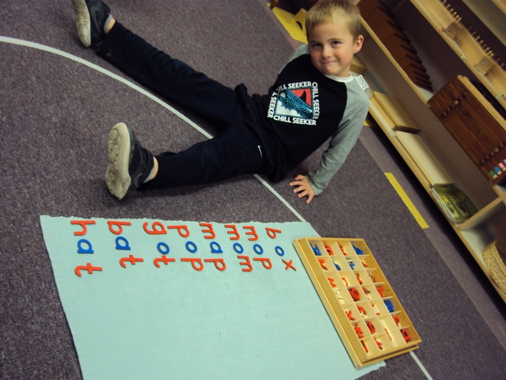
Carver analyzed the sounds of these words and made them with the moveable alphabet.
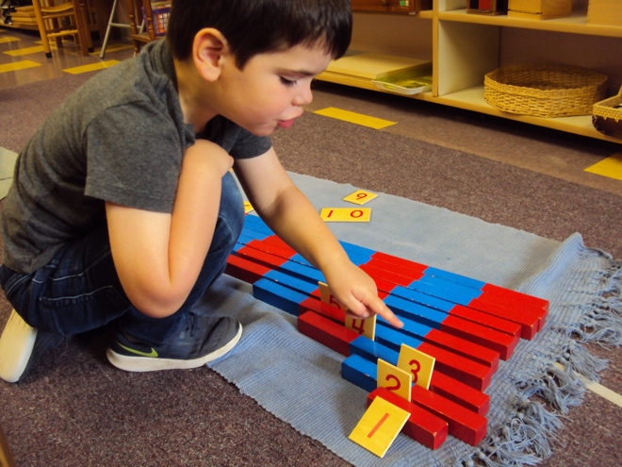
Here Reid counts the sections of the number rods and places the numeral with the quantity.
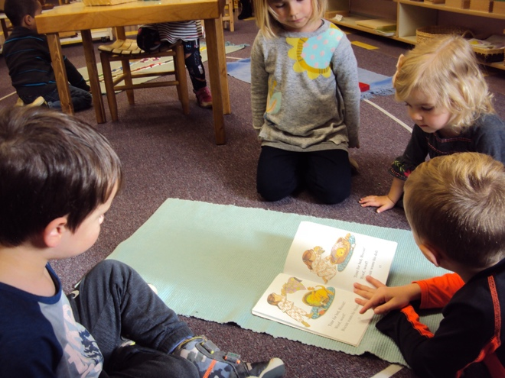
Jameson is happily reading a Biscuit book as Bowen, June and Madeline watch and listen.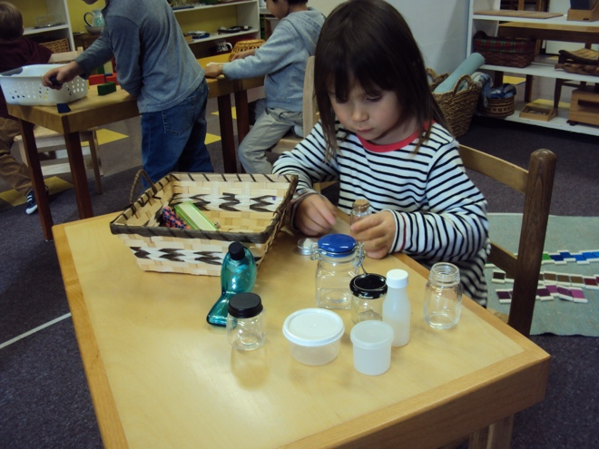
Here Abby is matching the different lids of containers in the ‘opening and closing’ basket. Welcome to our class Abby!

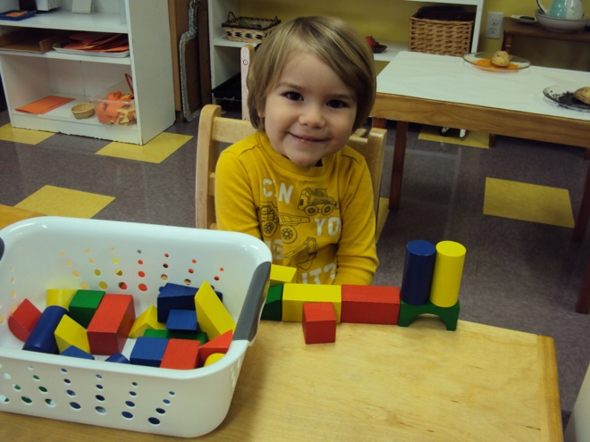
Carefully building with shapes, Quinn has found interest in the blocks that were on the shelf of transition materials.
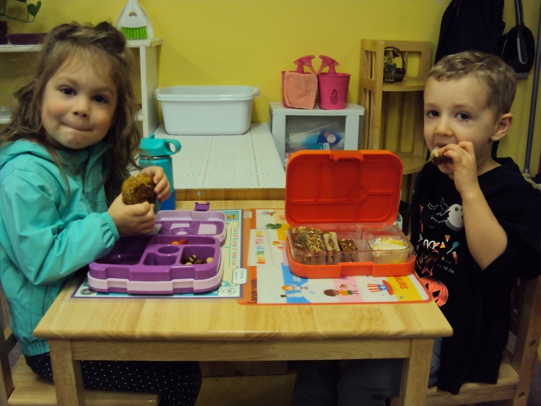
Nadine and Landon share a lunch table and are friends at home and school.

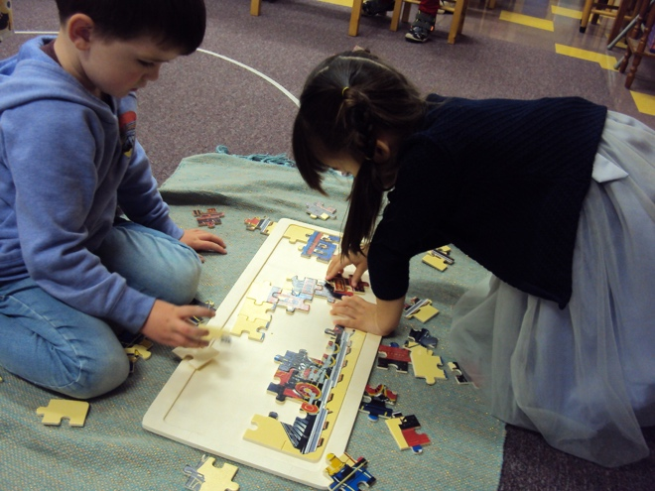
Archer and Ellie are working together on our largest puzzle.

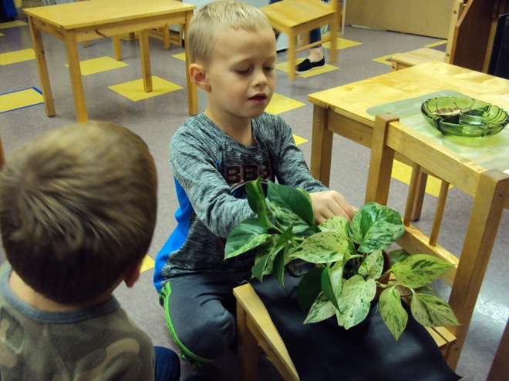

Jameson is helping to care for our room as he washes the leaves of a plant.

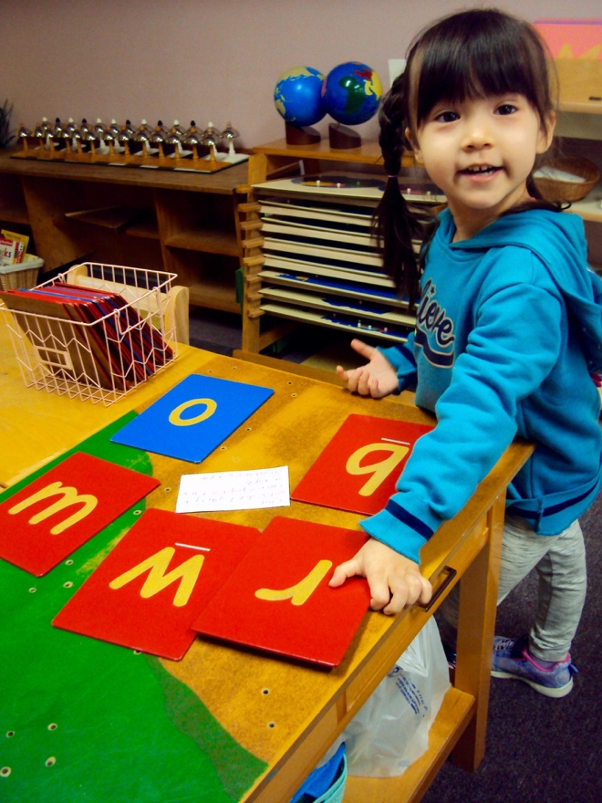
Ellie, one of our new friends, enjoys learning the sounds and shapes of the sandpaper letters.

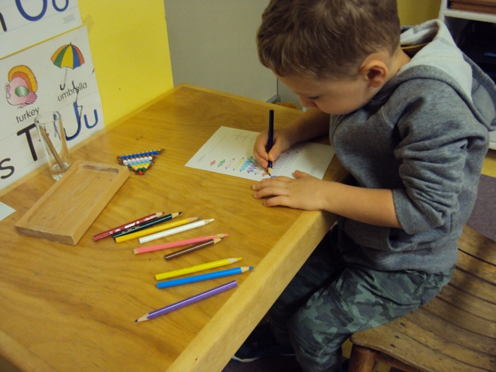
Landon is coloring the beads of the bead stair in preparation for working with the teen boards.

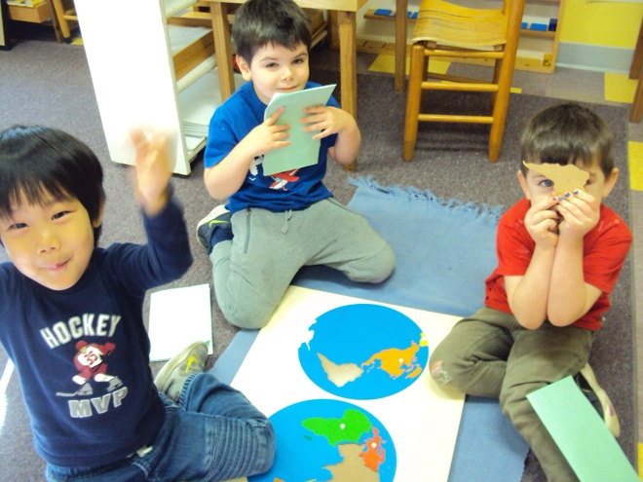
Ethan, Reid and Archer are learning the names, shapes and location of the continents and each making a book by pin pricking.

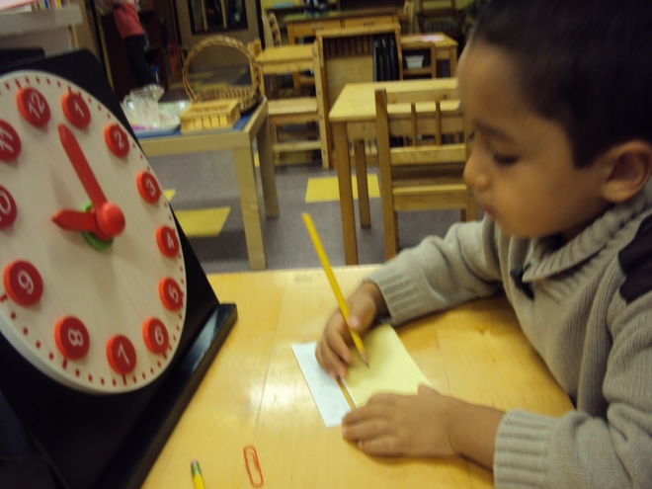
Richy with the hour lesson of telling time.

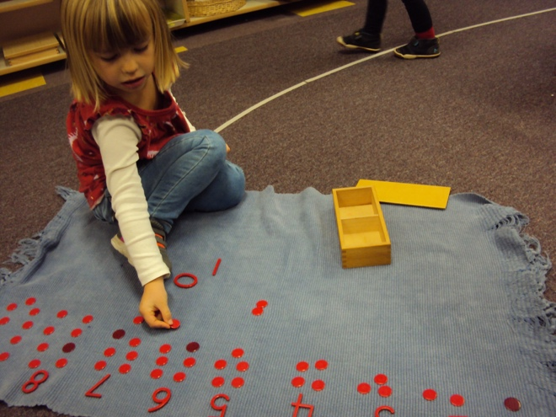
With the numerals and counters June understand quantity well and also learned the concept of odd and even numbers.

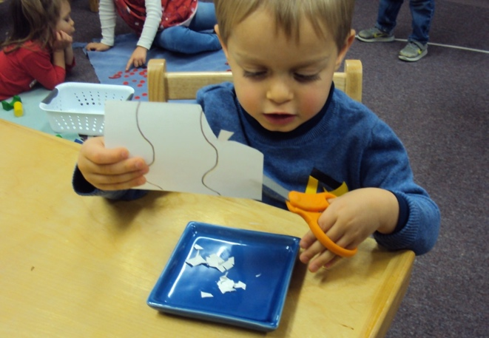
Nick is confirming his understanding that the scissors are for cutting paper.

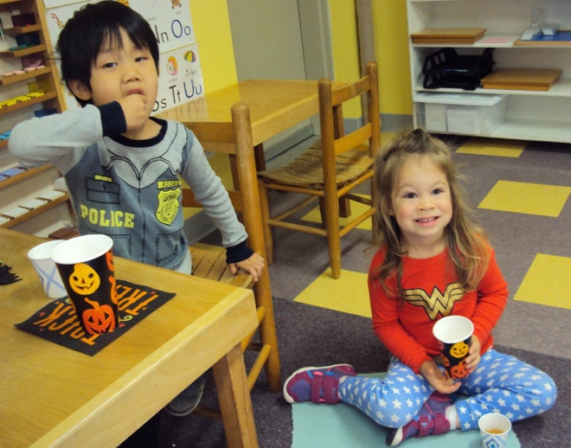
Nathan and Nadine are enjoying our popcorn and apple cider party. Thanks to Reid’s mom for helping!

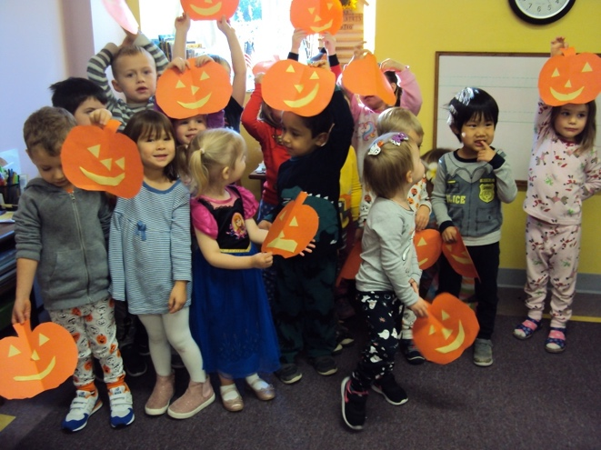
Our pumpkin patch!

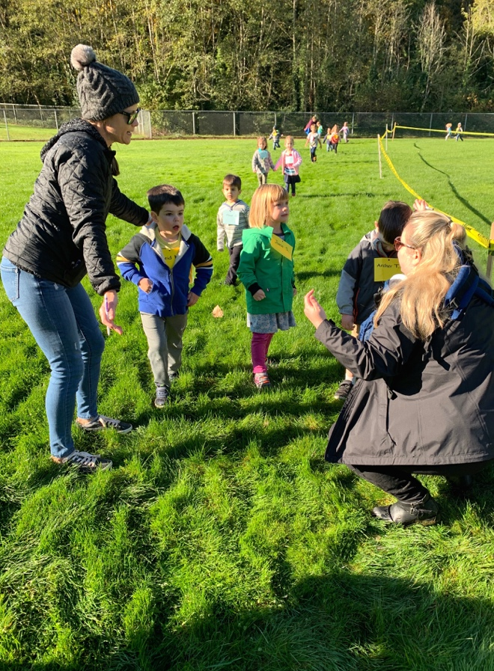
What a wonderful event on a perfect day with the love of parents cheering, a snack and a prize ribbon when we were done!

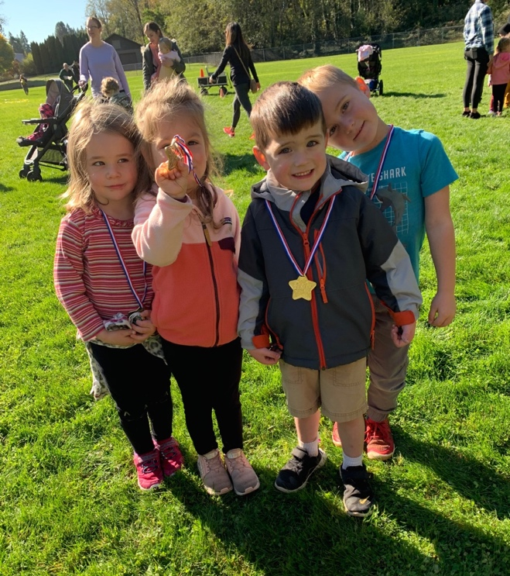
Lydia, Nadine, Archer and Carver quite happy they ran so many times around the course at Run for the Arts.

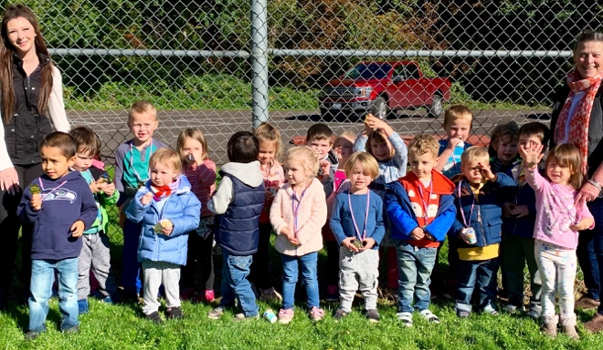

Please remember to check the school calendar for upcoming events.

Thank you again! We appreciate our parents and the sense of community you create.
Cheers!
Cindy Guschov. Ladybug Guide.

