Hello from the Butterfly room.

October has been a wonderful month. We have been discussing the change of seasons and noticing the trees and weather. We have read many Fall books during group.
As of November 4^{th,} we will do group and sharing first thing in the morning. Please be sure your child is on time. Group will be from 8:35- 9:00.
The children are looking forward to a fun pajama/ Halloween party.
Thanks for all the great toys for our little trick-or-treaters
Conferences were great. I really enjoyed getting to know each of you a bit better. Thank you so much for coming.

We had two Birthdays this month. JD turned 6 years old on the 2nd and Kayden turned 4 on the 30th. Happy Birthday!!!

Our classroom is running very smoothly. There have been many good friendships made and we see a lot of compassionate acts between the children. As always, the children are a joy to watch.
Here are some pictures of your children during their days at school.

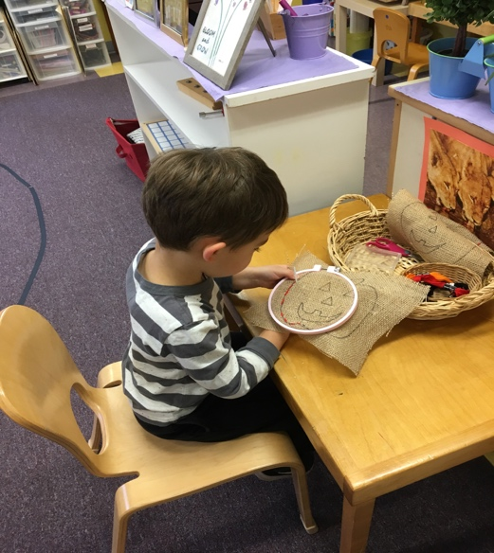
Blake stitching a jack-o-lantern

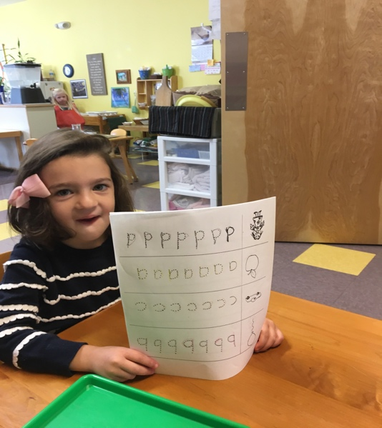
Lillian showing her letter tracing sheet.
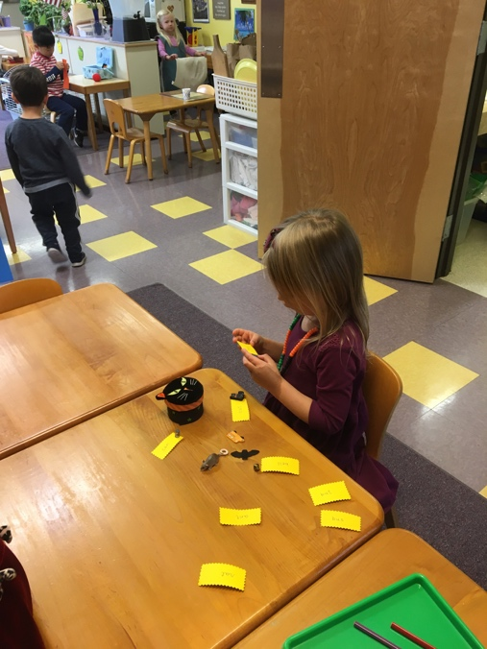
Cate reading and matching items to labels using the object box.

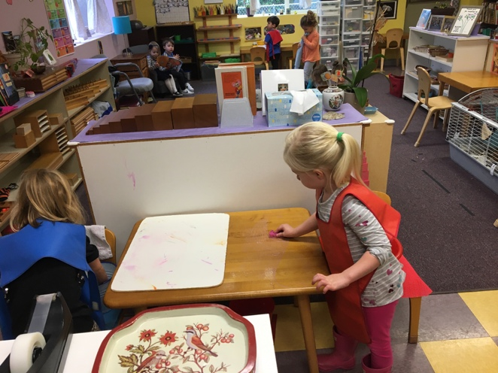
Mila scrubbing the table while her friend Elise scrubs an underlay

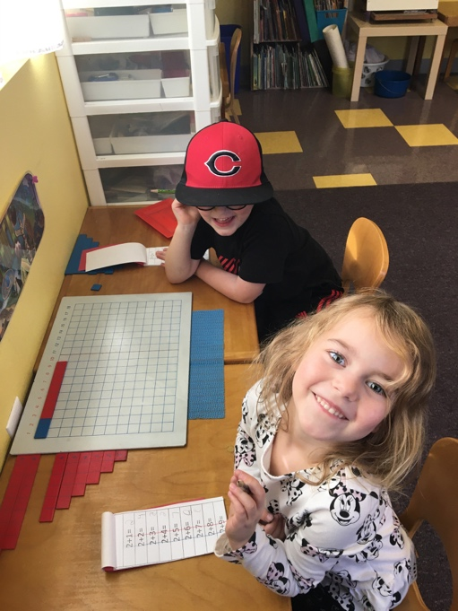
Grace and Anders working on the addition strip board.

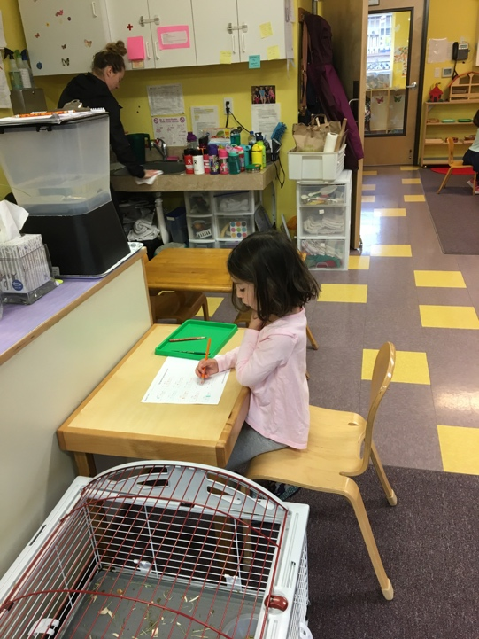
Lillian tracing her name.

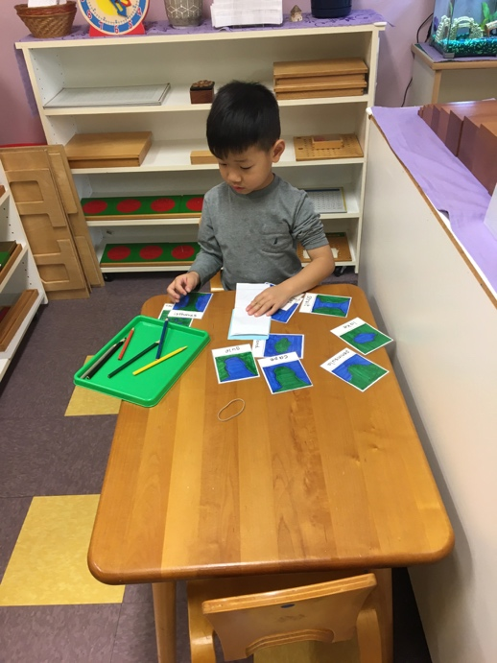
Raymond coloring and labeling land and water forms. (lake/island and gulf/peninsula
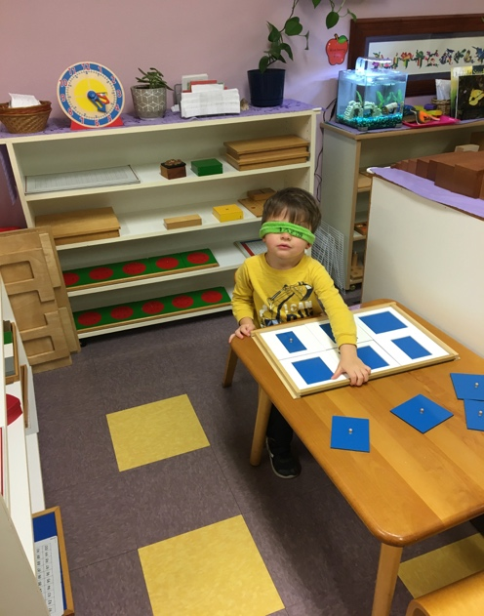
Blake using his blindfold to find the matching rectangle to its frame

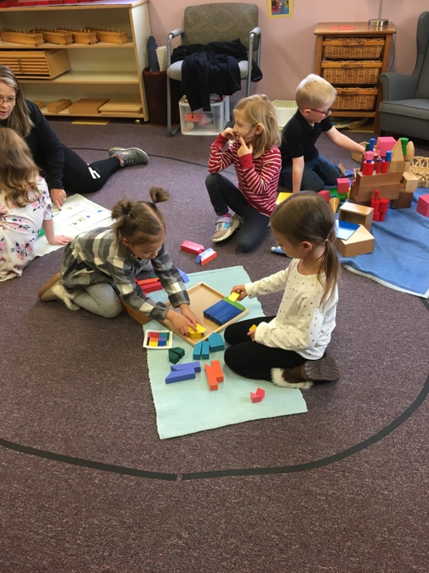
Hazel and Rowe working on the pattern puzzle.
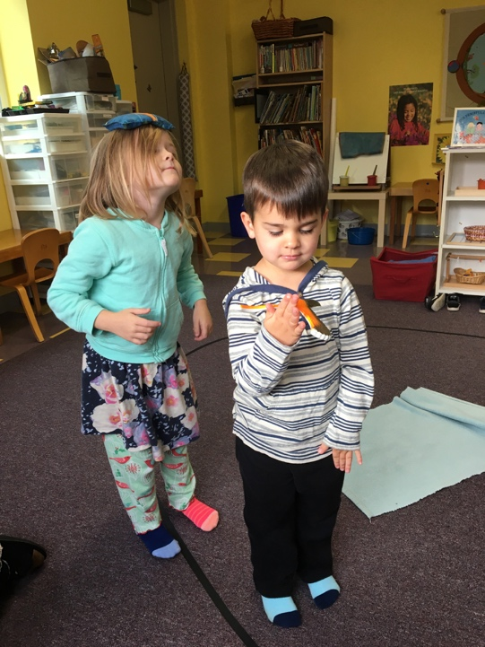
Jeweliann and Aksel balancing on the line.

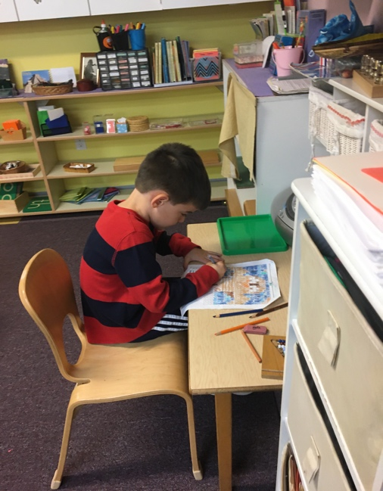

JD working on his number coding sheet.
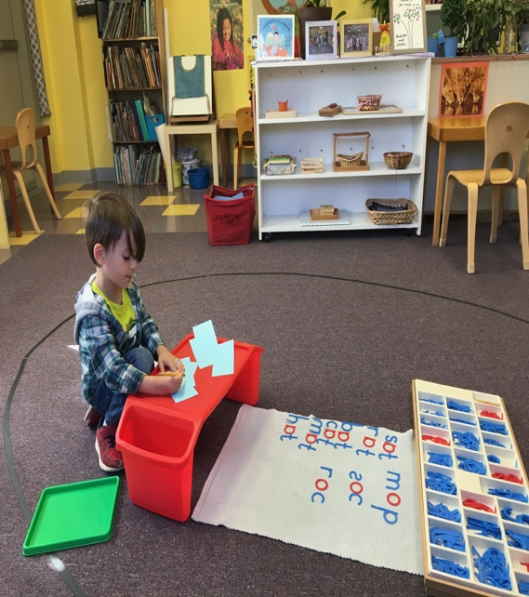
Riley recording words he built with the moveable alphabet.

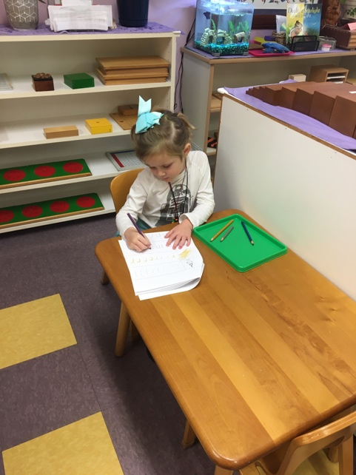
Jeweliann practicing her letters.

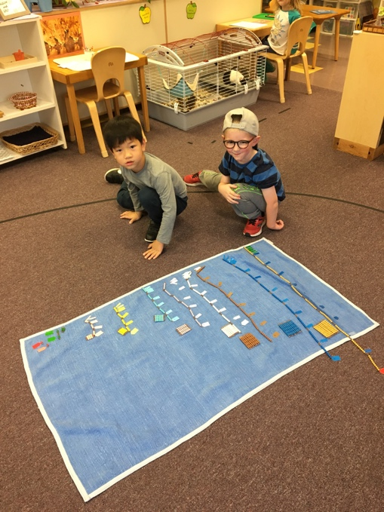

Raymond and Anders counting with the bead chain. Here they’ve laid out and labeled from 1 to 100 chain.
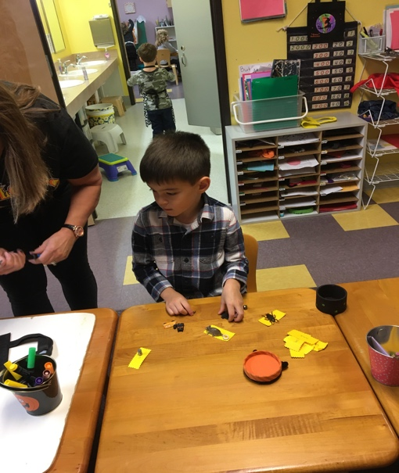
JD reading and labeling with the object box.
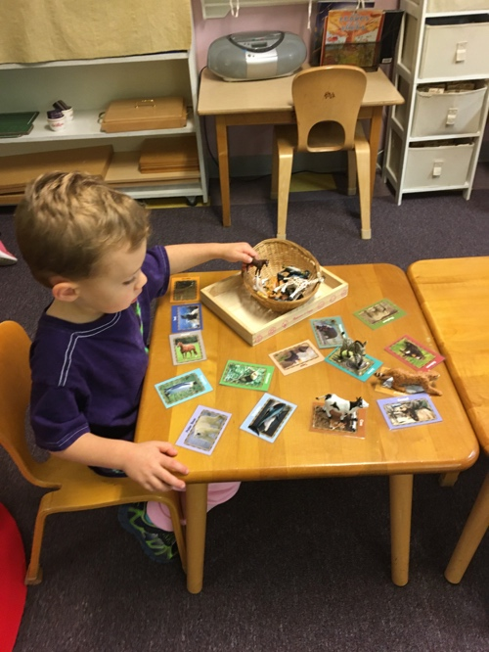
Ethan is matching wild animals to their pictures.

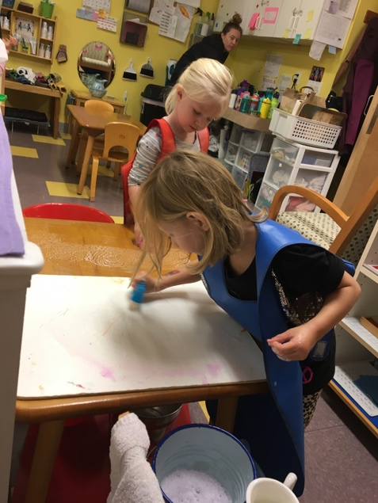
Elise scrubbing an underlay
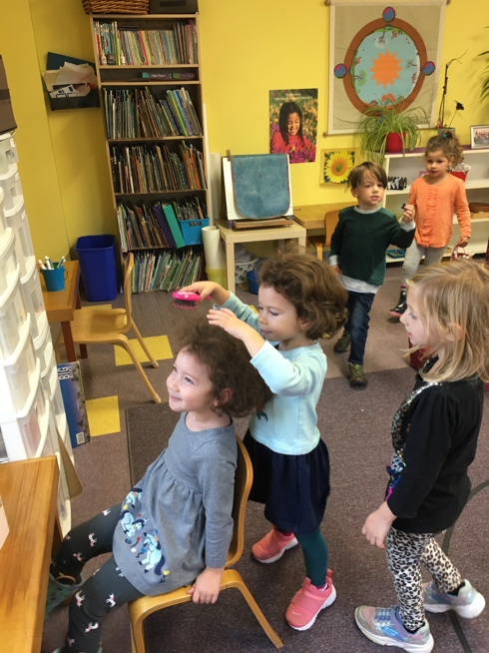
Adie using the personal care table to comb her sister Rivers hair. (Do you want it flat or spikey?)

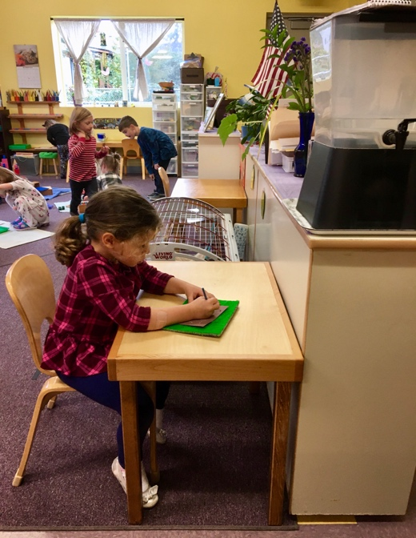
Whitley is pinpricking out a kitten
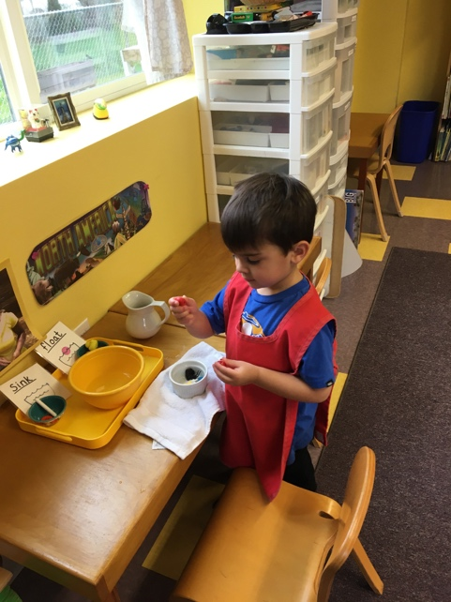
Aksel sorting sink and floating items with one of our science works
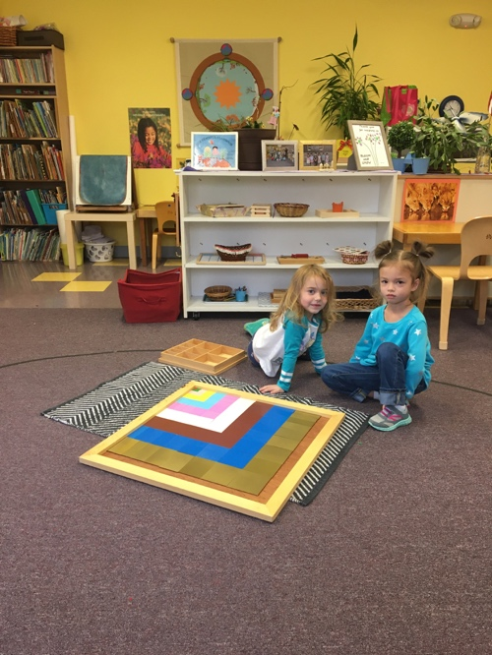
Grace and Hazel built the decanomial square

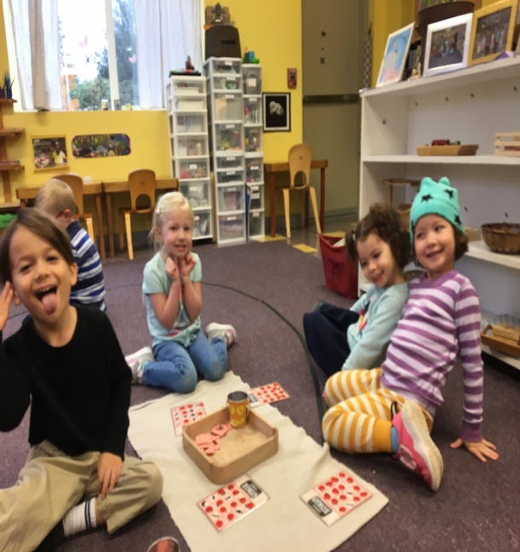
Riley, Mila, Adie, and River playing Halloween Bingo

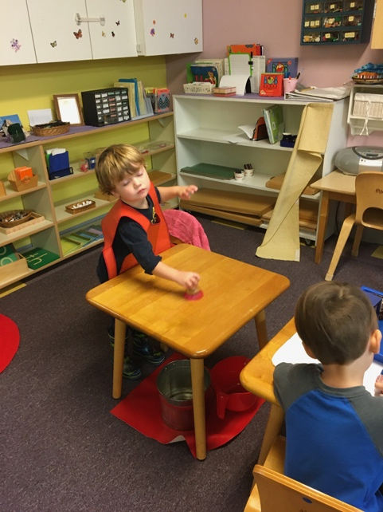
Kaden scrubbing a table

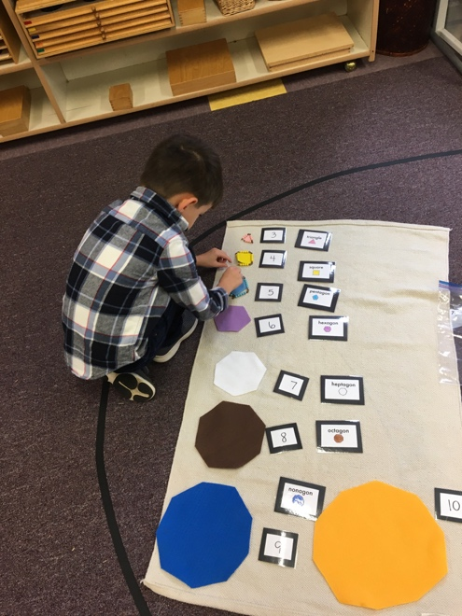
JD using a new lesson we saw at a Montessori conference. Using our bead chains to create all the polygons.
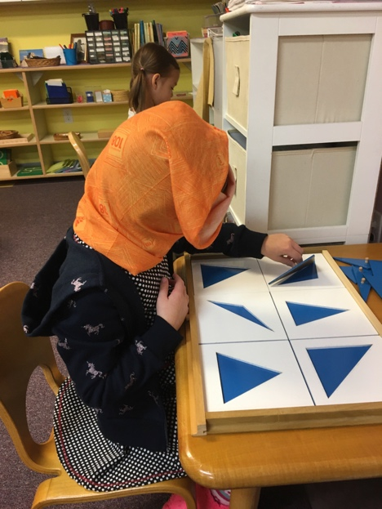
Jeweliann using her blindfold while using the geometry cabinet

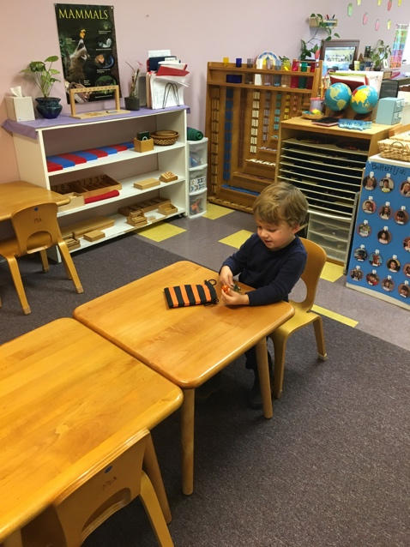
Kaden using Mystery bag (feeling and guessing what he feels)

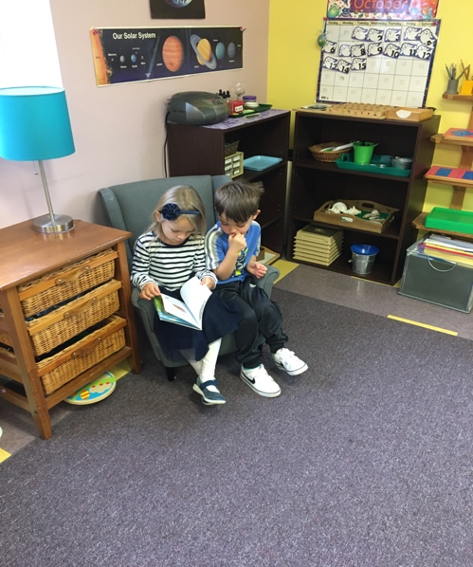
Cate and Blake looking at book together

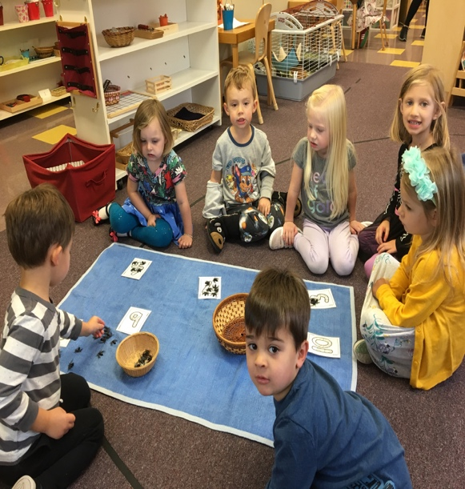
Group game counting spiders to match your number card.

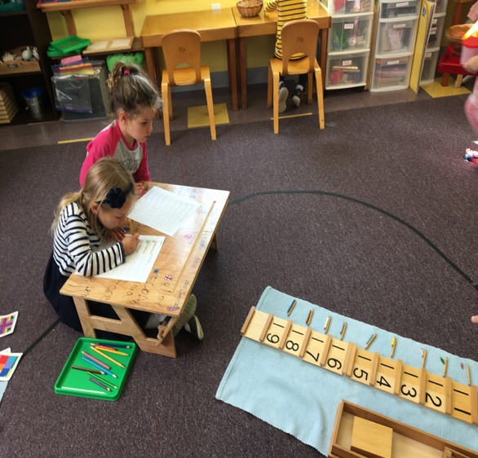
Cate and Whitley working on their teen numbers.

Hope you enjoyed these photos
Have a wonderful November!
Miss Nina and Miss Cindy

